**Day: - 1**

**Topics: - 1. Code Editor Setup.**

**2. Basics of HTML.**

**Introduction: -** HTML stands for Hypertext Markup Language and is a widely used programming language to develop web pages.

**1.HyperText stands for Link between web pages. 2. Markup Language means Text between tags that define the structure**.

HTML is a markup language that is used to create web pages. It defines how the web page looks and how to display content with the help of elements.

It forms or defines the structure of our Web Page, thus it forms or defines the structure of our Web Page. We must remember to save your file with a .html extension.

**HTML is Responsible for creating the web page. CSS is responsible for creating the styling of the web page. Java Script is responsible for adding functionality to the HTML elements. It is three core web developer Technologies.**

**HTML History and Creation: - Tim Berners-Lee, a physicist at the CERN research institute in Switzerland invented HTML in 1991. This First version consisted of 18 HTML tags. Now, there are currently about 140HTML tags, although not all of them are supported by modern browsers.**



**Creation: -**

* **1991-** Tim Berners-Lee invents HTML 1.0
* **1993-** HTML 1.0 is released. Not many developers are creating websites at this time.
* **1995-** HTML 2.0 is published. This contains the features of HTML 1.0 plus new features. This remained the standard mark-up language for designing and creating websites until 1997.
* **1997-** HTML 3.0 was invented. Here, Dave Raggett introduced a fresh draft of HTML, which improved new features of HTML and gave more powerful characteristics for webmasters in designing websites. Unfortunately, the powerful features slowed down the browser in applying further improvements.
* **1999-** The widely-used HTML 4.0 comes out. It is very successful.
* **2014-** HTML 5.0 is released and used worldwide. It is said to be the extended version of HTML 4.01, published in 2012.

**The main purpose was that there wanted to create a Webpages, and complex Social web apps to support Desktop screens to support mobile screens.**

**Webpages: -** A web page (or webpage) is **a hypertext document on the World Wide Web**. Web pages are delivered by a web server to the user and displayed in a web browser. A website consists of many web pages linked together under a common domain name. The name "web page" is a metaphor for paper pages bound together into a book.

**Webapps: -**  A Web application (Web App) is an application program that is stored on a remote server and delivered over the internet through a browser interface. Web services are web apps by definition and many, although not all, websites contain web apps. According to a web. Appstorm editor Jarel Remick, any website component that performs some function to the user qualifies as a web app.

**Code Editor Setup: -**

1. Visual Studio Code, also commonly referred to as VS Code, is a [source-code editor](https://en.wikipedia.org/wiki/Source-code_editor) made by [Microsoft](https://en.wikipedia.org/wiki/Microsoft) for [Windows](https://en.wikipedia.org/wiki/Windows), [Linux](https://en.wikipedia.org/wiki/Linux), and [macOS](https://en.wikipedia.org/wiki/MacOS" \o "MacOS). Features include support for [debugging](https://en.wikipedia.org/wiki/Debugging), [syntax highlighting](https://en.wikipedia.org/wiki/Syntax_highlighting), [intelligent code completion](https://en.wikipedia.org/wiki/Intelligent_code_completion), [snippets](https://en.wikipedia.org/wiki/Snippet_(programming)), [code refactoring](https://en.wikipedia.org/wiki/Code_refactoring), and embedded [Git](https://en.wikipedia.org/wiki/Git). Users can change the [theme](https://en.wikipedia.org/wiki/Theme_(computing)), [keyboard shortcuts](https://en.wikipedia.org/wiki/Keyboard_shortcut), and preferences, and install [extensions](https://en.wikipedia.org/wiki/Plug-in_(computing)) that add additional functionality.

Visual Studio Code was first announced on April 29, 2015, by Microsoft at the 2015 [Build](https://en.wikipedia.org/wiki/Build_(developer_conference)) conference. A [preview](https://en.wikipedia.org/wiki/Technical_preview) build was released shortly thereafter.

|  |  |  |  |
| --- | --- | --- | --- |
| ***Written in*** | [***Type-Script***](https://en.wikipedia.org/wiki/TypeScript)***,***[***JavaScript***](https://en.wikipedia.org/wiki/JavaScript)***,***[***HTML***](https://en.wikipedia.org/wiki/HTML)***, and***[***CSS***](https://en.wikipedia.org/wiki/CSS)   |  |  | | --- | --- | | ***Website*** | [***code.visualstudio.com***](https://code.visualstudio.com/) | |

1. **Git** is [free and open source software](https://en.wikipedia.org/wiki/Free_and_open_source_software) for [distributed version control](https://en.wikipedia.org/wiki/Distributed_version_control): tracking changes in any set of [files](https://en.wikipedia.org/wiki/Computer_file), usually used for coordinating work among [programmers](https://en.wikipedia.org/wiki/Programmer) collaboratively developing [source code](https://en.wikipedia.org/wiki/Source_code) during [software development](https://en.wikipedia.org/wiki/Software_development). Its goals include speed, [data integrity](https://en.wikipedia.org/wiki/Data_integrity), and support for distributed, non-linear workflows (thousands of parallel branches running on different systems). Git was originally authored by [Linus Torvalds](https://en.wikipedia.org/wiki/Linus_Torvalds) in 2005 for the development of the [Linux kernel](https://en.wikipedia.org/wiki/Linux_kernel), with other kernel developers contributing to its initial development. Since 2005, Junio Hamano has been the core maintainer.

|  |  |  |  |
| --- | --- | --- | --- |
| **Written in** | **Primarily in**[**C**](https://en.wikipedia.org/wiki/C_(programming_language))**, with**[**GUI**](https://en.wikipedia.org/wiki/GUI)**and**[**programming scripts**](https://en.wikipedia.org/wiki/Scripting_language)**are written in**[**Shell script**](https://en.wikipedia.org/wiki/Shell_script)**,**[**Perl**](https://en.wikipedia.org/wiki/Perl)**, [Tcl](https://en.wikipedia.org/wiki/Tcl" \o "Tcl), and**[**Python**](https://en.wikipedia.org/wiki/Python_(programming_language))   |  |  | | --- | --- | | **Website** | [**git-scm.com**](https://git-scm.com/) | |

1. GitHub is an [Internet hosting service](https://en.wikipedia.org/wiki/Internet_hosting_service) for [software development](https://en.wikipedia.org/wiki/Software_development) and [version control](https://en.wikipedia.org/wiki/Version_control) using [Git](https://en.wikipedia.org/wiki/Git). It provides the [distributed version control](https://en.wikipedia.org/wiki/Distributed_version_control) of Git plus [access control](https://en.wikipedia.org/wiki/Access_control), [bug tracking](https://en.wikipedia.org/wiki/Bug_tracking_system), [software feature](https://en.wikipedia.org/wiki/Software_feature) requests, [task management](https://en.wikipedia.org/wiki/Task_management), [continuous integration](https://en.wikipedia.org/wiki/Continuous_integration), and [wikis](https://en.wikipedia.org/wiki/Wiki) for every project. Headquartered in [California](https://en.wikipedia.org/wiki/California), it has been a subsidiary of [Microsoft](https://en.wikipedia.org/wiki/Microsoft) since 2018. It is commonly used to host [open-source](https://en.wikipedia.org/wiki/Open_source) software development projects. As of June 2022, GitHub reported having over 83 million developers[[7]](https://en.wikipedia.org/wiki/GitHub#cite_note-7) and more than 200 million [repositories](https://en.wikipedia.org/wiki/Repository_(version_control)),[[8]](https://en.wikipedia.org/wiki/GitHub#cite_note-8) including at least 28 million public repositories. It is the largest [source code](https://en.wikipedia.org/wiki/Source_code) host as of November 2021. Development of the GitHub.com platform began on October 19, 2007. The site was launched in April 2008 by [Tom Preston-Werner](https://en.wikipedia.org/wiki/Tom_Preston-Werner), [Chris Wanstrath](https://en.wikipedia.org/wiki/Chris_Wanstrath), [P. J. Hyett](https://en.wikipedia.org/wiki/P._J._Hyett), and [Scott Chacon](https://en.wikipedia.org/w/index.php?title=Scott_Chacon&action=edit&redlink=1) after it had been made available a few months prior as a beta release.GitHub has an annual [keynote](https://en.wikipedia.org/wiki/Keynote) called GitHub Universe.

|  |  |  |  |
| --- | --- | --- | --- |
| **Written in** | [**Ruby**](https://en.wikipedia.org/wiki/Ruby_(programming_language))[**JavaScript**](https://en.wikipedia.org/wiki/JavaScript)[**Go**](https://en.wikipedia.org/wiki/Go_(programming_language)) **C**   |  |  | | --- | --- | | **URL** | [**github.com**](https://github.com/) | |

**Let’s start VS Code for HTML link with the Browser for the HTML mark-up language to create web pages.**

**HTML STRUCTURE DOCUMENT**

1. **Open the VS Code to create a structural document.** 
2. **Open the Browser webpage, In which Vs Code Structure Document has been done or savedonal laptop or Desktop SERVER.** 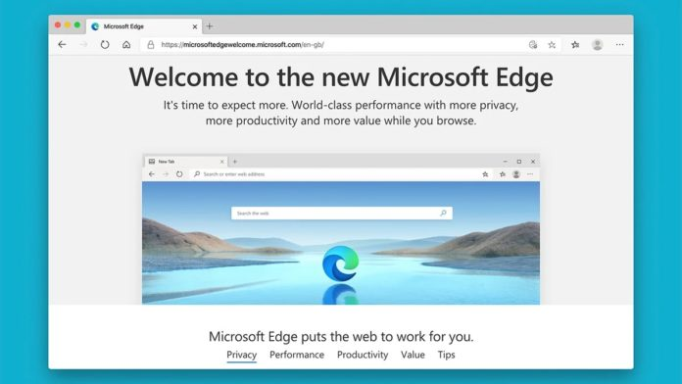
3. **Open both the Vs code and Microsoft edge side by side to check the program and execution of the file.**

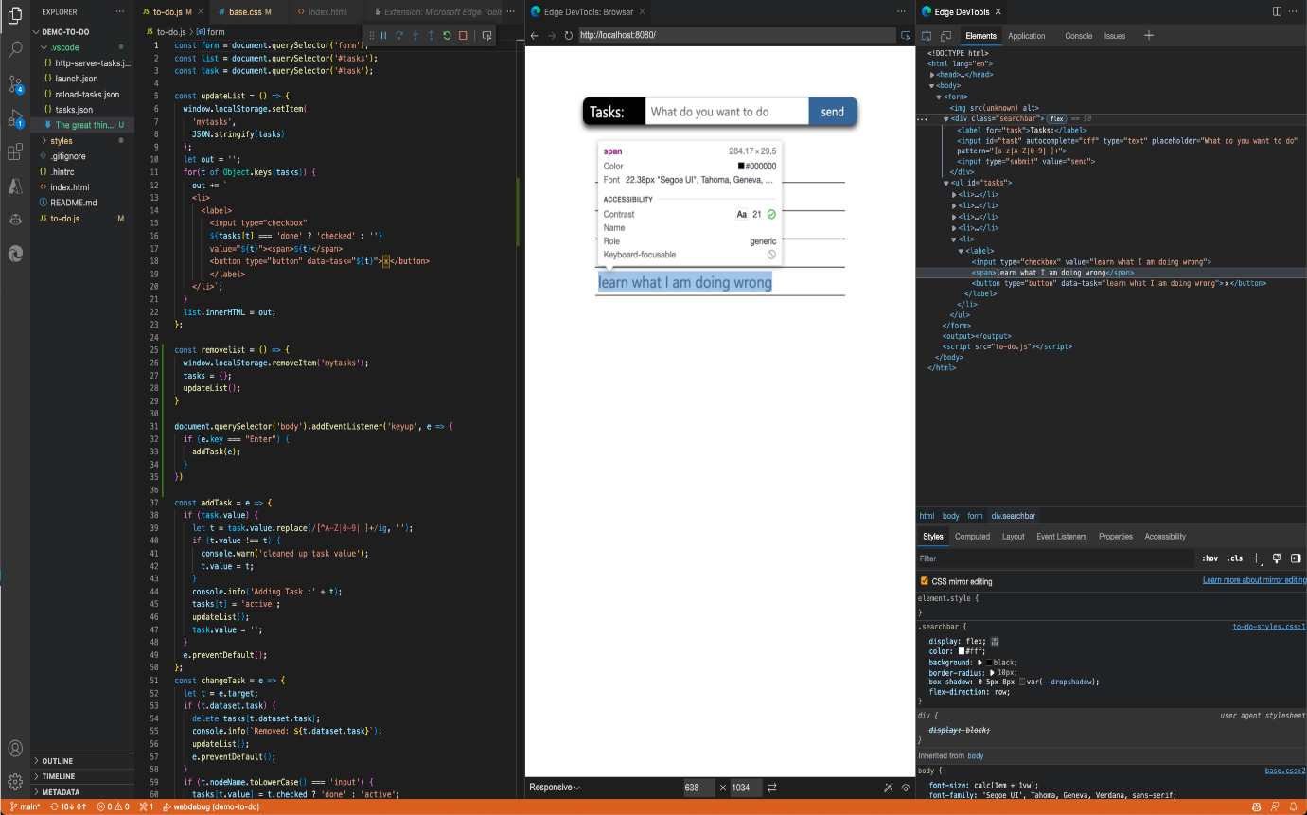

1. **Save the File using GitHub commit source to create a new repository and save it in the GitHub Document List.** 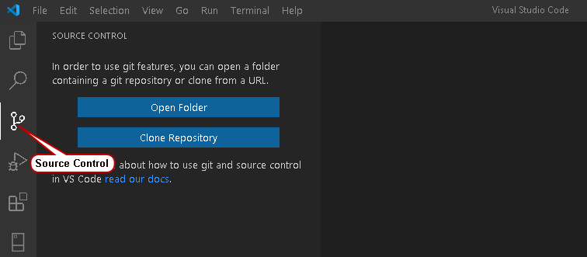

**The basic structure of the HTML document**

1. **<! DOCTYPE html> - An Html page also starts with document type declaration DOCTYPE. This is a way to tell the Browser what the document is.**
2. **<html >- Then, we have HTML tag. This HTML represents the rule of the HTML document. It is the container for other HTML elements.**
3. **<head>- the Head element contains the metadata like document title, charset, styles, links, scripts, etc.**
4. **<meta – the meta element is used to specify the metadata to provide the browsers and search engines with the technical information about the relevant page in this case it specifies the character coding in this HTML document is “UTF-8”>**

<meta charset="UTF-8">

<meta HTTP-equHTTPX-UA-Compatible" content="IE=edge">

<meta name="viewport" content="width=device-width, initial-scale=1.0">

**The <meta> tag defines metadata about an HTML document. Metadata is data (information) about data. <meta> tags always go inside the <head> element and are typically used to specify a character set, page description, keywords, author of the document, and viewport settings. Metadata will not be displayed on the page, but I machine parsable. Metadata is used by browsers (how to display content or reload the page), search engines (keywords), and other web services. There is a method to let web designers take control over the viewport (the user's visible area of a web page), through the <meta> tag (See "Setting The Viewport" example below).**

* **Define keywords for search engines:**

**<meta name="keywords" content="HTML, CSS, JavaScript">**

* **Define a description of your web page:**

**<meta name="description" content="Free Web tutorials for HTML and CSS">**

* **Define the author of a page:**

**<meta name="author" content="John Doe">**

* **Refresh document every 30 seconds:**

**<meta httHTTPuiv="refresh" content="30">**

* **Setting the viewport to make your website look good on all devices:**

**<meta name="viewport" content="width=device-width, initial-scale=1.0">**

**Link:- Links are very important — they are what makes the web a web! To add a link, we need to use a simple element —**[**<a>**](https://developer.mozilla.org/en-US/docs/Web/HTML/Element/a)**— "a" being the short form for "anchor". To make text within your paragraph into a link, follow these steps:**

1. Choose some text. We chose the text "Mozilla Manifesto".
2. Wrap the text in an [<a>](https://developer.mozilla.org/en-US/docs/Web/HTML/Element/a) element, as shown below: **<a>Mozilla Manifesto</a>**
3. Give the [<a>](https://developer.mozilla.org/en-US/docs/Web/HTML/Element/a) element an href attribute, as shown below: **<a href="">Mozilla Manifesto</a>**
4. Fill in the value of this attribute with the web address that you want the link to:

**<a href="https://www.mozilla.org/en-US/about/manifesto/">Mozilla Manifesto</a>**

**Script: - The <script> tag is used to embed a client-side script (JavaScript). The <script> element either contains scripting statements or points to an external script file through the src attribute. Common uses for JavaScript are image manipulation, form validation, and dynamic changes in content.**

<script>  
document.getElementById("demo").innerHTML = "Hello JavaScript!";  
</script>

1. **<Title>- we defined element title, To define the title of our document. So, This title is visible in the browser tab. (Microsoft Edge). This title is visible in the browser tab. (Hello World is Visible in the Browser tab) in my first HTML page.**
2. **<body> - The body tag contains the body of the content of all the Html elements to use in the design of the web page. EX- Heading, images, paragraphs, lists, etc.**
3. **What is the Html Tag?**

**Ans: The HTML tag is the combination of the characters enclosed by the angle brackets. Each Tag has a different purpose for ex: - angle bracket <p> is the paragraph tag**

**Angle bracket <h1> is the heading tag.**

**They are two types of tags in HTML.**

1. **Pair and 2. Unpair Tag.**
2. **Some tags require closing tags because their rap some of the content for example the paragraph tag is required as the closing tag</p>. for example, the heading tags also have the closing tag wrapped around some content. These are called Pair tags. On the other hand, some tags don’t require the closing tag for example: - Image tag, breaking tag, <img/>, <br/> these are called the unpair tags.**

**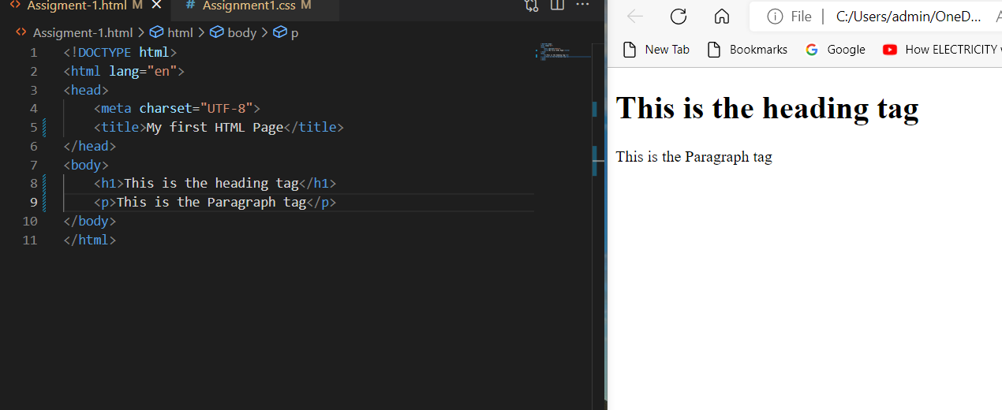**

**Tags: - HTML elements tell the browser how to display the content. HTML elements label pieces of content such as "this is a heading", "this is a paragraph", "this is a link", etc.**

**Attributes: - HTML attributes provide additional information about HTML elements. All HTML elements can have attributes Attributes provide additional information about elements Attributes are always specified at the start tag Attributes usually come in name/value pairs like name="value"**

**The <a> tag defines a hyperlink. The href attribute specifies the URL of the page the link goes to: <a href="https://www.w3schools.com">Visit W3Schools</a>**

1. **Heading:** - HTML Provides the 6 different heading tags H1 to H6. **<h1>–<h6>: The HTML Section Heading elements.**

H1>- It is the most important tag for heading and H6>- Represents the least important tag.

**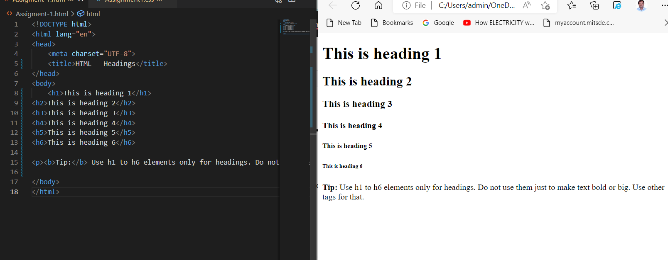**

# Paragraph: - <p>: The Paragraph element: The <p> [HTML](https://developer.mozilla.org/en-US/docs/Web/HTML) element represents a paragraph. Paragraphs are usually represented in visual media as blocks of text separated from adjacent blocks by blank lines and/or first-line indentation, but HTML paragraphs can be any structural grouping of related content, such as images or form fields.

# paragraph element including opening tag, content reading 'my cat is very grumpy', and a closing tag

# 

**The main parts of our element are as follows:**

1. **The opening tag: This consists of the name of the element (in this case, p), wrapped in opening and closing angle brackets. This states where the element begins or starts to take effect — in this case where the paragraph begins.**
2. **The closing tag: This is the same as the opening tag, except that it includes a *forward slash* before the element name. This states where the element ends — in this case where the paragraph ends. Failing to add a closing tag is one of the standard beginner errors and can lead to strange results.**
3. **The content: This is the content of the element, which in this case, is just text.**
4. **The element: The opening tag, the closing tag, and the content together comprise the element.**

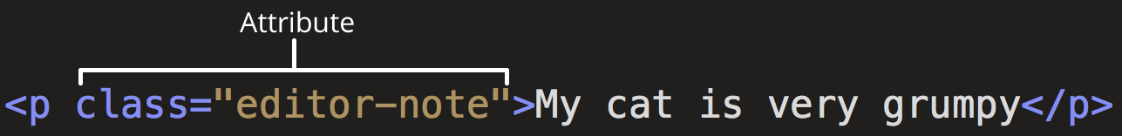

# Attributes contain extra information about the element that you don't want to appear in the actual content. Here, class is the attribute name and editor-note is the attribute value. The class attribute allows you to give the element a non-unique identifier that can be used to target it (and any other elements with the same class value) with style information and other things.

### [**Nesting elements**](https://developer.mozilla.org/en-US/docs/Learn/Getting_started_with_the_web/HTML_basics#nesting_elements)**: - You can put elements inside other elements too — this is called nesting.**

**<p>My cat is <strong>very</strong> grumpy. </p>**

### [**Empty elements**](https://developer.mozilla.org/en-US/docs/Learn/Getting_started_with_the_web/HTML_basics#empty_elements)**: - Some elements have no content and are called empty elements**.

**<img src="images/firefox-icon.png" alt="My test image">**

# Image: - <img>: The Image Embed element. The above example shows usage of the <img> element: 1. The src attribute is required, and contains the path to the image you want to embed. 2. The alt attribute holds a text description of the image, which isn't mandatory but is incredibly useful for accessibility — screen readers read this description out to their users so they know what the image means. Alt text is also displayed on the page if the image can't be loaded for some reason: for example, network errors, content blocking, or linkrot.

# 

1. **Lists: -** **Some tags require closing tags because their rap some of the content for example the paragraph tag is required as the closing tag</p>. for example, the heading tags also have the closing tag wrapped around some content. These are called Pair tags. On the other hand, some tags don’t require the closing tag for example: - Image tag, breaking tag, <img/>, <br/> these are called the unpair tags.**

**An unordered list starts with the <ul> tag. Each list item starts with the <li> tag. The list items will be marked with bullets (small black circles) by default. List style**

**An ordered list starts with the <ol> tag. Each list item starts with the <li> tag. The list items will be marked with numbers by default. Alphabet, Nurmerial…**

**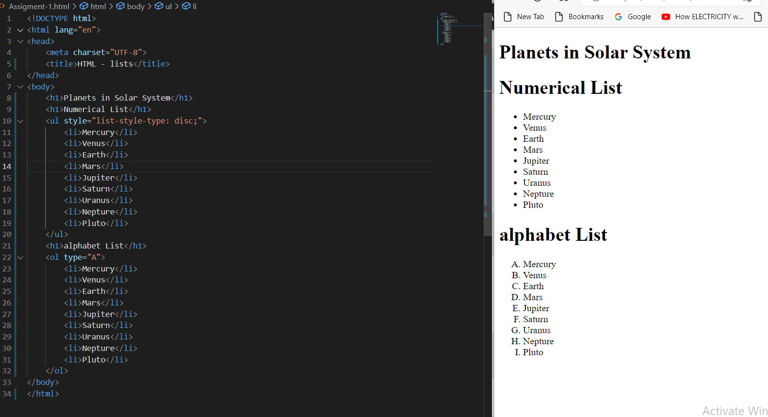**

## **Links: Links are very important — they are what makes the web a web! To add a link, we need to use a simple element —**[**<a>**](https://developer.mozilla.org/en-US/docs/Web/HTML/Element/a)**— "a" being the short form for "anchor". To make text within your paragraph into a link, follow these steps:**

1. Choose some text. We chose the text "Mozilla Manifesto".
2. Wrap the text in an [<a>](https://developer.mozilla.org/en-US/docs/Web/HTML/Element/a) element, as shown below: **<a>Mozilla Manifesto</a>**
3. Give the [<a>](https://developer.mozilla.org/en-US/docs/Web/HTML/Element/a) element an href attribute, as shown below: **<a href="">Mozilla Manifesto</a>**
4. Fill in the value of this attribute with the web address that you want the link to:

**<a href="https://www.mozilla.org/en-US/about/manifesto/">Mozilla Manifesto</a>**

**Day: - 2**

**Topics: - 1. Basic Styling: - 1.HTML <style> Tag. The <style> tag is used to define style information (CSS) for a document. Inside the <style> element you specify how HTML elements should render in a browser.**

# TEXT FORMATTING

This text is styled with some of the text formatting properties. The heading uses text-align, text-transform, and color properties. The paragraph is indented, aligned, and the space between characters is specified. The underline is removed from this colored ["Try it Yourself"](https://www.w3schools.com/css/tryit.asp?filename=trycss_text) link.

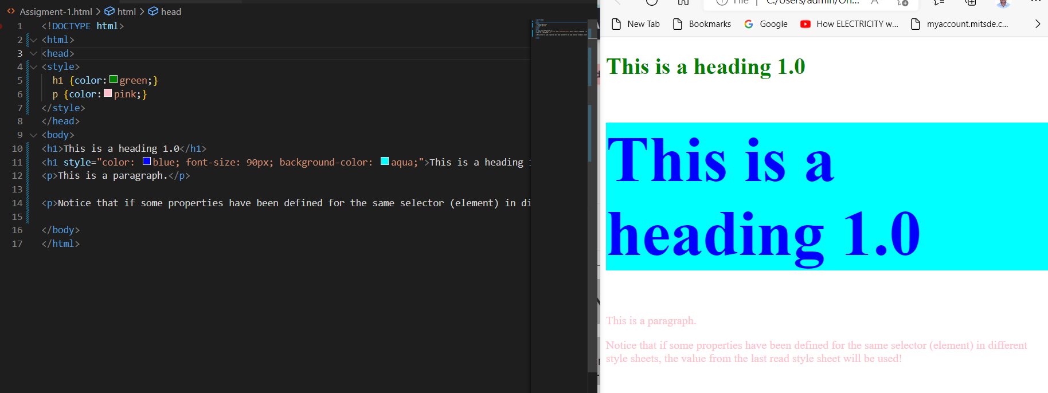

**2.HTML <div> Tag: - The <div> tag defines a division or a section in an HTML document. The <div> tag is used as a container for HTML elements - which are then styled with CSS or manipulated with JavaScript. The <div> tag is easily styled by using the class or id attribute. Any sort of content can be put inside the <div> tag!**

**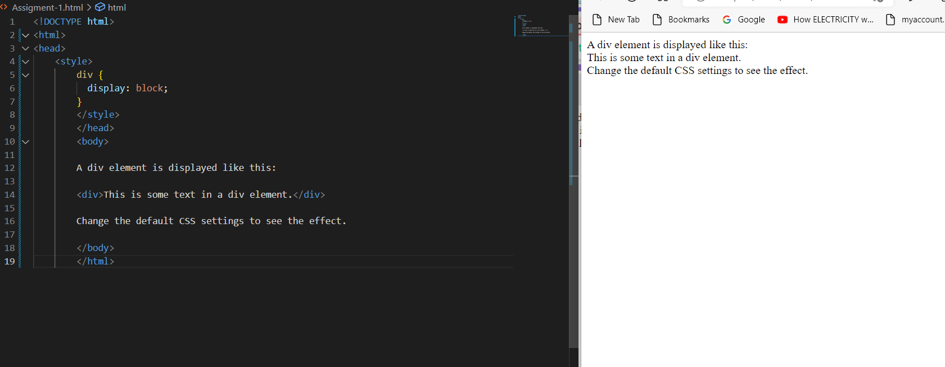**

**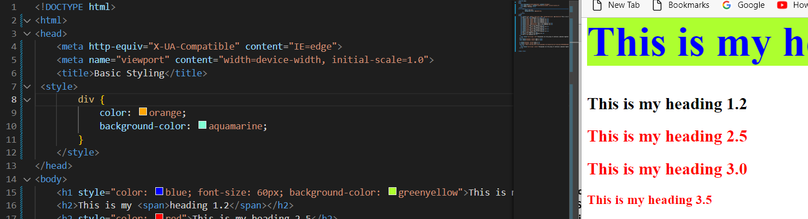**

**2.HTML <span> Tag: - The <span> tag is an inline container used to mark up a part of a text, or a part of a document. The <span> tag is easily styled by CSS or manipulated with JavaScript using the class or id attribute. The <span> tag is much like the**[**<div>**](https://www.w3schools.com/tags/tag_div.asp)**element, but <div> is a block-level element and <span> is an inline element.**

## **Font Size: - The font-size property sets the size of the text. Being able to manage the text size is important in web design. However, you should not use font size adjustments to make paragraphs look like headings, or headings look like paragraphs. Always use the proper HTML tags, like <h1> - <h6> for headings and <p> for paragraphs. The font-size value can be an absolute, or relative size. Absolute size:**

* **Sets the text to a specified size**
* **Does not allow a user to change the text size in all browsers (bad for accessibility reasons)**
* **Absolute size is useful when the physical size of the output is known**

**Relative size:**

* **Sets the size relative to surrounding elements**
* **Allows a user to change the text size in browsers**

**Font Color: - The Color is an attribute of the <font> tag, which specifies the text color.** <font color="Color\_name|rgb\_number|hex\_number">

<font Color="Blue">

**Background color: -**

**The background-color**[**CSS**](https://developer.mozilla.org/en-US/docs/Web/CSS)**property sets the background color of an element. background-color: brown; /\* Keyword values \*/**

**background-color: red;**

**background-color: indigo;**

**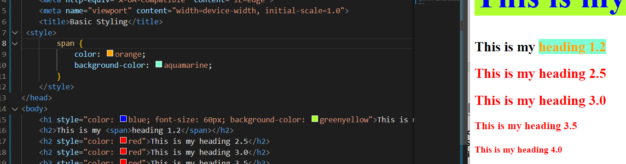**

**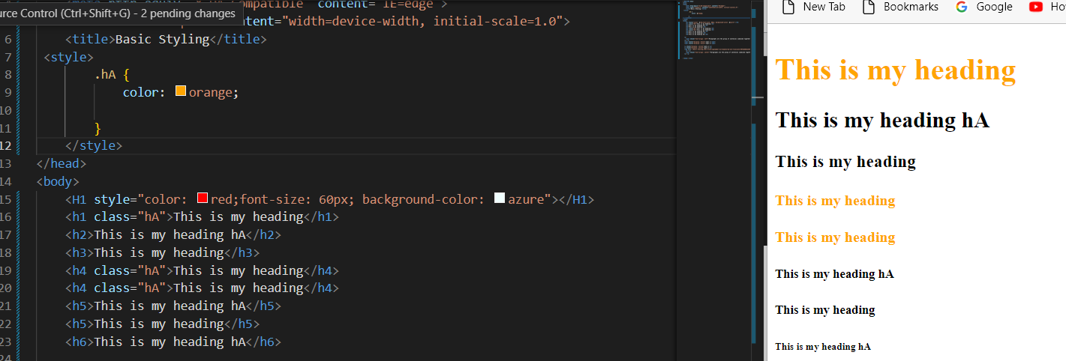**

**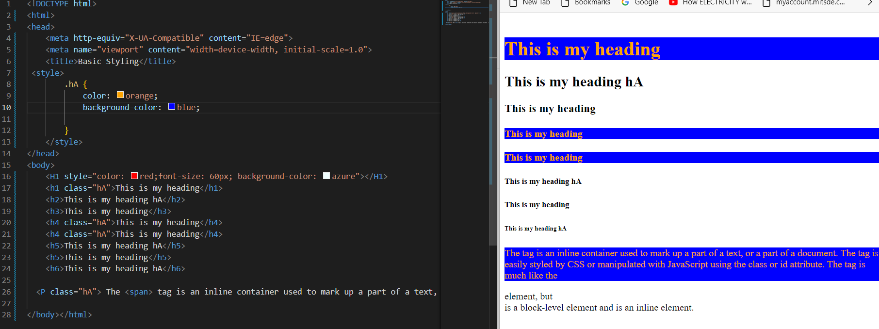**

**2. Basic Styling: - HTML Class Attribute: - The class attribute specifies one or more class names for an element. The class attribute is mostly used to point to a class in a style sheet. However, it can also be used by JavaScript (via the HTML DOM) to make changes to HTML elements with a specified class.**

**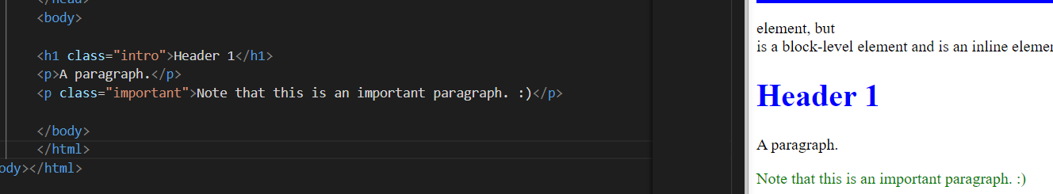**

**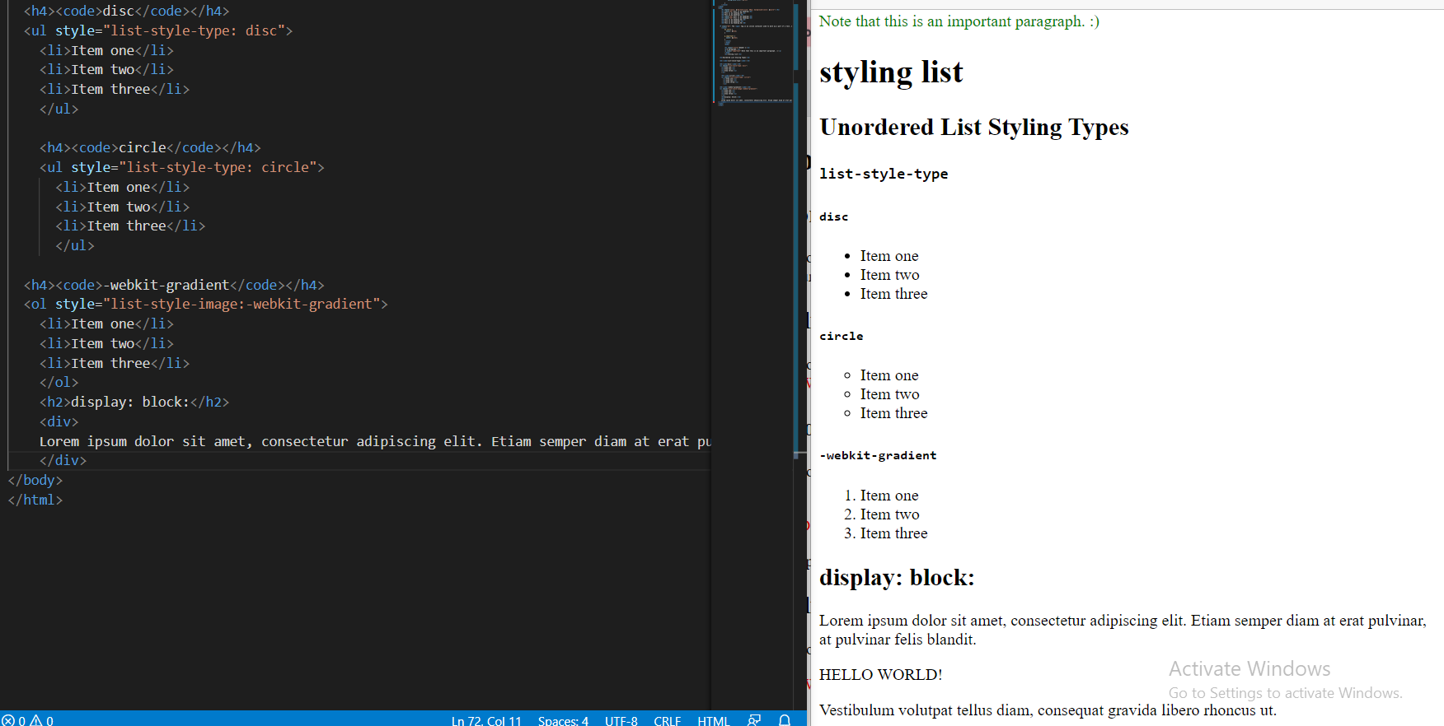**

**“style” tag inside = “Property”**

**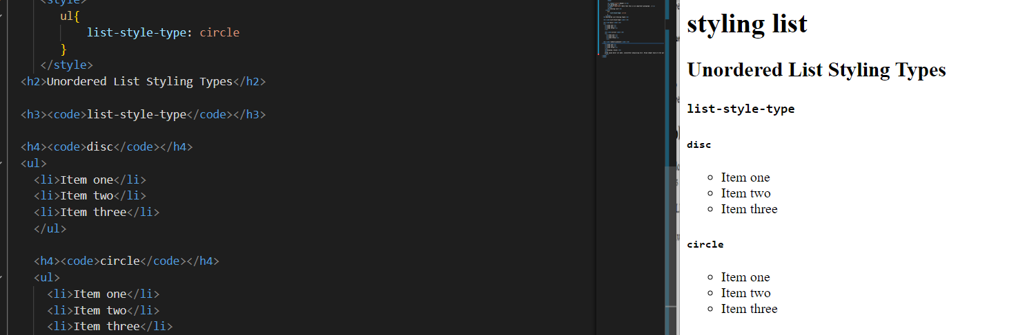**

**We have removed all the style= list-style-type: circle, square. And placed in**

**ul { list-style-type: circle; } --- changed into disc all it will changed into disc.**

**list-style-image: “url”=**

**Quest: - how do display icons in front of the list? Answer: - icon in the unordered list with the list-style image with the URL icon image will be displayed.**

**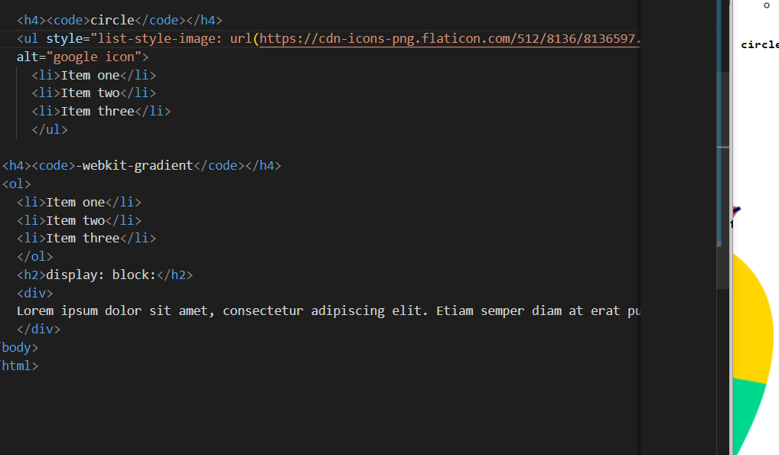**

1. **Display Types – 1. Block Element:**

**The display**[**CSS**](https://developer.mozilla.org/en-US/docs/Web/CSS)**property sets whether an element is treated as a**[**block or inline element**](https://developer.mozilla.org/en-US/docs/Web/CSS/CSS_Flow_Layout)**and the layout used for its children, such as**[**flow layout**](https://developer.mozilla.org/en-US/docs/Web/CSS/CSS_Flow_Layout)**,**[**grid**](https://developer.mozilla.org/en-US/docs/Web/CSS/CSS_Grid_Layout)**, or**[**flex**](https://developer.mozilla.org/en-US/docs/Web/CSS/CSS_Flexible_Box_Layout)**. The element generates a block element box, generating line breaks both before and after the element when in the normal flow.**

**HTML Display Block is one of the most important position properties in HTML, which is responsible for placing block-level elements into the display block. While designing a webpage, it is always important to arrange elements properly in a specific position. Setting a proper position for the layout is one of the most important tasks. By default, it took the display property as inline. This will always start with a new line and stretch elements from left to right to occupy full-width space. One can set height and width properties to the block-level elements, and it is possible to include other inline or block elements within it.**

Here are the block-level elements in HTML:

[**<address>**](https://www.w3schools.com/tags/tag_address.asp)[**<article>**](https://www.w3schools.com/tags/tag_article.asp)[**<aside>**](https://www.w3schools.com/tags/tag_aside.asp)[**<blockquote>**](https://www.w3schools.com/tags/tag_blockquote.asp)[**<canvas>**](https://www.w3schools.com/tags/tag_canvas.asp)[**<dd>**](https://www.w3schools.com/tags/tag_dd.asp)[**<div>**](https://www.w3schools.com/tags/tag_div.asp)[**<dl>**](https://www.w3schools.com/tags/tag_dl.asp)[**<dt>**](https://www.w3schools.com/tags/tag_dt.asp)[**<fieldset>**](https://www.w3schools.com/tags/tag_fieldset.asp)[**<figcaption>**](https://www.w3schools.com/tags/tag_figcaption.asp)[**<figure>**](https://www.w3schools.com/tags/tag_figure.asp)[**<footer>**](https://www.w3schools.com/tags/tag_footer.asp)[**<form>**](https://www.w3schools.com/tags/tag_form.asp)[**<h1>-<h6>**](https://www.w3schools.com/tags/tag_hn.asp)[**<header>**](https://www.w3schools.com/tags/tag_header.asp)[**<hr>**](https://www.w3schools.com/tags/tag_hr.asp)[**<li>**](https://www.w3schools.com/tags/tag_li.asp)[**<main>**](https://www.w3schools.com/tags/tag_main.asp)[**<nav>**](https://www.w3schools.com/tags/tag_nav.asp)[**<noscript>**](https://www.w3schools.com/tags/tag_noscript.asp)[**<ol>**](https://www.w3schools.com/tags/tag_ol.asp)[**<p>**](https://www.w3schools.com/tags/tag_p.asp)[**<pre>**](https://www.w3schools.com/tags/tag_pre.asp)[**<section>**](https://www.w3schools.com/tags/tag_section.asp)[**<table>**](https://www.w3schools.com/tags/tag_table.asp)[**<tfoot>**](https://www.w3schools.com/tags/tag_tfoot.asp)[**<ul>**](https://www.w3schools.com/tags/tag_ul.asp)[**<video>**](https://www.w3schools.com/tags/tag_video.asp)

**display: block;**

**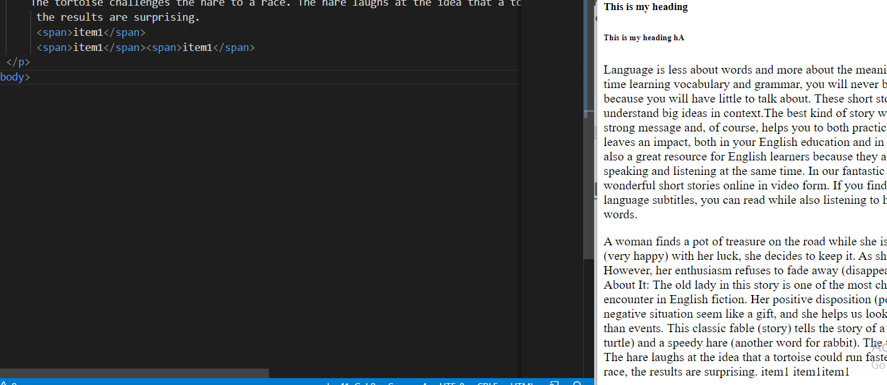**

**3.1Display Types – 1. In-line Element: The element generates one or more inline element boxes that do not generate line breaks before or after themselves. In normal flow, the next element will be on the same line if there is space. Span is an inline element; we have to use a display property called display: Inline; inline-block: The element generates a block element box that will be flowed with surrounding content as if it were a single inline box (behaving much like a replaced element would).**

**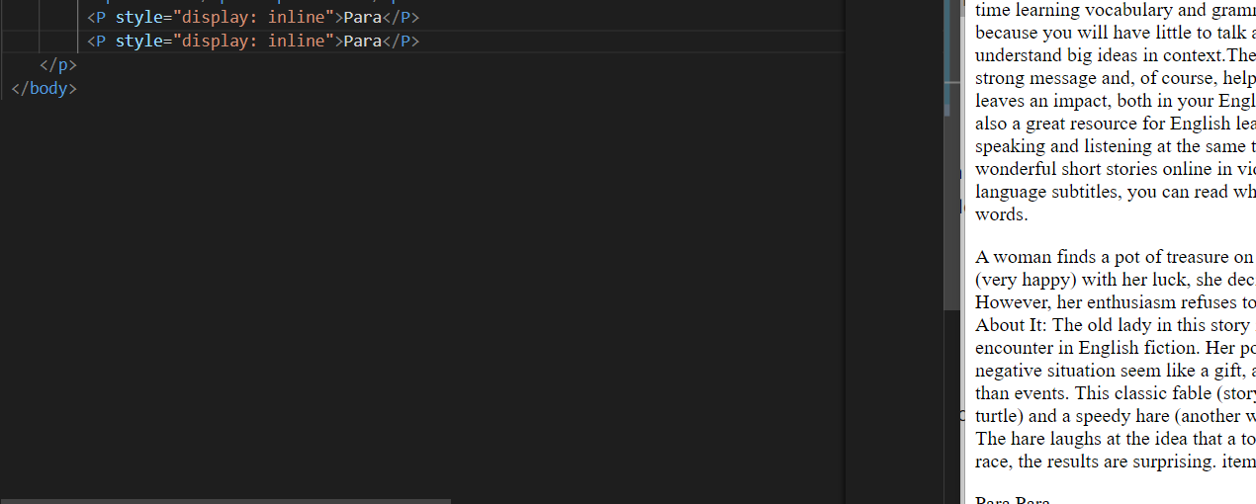Para Para.**

Here are the inline elements in HTML:

[**<a>**](https://www.w3schools.com/tags/tag_a.asp)[**<abbr>**](https://www.w3schools.com/tags/tag_abbr.asp)[**<acronym>**](https://www.w3schools.com/tags/tag_acronym.asp)[**<b>**](https://www.w3schools.com/tags/tag_b.asp)[**<bdo>**](https://www.w3schools.com/tags/tag_bdo.asp)

[**<big>**](https://www.w3schools.com/tags/tag_big.asp)[**<br>**](https://www.w3schools.com/tags/tag_br.asp)[**<button>**](https://www.w3schools.com/tags/tag_button.asp)[**<cite>**](https://www.w3schools.com/tags/tag_cite.asp)[**<code>**](https://www.w3schools.com/tags/tag_code.asp)[**<dfn>**](https://www.w3schools.com/tags/tag_dfn.asp)[**<em>**](https://www.w3schools.com/tags/tag_em.asp)[**<i>**](https://www.w3schools.com/tags/tag_i.asp)[**<img>**](https://www.w3schools.com/tags/tag_img.asp)[**<input>**](https://www.w3schools.com/tags/tag_input.asp)[**<kbd>**](https://www.w3schools.com/tags/tag_kbd.asp)[**<label>**](https://www.w3schools.com/tags/tag_label.asp)[**<map>**](https://www.w3schools.com/tags/tag_map.asp)

[**<object>**](https://www.w3schools.com/tags/tag_object.asp)[**<output>**](https://www.w3schools.com/tags/tag_output.asp)[**<q>**](https://www.w3schools.com/tags/tag_q.asp)[**<samp>**](https://www.w3schools.com/tags/tag_samp.asp)[**<script>**](https://www.w3schools.com/tags/tag_script.asp)[**<select>**](https://www.w3schools.com/tags/tag_select.asp)[**<small>**](https://www.w3schools.com/tags/tag_small.asp)[**<span>**](https://www.w3schools.com/tags/tag_span.asp)[**<strong>**](https://www.w3schools.com/tags/tag_strong.asp)[**<sub>**](https://www.w3schools.com/tags/tag_sub.asp)[**<sup>**](https://www.w3schools.com/tags/tag_sup.asp)[**<textarea>**](https://www.w3schools.com/tags/tag_textarea.asp)[**<time>**](https://www.w3schools.com/tags/tag_time.asp)[**<tt>**](https://www.w3schools.com/tags/tag_tt.asp)[**<var>**](https://www.w3schools.com/tags/tag_var.asp)

**Adding Hyperlinks: - Links are found on nearly all web pages. Links allow users to click their way from page to page. HTML links are hyperlinks. You can click on a link and jump to another document. When you move the mouse over a link, the mouse arrow will turn into a little hand.**

## **HTML Links – Syntax The HTML <a> tag defines a hyperlink. It has the following syntax: <a href="*url*">*link text*</a>**

**EX: - <a href="https://www.w3schools.com/">Visit W3Schools.com! </a>**

**The image is inside the anchor tag, so an a-anchor tag means href copy from the browser and paste inside the href links for the website.**

**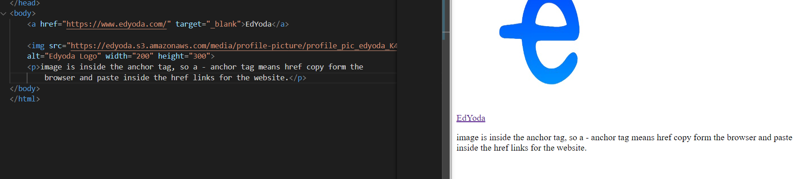**

**Day: - 3**

**Topics: - 1. Basic HTML: - HYPERLINKS: - Links are found on nearly all web pages. Links allow users to click their way from page to page. HTML links are hyperlinks. You can click on a link and jump to another document. When you move the mouse over a link, the mouse arrow will turn into a little hand.**

**HTML <a> Tag. The <a> tag (anchor tag) in HTML is used to create a hyperlink on the webpage. This hyperlink is used to link the webpage to other web pages or some section of the same web page. It's either used to provide an absolute reference or a relative reference as its “href” value.**

**<a href="https://www.w3schools.com">Visit W3Schools.com!</a>**

**If the <a> tag has no href attribute, it is only a placeholder for a hyperlink.**

[**href**](https://developer.mozilla.org/en-US/docs/Web/HTML/Element/a#attr-href)**: -The URL that the hyperlink points to. Links are not restricted to HTTP-based URLs — they can use any URL scheme supported by browsers:**

* **Sections of a page with fragment URLs**
* **Pieces of media files with media fragments**
* **Telephone numbers with tel: URLs**
* **Email addresses with mailto: URLs**
* **While web browsers may not support other URL schemes, websites can with [registerProtocolHandler()](https://developer.mozilla.org/en-US/docs/Web/API/Navigator/registerProtocolHandler)**

## **HTML Links – Syntax The HTML <a> tag defines a hyperlink. It has the following syntax: <a href="*url*">*link text*</a>**

**EX: - <a href="https://www.w3schools.com/">Visit W3Schools.com! </a>**

**The image is inside the anchor tag, so an a-anchor tag means href copy from the browser and paste inside the href links for the website.**

## **HTML Links - The target Attribute: -**By default, the linked page will be displayed in the current browser window. To change this, you must specify another target for the link. The target attribute specifies where to open the linked document. The target attribute can have one of the following values:

* \_self - Default. Opens the document in the same window/tab as it was clicked
* \_blank - Opens the document in a new window or tab
* \_parent - Opens the document in the parent frame
* \_top - Opens the document in the full body of the window ex: - <a href="https://www.w3schools.com/" target="\_blank">Visit W3Schools! </a>

By default, links will appear as follows in all browsers: An unvisited link is underlined and blue A visited link is underlined and purple An active link is underlined and red **Tip:** Links can, of course, be styled with CSS, to get another look!

**Navigation Tab in Html: - The <nav> tag defines a set of navigation links.**

**Notice that NOT all links of a document should be inside an <nav> element. The <nav> element is intended only for a mablockslock of navigation links.**

**Browsers, such as screen readers for disabled users, can use this element to determine whether to omit the initial rendering of this content.**

**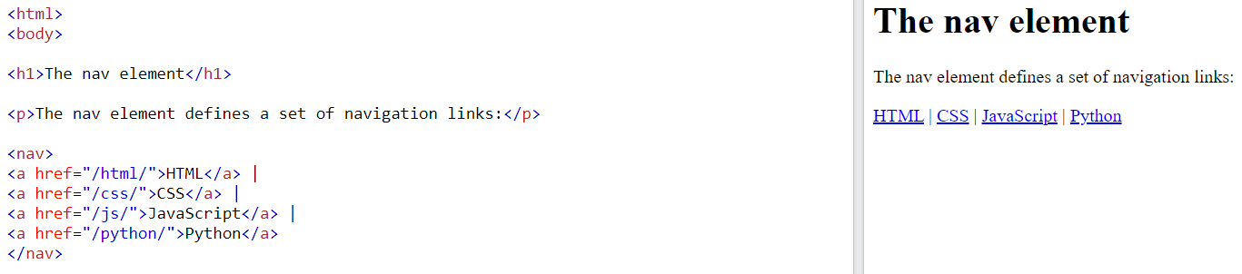**

**It will explain the top bar, bottom bar, and navigation bar**

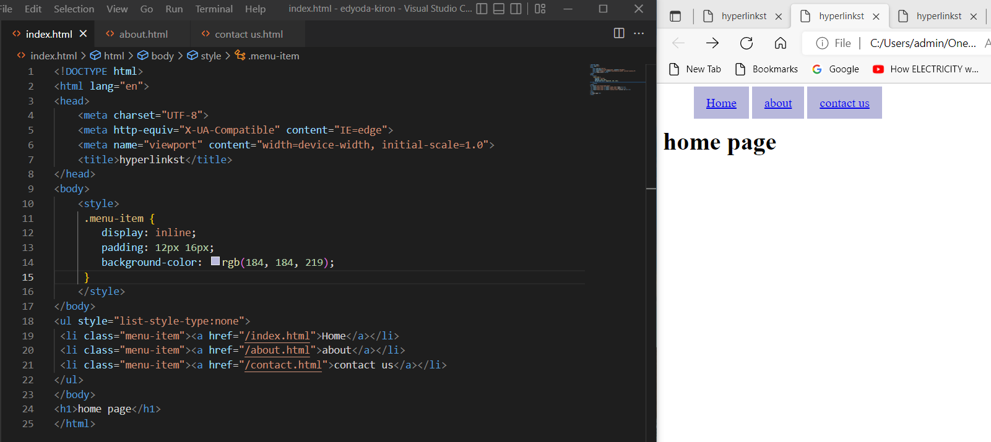

**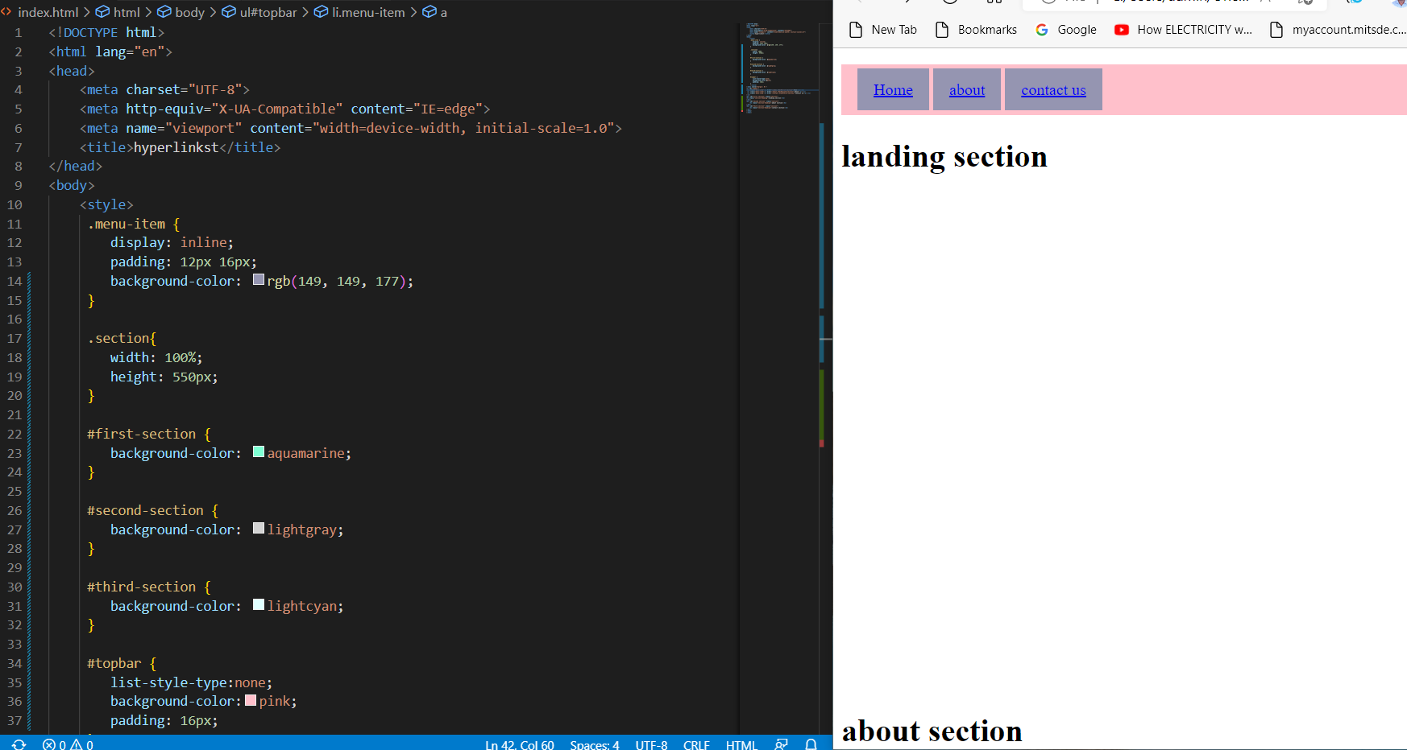**

**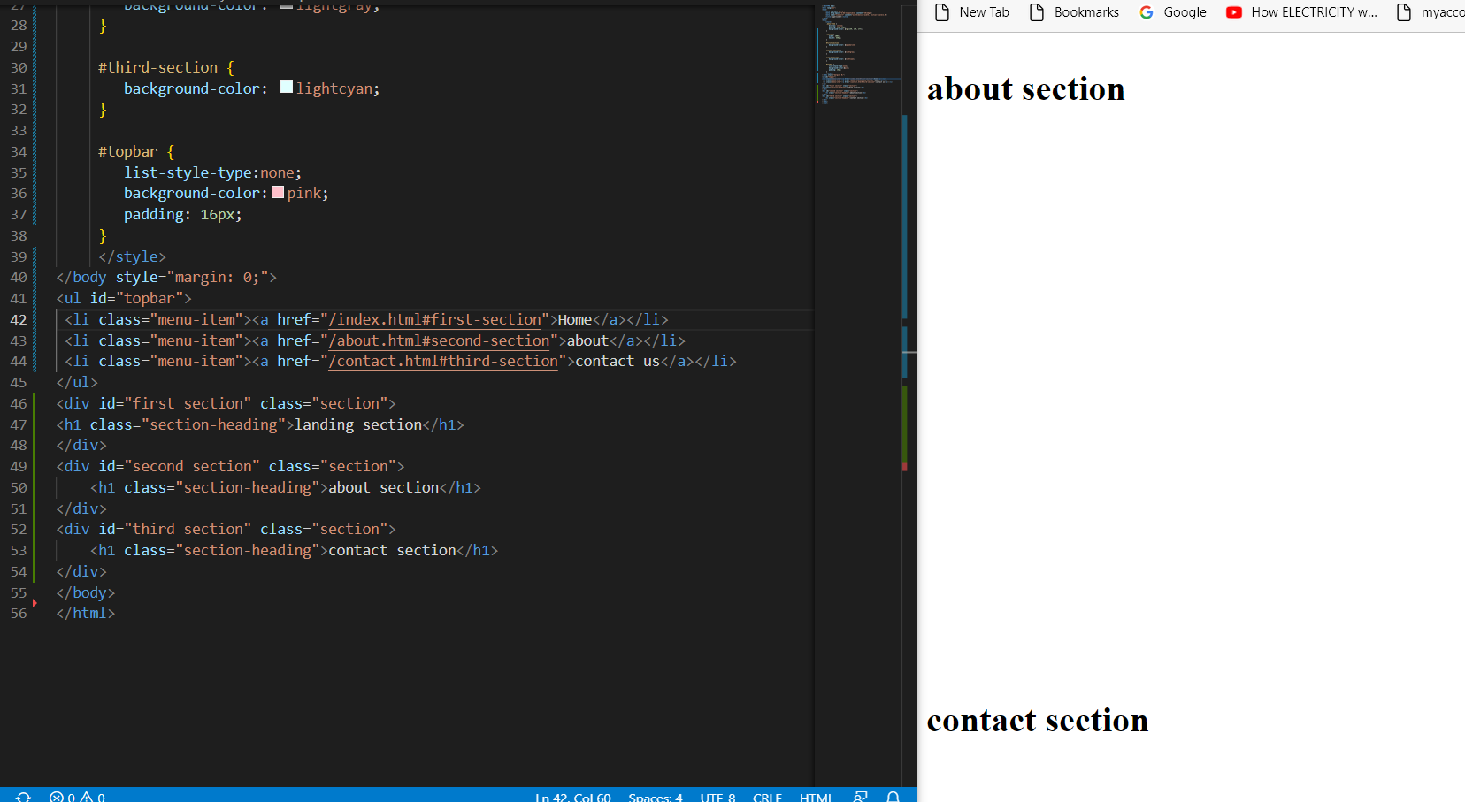**

**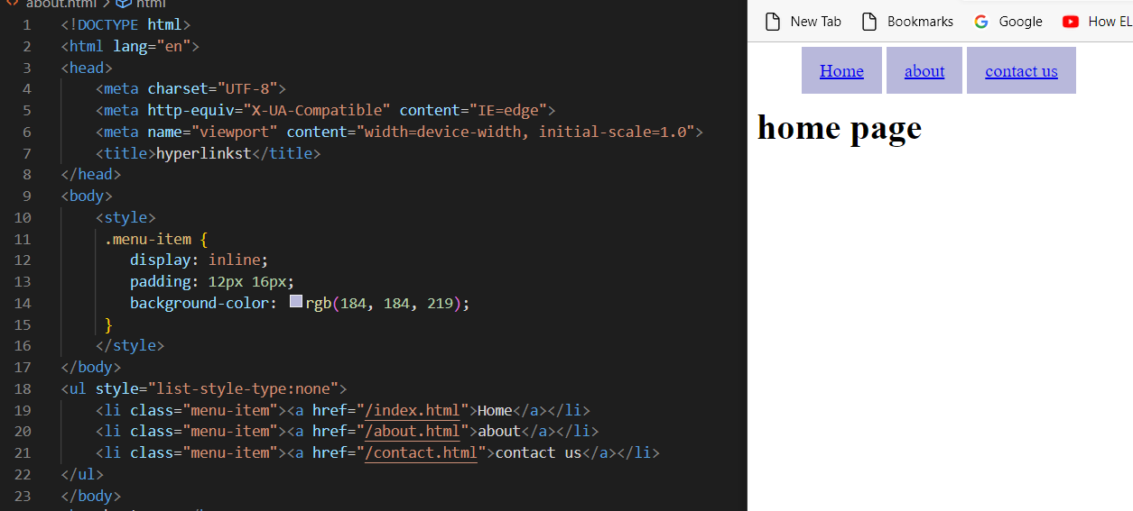**

# 

**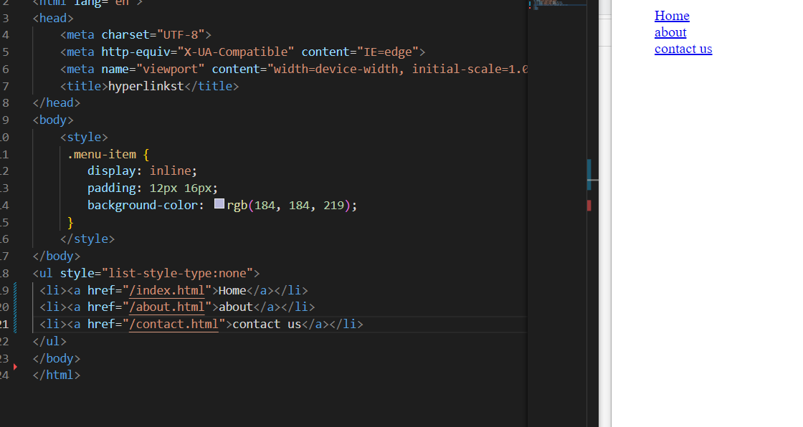**

**2. Connecting Webpages using links/ Tab nabbing: - is a computer**[**exploit**](https://en.wikipedia.org/wiki/Exploit_(computer_security))**and**[**phishing**](https://en.wikipedia.org/wiki/Phishing)**attack, which persuades users to submit their**[**login**](https://en.wikipedia.org/wiki/Login)**details and**[**passwords**](https://en.wikipedia.org/wiki/Password)**to popular**[**websites**](https://en.wikipedia.org/wiki/Website)**by impersonating those sites and convincing the user that the site is genuine. The attack's name was coined in early 2010 by**[**Aza Raskin**](https://en.wikipedia.org/wiki/Aza_Raskin)**, a security researcher, and design expert. The attack takes advantage of user trust and inattention to detail regarding tabs, and the ability of browsers to navigate across a**[**page's origin**](https://en.wikipedia.org/wiki/Same-origin_policy)**in inactive tabs a long time after the page is loaded. Tabnabbing is different from most phishing attacks in that the user no longer remembers that a certain tab was the result of a link unrelated to the login page because the fake login page is loaded in one of the long-lived open tabs in their browser.**

**The attack causes the browser to navigate to the impersonated page after the page has been left unattended for some time. A user who returns after a while and sees the login page may be induced to believe the page is legitimate and enter their login, password, and other details that will be used for improper purposes. The attack can be made more likely to succeed if the attacker can check for well-known websites the user has loaded in the past or other tabs and loads a simulation of the same sites. This attack can be done even if**[**JavaScript**](https://en.wikipedia.org/wiki/JavaScript)**is disabled, using the "**[**meta refresh**](https://en.wikipedia.org/wiki/Meta_refresh)**"**[**meta element**](https://en.wikipedia.org/wiki/Meta_element)**, an**[**HTML attribute**](https://en.wikipedia.org/wiki/HTML_attribute)**used for page redirection that causes a reload of a specified new page after a given time interval.**

**The [NoScript](https://en.wikipedia.org/wiki/NoScript" \o "NoScript) extension for**[**Mozilla**](https://en.wikipedia.org/wiki/Mozilla)[**Firefox**](https://en.wikipedia.org/wiki/Firefox)**defends both the JavaScript-based and the scriptless attack, based on meta refresh, by preventing inactive tabs from changing the location of the page. Because there are legitimate purposes for inactive tab redirects, it cannot be disabled in all browsers by default without breaking some applications. The attack is also not very common, giving browser vendors little incentive to implement a breaking change.**

**"It can detect that you're logged into**[**Citibank**](https://en.wikipedia.org/wiki/Citibank)**right now and Citibank has been training you to log into your account every 15 minutes because it logs you out for better security. It's like being hit by the wrong end of the sword", said**[**Aza Raskin**](https://en.wikipedia.org/wiki/Aza_Raskin)**.**

## **Overview: - With backlink Link between parent and child pages when prevention attribute is not used:**

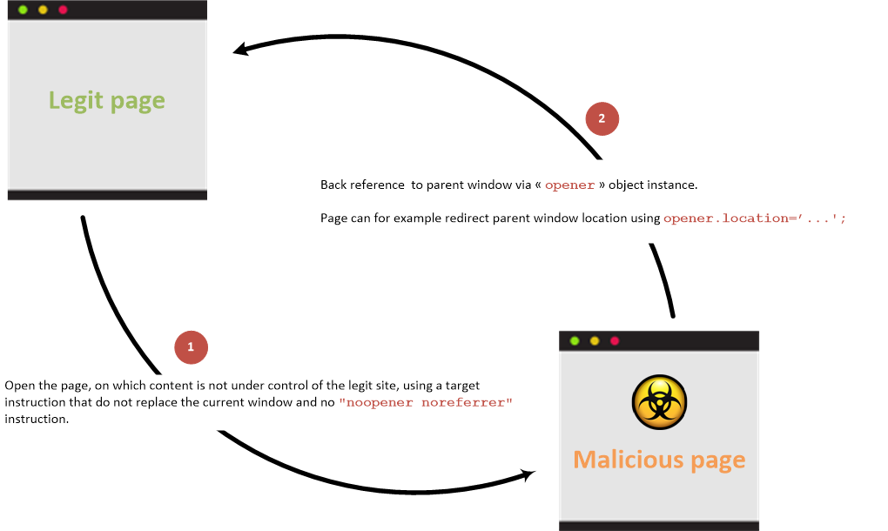

### **Without backlink: Link between parent and child pages when prevention attribute is used:**

**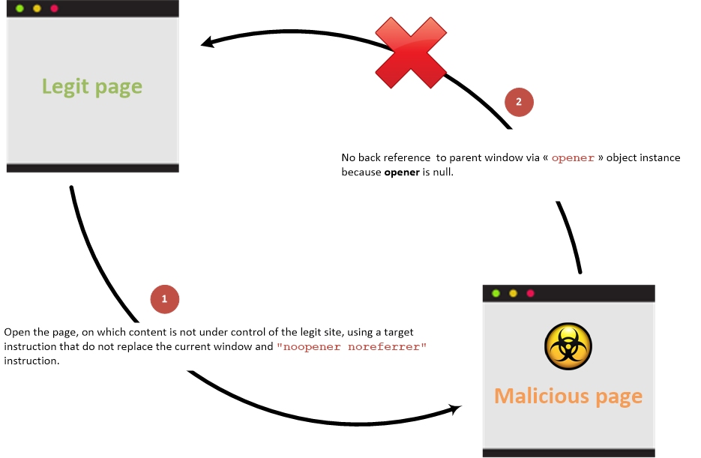**

## **Examples: - Vulnerable page:**

**<html>**

**<body>**

**<li><a href="bad.example.com" target="\_blank">Vulnerable target using HTML link to open the new page</a></li>**

**<button onclick="window.open('https://bad.example.com')">Vulnerable target using javascript to open the new page</button>**

**</body>**

**</html>**

**Malicious Site that is linked to:**

**<html>**

**<body>**

**<script>**

**if (window.opener) {**

**window. opener.location = "https://phish.example.com";**

**}**

**</script>**

**</body>**

**</html>**

**When a user clicks on the Vulnerable Target link/button then the Malicious Site is opened in a new tab (as expected) but the target site in the original tab is replaced by the phishing site. HTML target Attribute: -For <a> and <area> elements, the target attribute specifies where to open the linked document.For <base> elements, the target attribute specifies the default target for all hyperlinks and forms on the page. For <form> elements, the target attribute specifies a name or a keyword that indicates where to display the response that is received after submitting the form.**

# 

**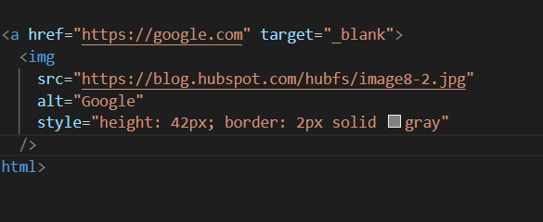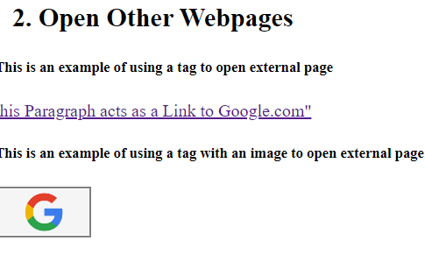**

**If I Have put IMG in the next of the Google link. It will take the Link for IMG, not for Google. Users will be confused about the link. We have to be careful about the link.**

**IMG – The user will be confused about the link. We have to be careful about the link.**

**The image should be inside the anchor tag< a href…**

**< a href =” google” target=” \_blank”>**

**<img src, alt, style />**

# <section>: The Generic Section element: - The <section> [HTML](https://developer.mozilla.org/en-US/docs/Web/HTML) element represents a generic standalone section of a document, which doesn't have a more specific semantic element to represent it. Sections should always have a heading, with very few exceptions.

## [Examples](https://developer.mozilla.org/en-US/docs/Web/HTML/Element/section#examples)

### [Simple usage example](https://developer.mozilla.org/en-US/docs/Web/HTML/Element/section#simple_usage_example)

#### Before: -

<div>

<h2>Heading</h2>

<p>Bunch of awesome content</p>

</div>

Copy to Clipboard

#### After: -

<section>

<h2>Heading</h2>

<p>Bunch of awesome content</p>

</section>

**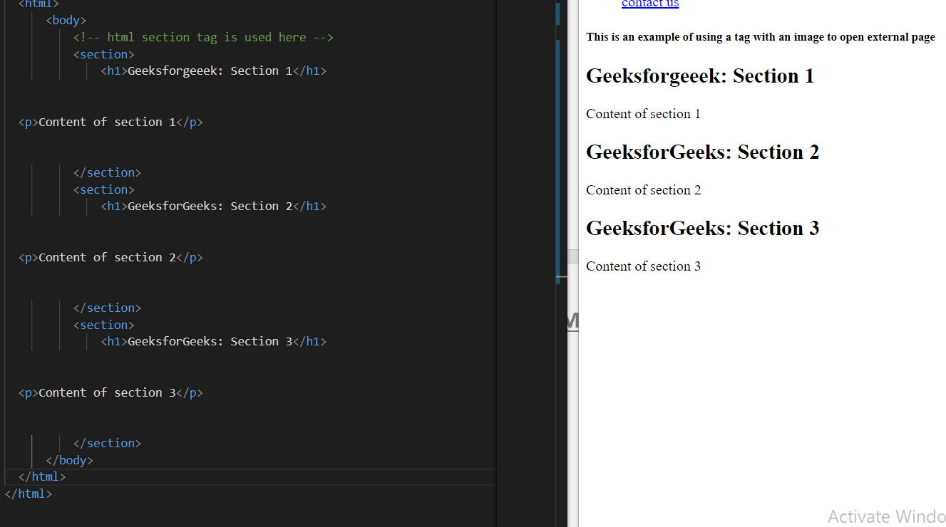**

**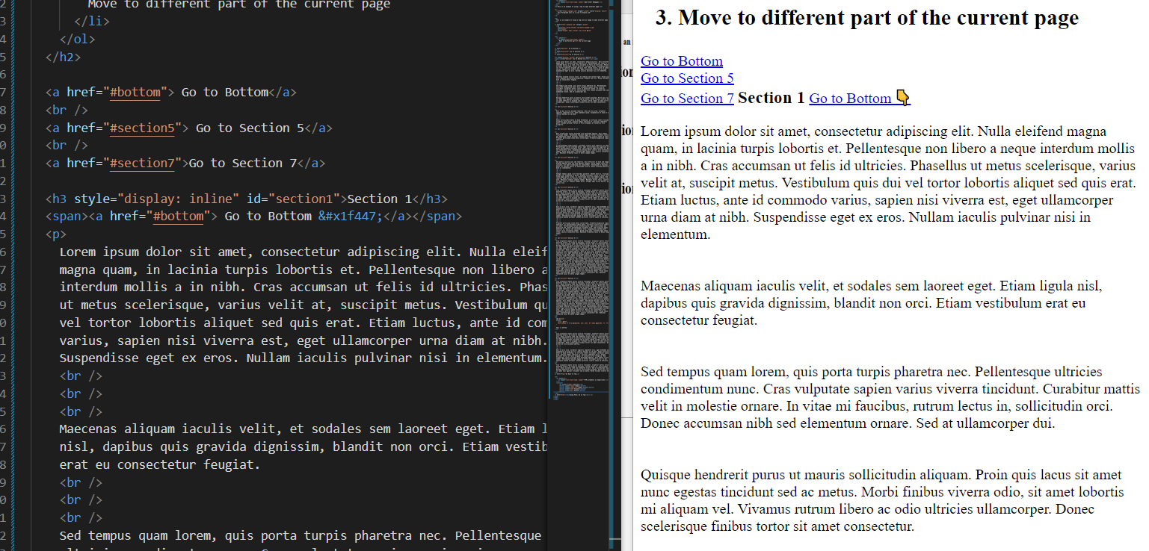**

**Interview quest: - If you have these 2 navigation IDs in the HTML solve this issue.**

**Ans: - it will go to #top id. In the header area.id=” top”.it will go to be second top id.**

# 3. IDENTIFIER ATTRIBUTES: - HTML id Attribute The HTML id attribute is used to specify a unique id for an HTML element. You cannot have more than one element with the same id in an HTML document. Using The id Attribute: - The id attribute specifies a unique id for an HTML element. The value of the id attribute must be unique within the HTML document. The id attribute is used to point to a specific style declaration in a style sheet. It is also used by JavaScript to access and manipulate the element with the specific id. The syntax for id is: write a hash characterizer (#), followed by an id name. Then, define the CSS properties within curly braces {}. In the following exam, plus we have an <h1> element that points to the id name "my Header". This <h1> element will be styled according to the #my Header style definition in the head section:

**4. Link Bookmarking in HTML hyperlinks: - To create a bookmark link in HTML, you need to create a bookmark using the <a> tag name attribute. Now, add a link to the bookmark. Bookmarks are also known as named anchors. This is quite useful to take readers to a specific section of the web page.**

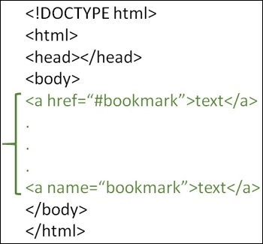

**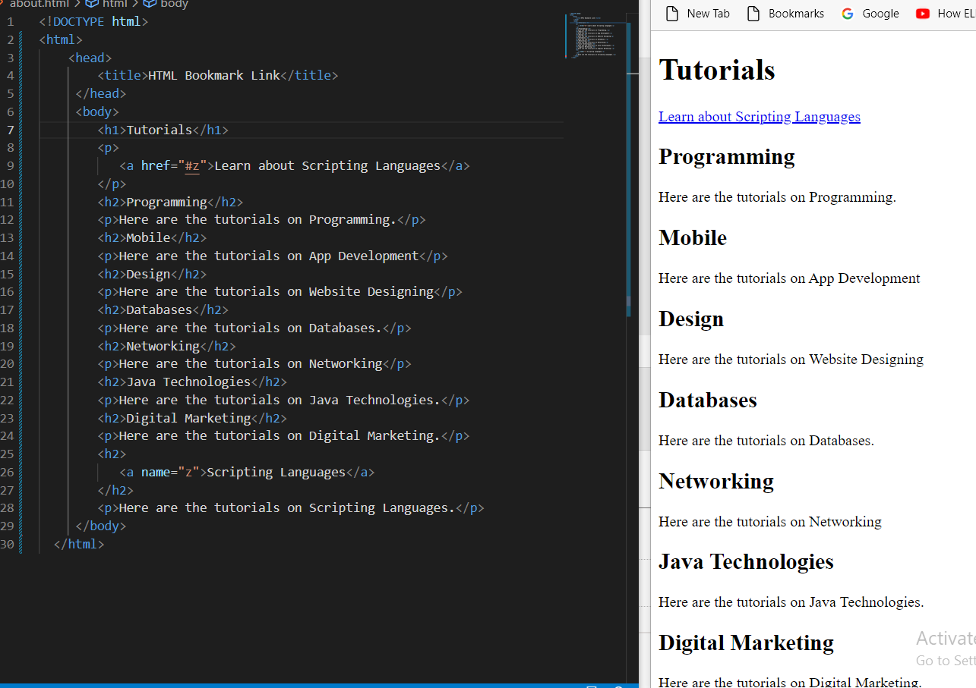**

**Day: - 4**

**Topics: - 1. Introduction to Tables: -**

# <table>: The Table element

**The <table>**[**HTML**](https://developer.mozilla.org/en-US/docs/Web/HTML)**element represents tabular data — that is, the information presented in a two-dimensional table comprised of rows and columns of cells containing data.** [**Attributes**](https://developer.mozilla.org/en-US/docs/Web/HTML/Element/table#attributes)**: - This element includes the**[**global attributes**](https://developer.mozilla.org/en-US/docs/Web/HTML/Global_attributes)**.** [**Deprecated attributes**](https://developer.mozilla.org/en-US/docs/Web/HTML/Element/table#deprecated_attributes)[**align**](https://developer.mozilla.org/en-US/docs/Web/HTML/Element/table#attr-align)**Deprecated This enumerated attribute indicates how the table must be aligned inside the containing document. It may have the following values: left: the table is displayed on the left side of the document; center: the table is displayed in the center of the document; right: the table is displayed on the right side of the document. Set**[**margin-left**](https://developer.mozilla.org/en-US/docs/Web/CSS/margin-left)**and**[**margin-right**](https://developer.mozilla.org/en-US/docs/Web/CSS/margin-right)**to auto or**[**margin**](https://developer.mozilla.org/en-US/docs/Web/CSS/margin)**to 0 auto to achieve an effect that is similar to the align attribute.** [**bg**](https://developer.mozilla.org/en-US/docs/Web/HTML/Element/table#attr-bgcolor) **color Deprecated The background color of the table. It is a**[**6-digit hexadecimal RGB code**](https://developer.mozilla.org/en-US/docs/Web/CSS/color_value#rgb_colors)**, prefixed by a '#'. One of the predefined**[**color keywords**](https://developer.mozilla.org/en-US/docs/Web/CSS/color_value#color_keywords)**can also be used. To achieve a similar effect, use the CSS**[**background-color**](https://developer.mozilla.org/en-US/docs/Web/CSS/background-color)**property.** [**border**](https://developer.mozilla.org/en-US/docs/Web/HTML/Element/table#attr-border)**Deprecated This integer attribute defines, in pixels, the size of the frame surrounding the table. If set to 0, the**[**frame**](https://developer.mozilla.org/en-US/docs/Web/HTML/Element/table#attr-frame)**attribute is set to void. To achieve a similar effect, use the CSS**[**border**](https://developer.mozilla.org/en-US/docs/Web/CSS/border)**shorthand property.** [**cell**](https://developer.mozilla.org/en-US/docs/Web/HTML/Element/table#attr-cellpadding) **padding Deprecated**

**This attribute defines the space between the content of a cell and its border, displayed or not. If the cellpadding's length is defined in pixels, this pixel-sized space will be applied to all four sides of the cell's content. If the length is defined using a percentage value, the content will be centered and the total vertical space (top and bottom) will represent this value. The same is true for the total horizontal space (left and right).**

**To achieve a similar effect, apply the**[**border-collapse**](https://developer.mozilla.org/en-US/docs/Web/CSS/border-collapse)**property to the <table> element, with its value set to collapse, and the**[**padding**](https://developer.mozilla.org/en-US/docs/Web/CSS/padding)**property to the**[**<td>**](https://developer.mozilla.org/en-US/docs/Web/HTML/Element/td)**elements.**

[**cell**](https://developer.mozilla.org/en-US/docs/Web/HTML/Element/table#attr-cellspacing) **spacing Deprecated**

**This attribute defines the size of the space between two cells in a percentage value or pixels. The attribute is applied both horizontally and vertically, to the space between the top of the table and the cells of the first row, the left of the table and the first column, the right of the table and the last column and the bottom of the table and the last row. To achieve a similar effect, apply the**[**border-spacing**](https://developer.mozilla.org/en-US/docs/Web/CSS/border-spacing)**property to the <table> element. border-spacing does not have any effect if**[**border-collapse**](https://developer.mozilla.org/en-US/docs/Web/CSS/border-collapse)**is set to collapse.**

[**frame**](https://developer.mozilla.org/en-US/docs/Web/HTML/Element/table#attr-frame)**Deprecated**

**This enumerated attribute defines which side of the frame surrounding the table must be displayed. To achieve a similar effect, use the**[**border-style**](https://developer.mozilla.org/en-US/docs/Web/CSS/border-style)**and**[**border-width**](https://developer.mozilla.org/en-US/docs/Web/CSS/border-width)**properties.**

[**rules**](https://developer.mozilla.org/en-US/docs/Web/HTML/Element/table#attr-rules)**Deprecated**

**This enumerated attribute defines where rules, i.e. lines, should appear in a table. It can have the following values:**

* **none, which indicates that no rules will be displayed; it is the default value;**
* **groups, which will cause the rules to be displayed between row groups (defined by the**[**<thead>**](https://developer.mozilla.org/en-US/docs/Web/HTML/Element/thead)**,**[**<tbody>**](https://developer.mozilla.org/en-US/docs/Web/HTML/Element/tbody)**, and**[**<tfoot>**](https://developer.mozilla.org/en-US/docs/Web/HTML/Element/tfoot)**elements) and between column groups (defined by the**[**<col>**](https://developer.mozilla.org/en-US/docs/Web/HTML/Element/col)**and**[**<colgroup>**](https://developer.mozilla.org/en-US/docs/Web/HTML/Element/colgroup)**elements) only;**
* **rows, which will cause the rules to be displayed between rows;**
* **columns, which will cause the rules to be displayed between columns;**
* **all, which will cause the rules to be displayed between rows and columns.**

**To achieve a similar effect, apply the**[**border**](https://developer.mozilla.org/en-US/docs/Web/CSS/border)**property to the appropriate**[**<thead>**](https://developer.mozilla.org/en-US/docs/Web/HTML/Element/thead)**,**[**<tbody>**](https://developer.mozilla.org/en-US/docs/Web/HTML/Element/tbody)**,**[**<tfoot>**](https://developer.mozilla.org/en-US/docs/Web/HTML/Element/tfoot)**,**[**<col>**](https://developer.mozilla.org/en-US/docs/Web/HTML/Element/col)**, or**[**<colgroup>**](https://developer.mozilla.org/en-US/docs/Web/HTML/Element/colgroup)**elements.**

[**summary**](https://developer.mozilla.org/en-US/docs/Web/HTML/Element/table#attr-summary)**Deprecated**

**This attribute defines an alternative text that summarizes the content of the table. Use the**[**<caption>**](https://developer.mozilla.org/en-US/docs/Web/HTML/Element/caption)**element instead.**

[**width**](https://developer.mozilla.org/en-US/docs/Web/HTML/Element/table#attr-width)**Deprecated**

**This attribute defines the width of the table. Use the CSS**[**width**](https://developer.mozilla.org/en-US/docs/Web/CSS/width)**property instead.**

**Ex: - <table>**

**<tr>**

**<td>John</td>**

**<td>Doe</td>**

**</tr>**

**<tr>**

**<td>Jane</td>**

**<td>Doe</td>**

**</tr> <table> o/p:-**

|  |  |
| --- | --- |
| John | Doe |
| Jane | Doe |

**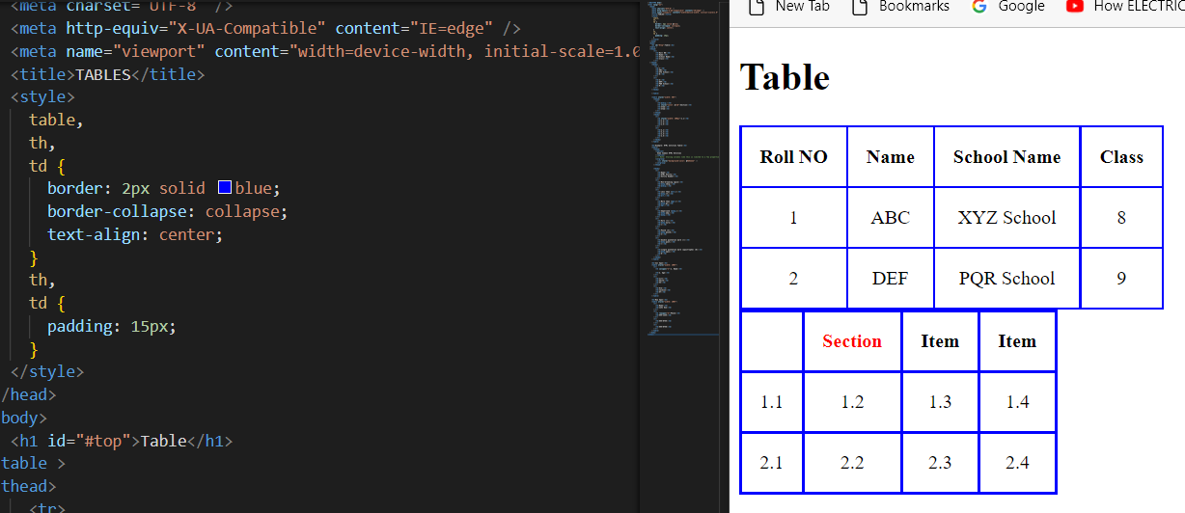**

**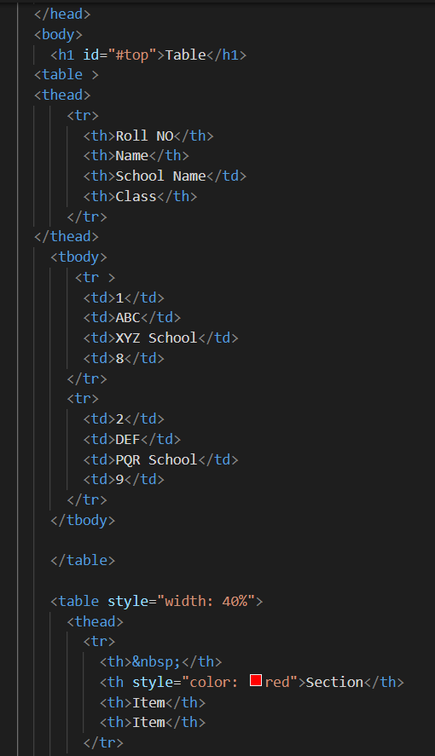**

**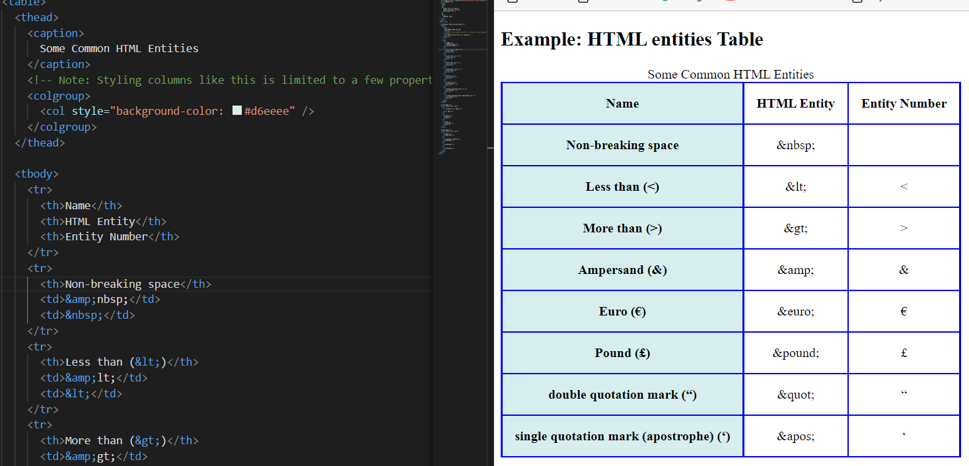**

**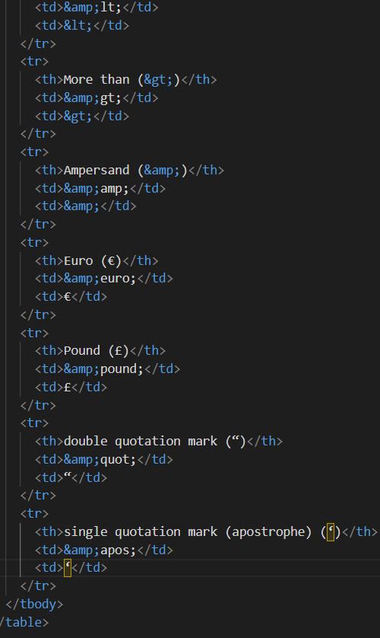**

**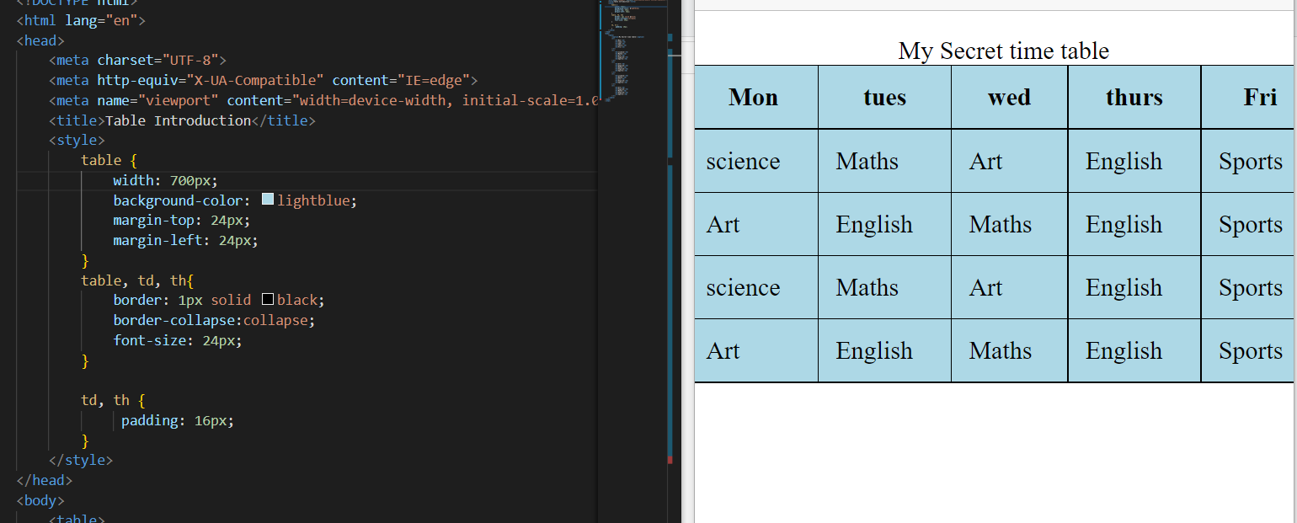**

**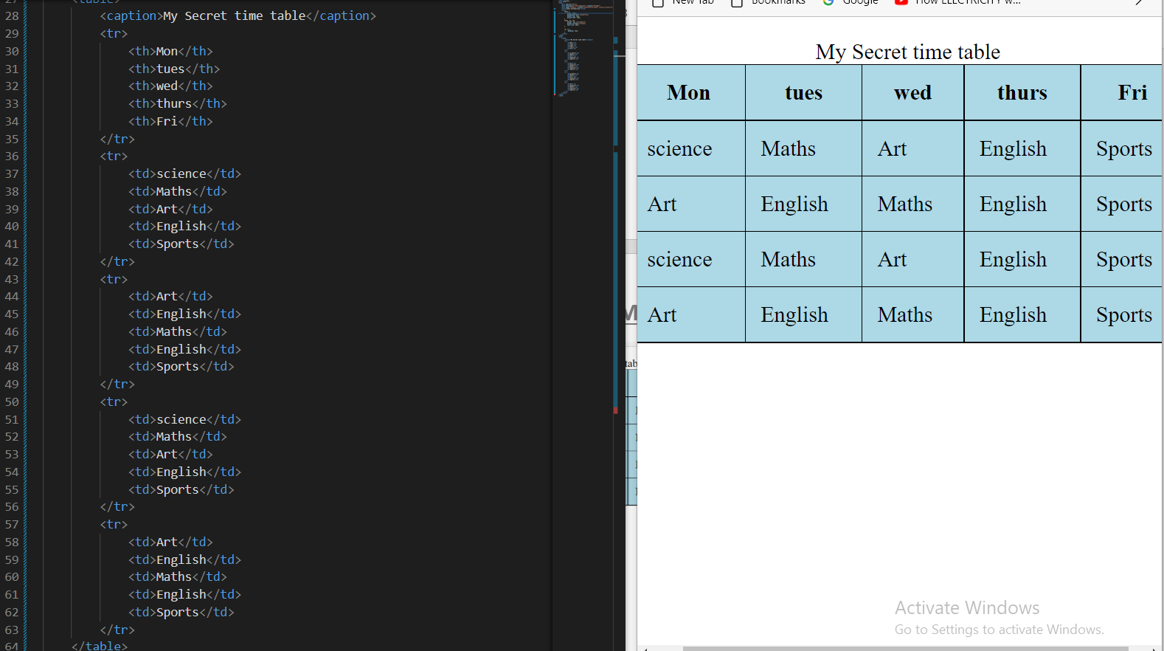**

**2. Layout using Tables: -**

**1. Rowspan: - The rowspan attribute specifies the number of rows a cell should span. 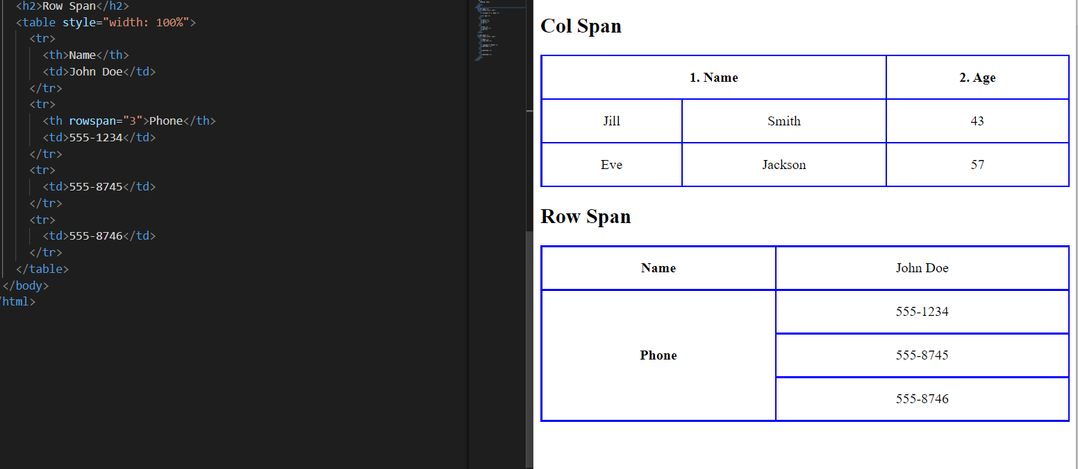**

**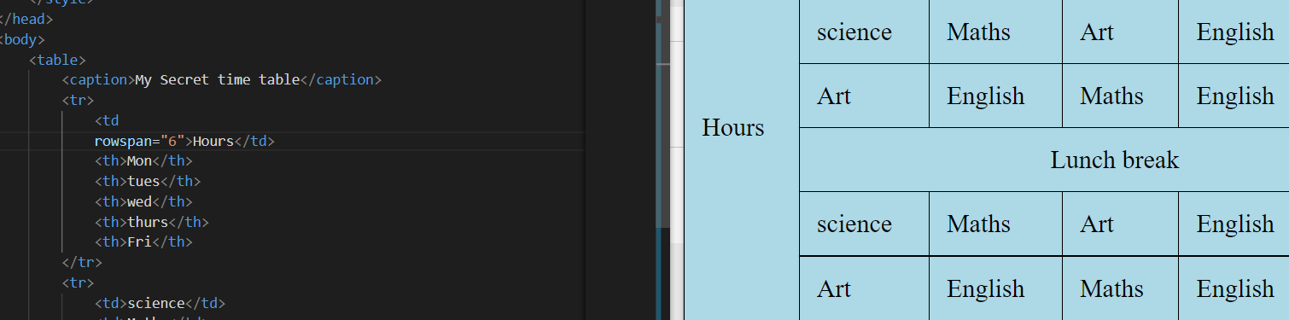**

**2. Colspan: - The colspan attribute defines the number of columns a table cell should span.**

**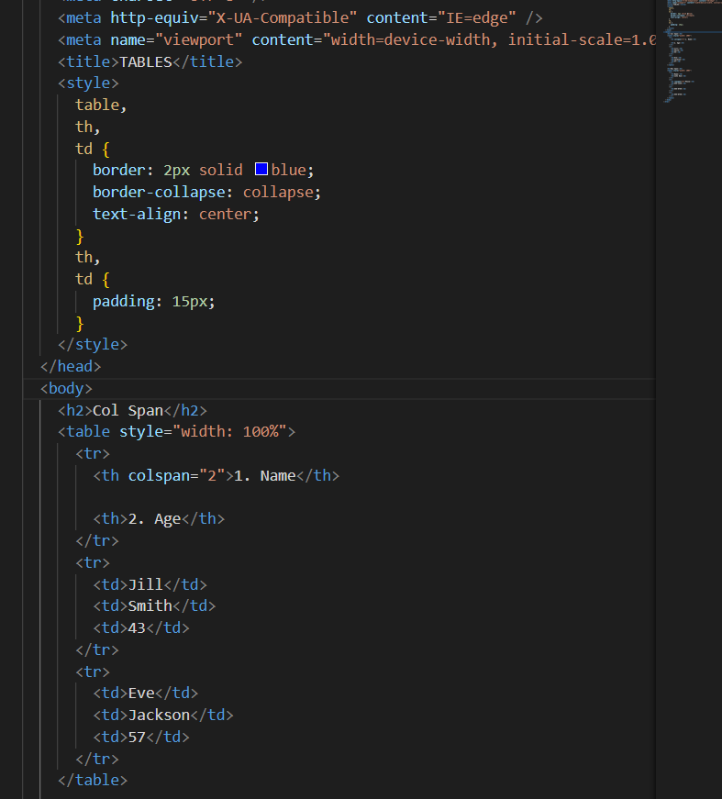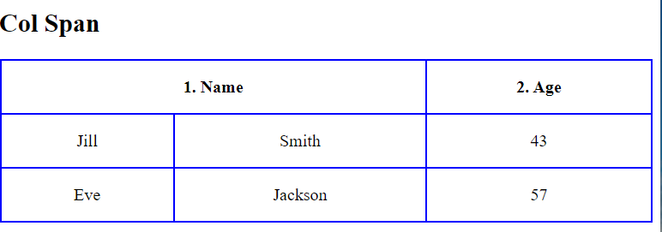**

**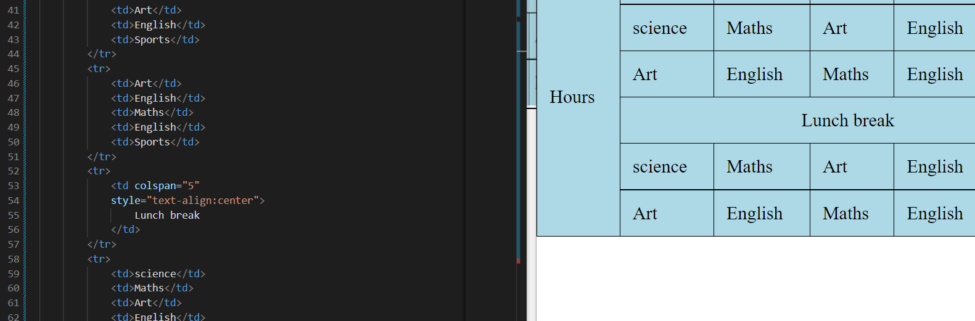**

1. **Layout using tables: -**

## **HTML Layout Elements**

HTML has several semantic elements that define the different parts of a web page:

|  |  |
| --- | --- |
| HTML5 Semantic Elements | <header> - Defines a header for a document or a section  <nav> - Defines a set of navigation links  <section> - Defines a section in a document  <article> - Defines an independent, self-contained content  <aside> - Defines content aside from the content (like a sidebar)  <footer> - Defines a footer for a document or a section  <details> - Defines additional details that the user can open and close on demand <summary> - Defines a heading for the <details> element **HTML Layout - Using Tables** The simplest and most popular way of creating layouts is using HTML <table> tag. These tables are arranged in columns and rows, so you can utilize these rows and columns in whatever way you like. **Example** For example, the following HTML layout example is achieved using a table with 3 rows and 2 columns but the header and footer column span both columns using the colspan attribute |

## **Multiple Columns Layout - Using Tables**

You can design your webpage to put your web content on multiple pages. You can keep your content in the middle column and you can use the left column to use mtheemenuand the right column can be used to put advertisements or some other stuff. This layout will be very similar to what we have on our website tutorialspoint.com.

### **Example**

Here is an example to create three column layout −

## **HTML Layouts - Using DIV, SPAN**

The <div> element is a block level element used for grouping HTML elements. While the <div> tag is a block-level element, the HTML <span> element is used for grouping elements at an inline level.

Although we can achieve pretty nice layouts with HTML tables, tables weren't designed as a layout tool. Tables are more suited to presenting tabular data.

**Note** − This example makes use of Cascading Style Sheet (CSS), so before understanding this example you need to have a better understanding of how CSS works.

### **Example**

Here we will try to achieve the same result using the <div> tag along with CSS, whatever you have achieved using the <table> tag in the previous example.

**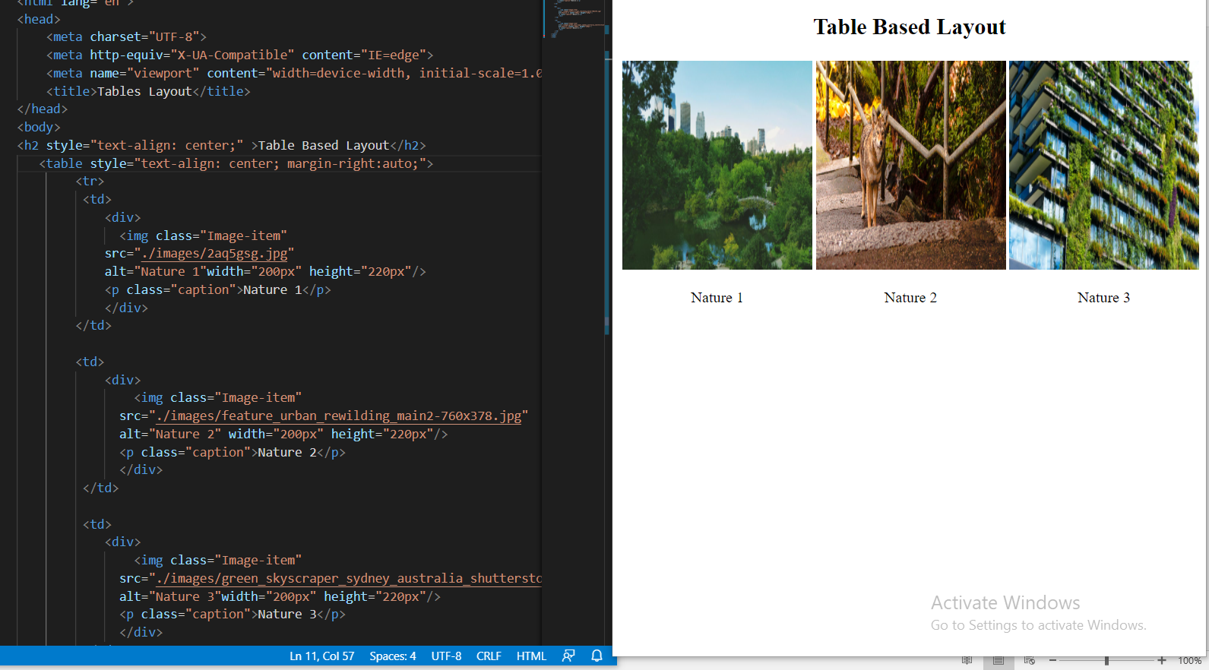**

**Day: - 5**

**Topics: - 1. Introduction to HTML5: -**

**Html5 Introduces semantic elements: These elements provide meaning to both the browser and search engines like Google and Bing.**

**HTML 4:-**

**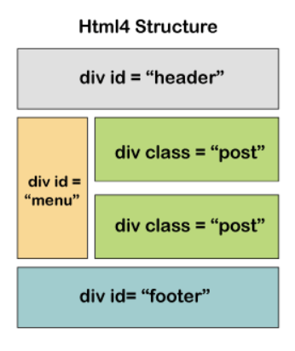**

**In Html 4 layout everything is div. the browser and search engines wouldn’t get any information about any type of data from this structural element. But, on the right-hand side of the HTML5, the browser knows which part of the page is the header, navigation menu, main content, or footer.**

**HTML5: -**

**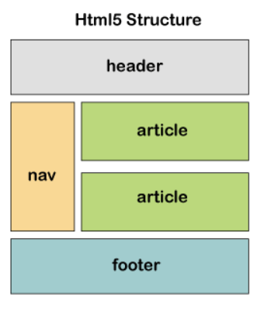**

|  |
| --- |
|  |

|  |  |
| --- | --- |
| **HTML 4** | **HTML 4** |
| **IT Has no support for audio and video files.** | **It has inbuilt support for audio and video files.** |
| **It has no inbuilt support for vector graphics. But these can be supported with the help of adobe flash, Silverlight, etc.,** | **It has inbuilt support for vector graphics like SVG and CANVAS.** |
| **It just provides cookies for application data storage.** | **It supports multiple storage options like Application Cache, SQL Databases, and web storage.** |
| **Browser Interface and JS run on the same thread leading to performance issues.** | **It has JS Web worker API which allows JS and browser interface to run on different threads.** |

**You may sometimes hear about "new HTML5 elements", or find HTML5 described as a new version of HTML. HTML5 was the successor to previous HTML versions and introduced new elements and capabilities to the language on top of the previous version, HTML 4.01, as well as improving or removing some existing functionality. However, as a Living Standard HTML now has no version. The up-to-date specification can be found at**[**html.spec.whatwg.org**](https://html.spec.whatwg.org/)**.**

**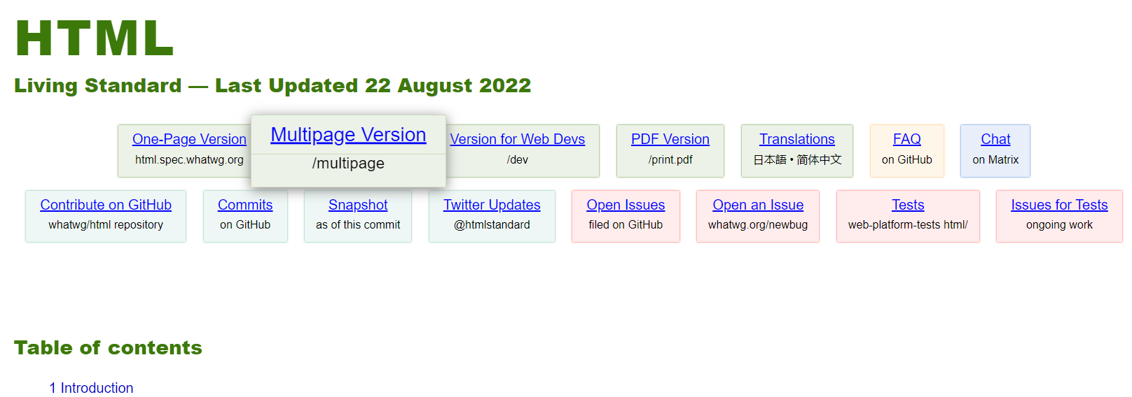**

**What’s new in HTML5?**

**New semantic and Structural Elements.**

**Many web sites contain HTML code like: <div id="nav"> <div class="header"> <div id="footer"> to indicate navigation, header, and footer. <article> <aside> <bdi> <aside> <details> <figcaption> <figure> <footer> <header> <main> <mark> <meter> <nav> <progress> <rp> <rt> <ruby> <section> <summary> <time> <wbr>**

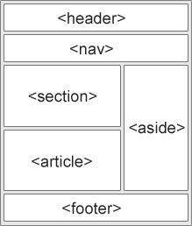

|  |  |
| --- | --- |
| **NEW FORM ELEMENTS** | |
| **<datalist>** | **<output>** |

|  |  |
| --- | --- |
| **New Input Types** | |
| **Color** | **Range** |
| **Data** | **Search** |
| **Data time** | **Tel** |
| **Datatime-local** | **Time** |
| **Email** | **url** |
| **Month** | **Week** |
| **number** |  |

|  |  |
| --- | --- |
| **Vector Graphics** | |
| **<canvas>** | **<svg>** |

|  |  |
| --- | --- |
| **New Media Elements** | |
| **<audio>** | **<source>** |
| **<embed>** | **<video>** |

# Top 10 new features of HTML5

1. **Intro of**[**audio**](https://www.geeksforgeeks.org/html5-audio/)**and**[**video**](https://www.geeksforgeeks.org/html5-video/)**:**

     Audio and Video tags are the two major addition to HTML5. It allows developers to embed a video or audio on their website. HTML5 video can use CSS and CSS3 to style the video tag. You can change the border, opacity, reflections, gradients, transitions, transformations, and even animations. HTML5 makes adding video super-fand without having to build a video player. This saves time for the developer and offers the client a superior and more affordable solution.

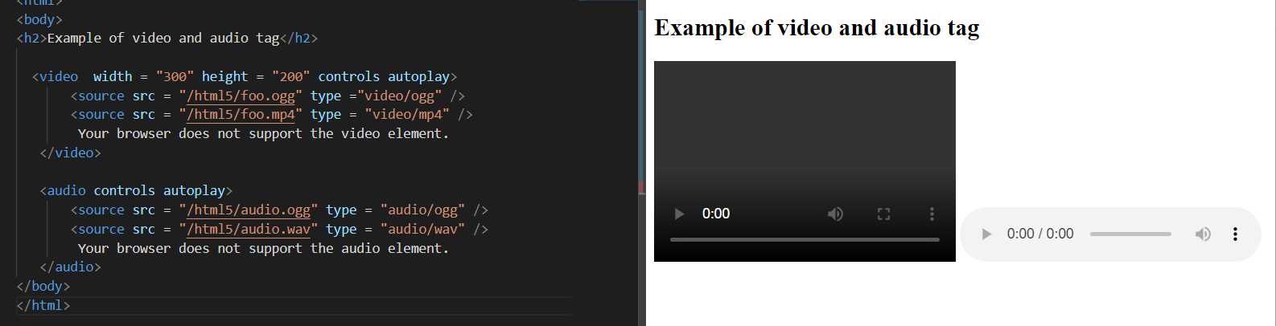

2. [**Vector Graphics**](https://www.geeksforgeeks.org/html-svg-basics/)**:**

     This is a new addition to the revised version which has hugely impacted the use of Adobe Flash on websites. It can be used to draw graphics with various shapes and colors via scripting usually JS. Vector graphics are scalable, and easy to create and edit. It also supports interactivity and animation. Having a smaller file size makes transferring and loading graphics much faster on the web. That’s the reason why many people prefer to use vector graphics.

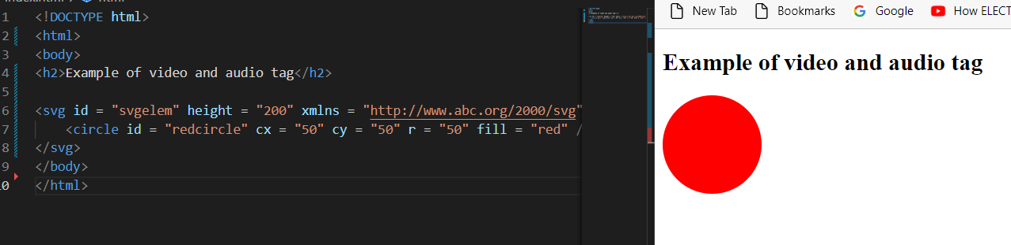

**3** [**Header**](https://www.geeksforgeeks.org/html-5-header-tag/)**and**[**Footer:**](https://www.geeksforgeeks.org/html5-footer-tag/)

     With these new tags, there is no longer a need to identify the two elements with a <div> tag. Footer is placed at the end of the web page while Header is placed at the start of the web page. By using <header> and <footer> HTML5 elements, the browser will know what to load first and what to load later.

The header can contain- One or more heading elements (<h1> – <h6>) Logo or icon Authorship information

Footer can contain- Authorship Information Copyright information Contact information Back to top link. They both have the same default CSS property as a display block.

**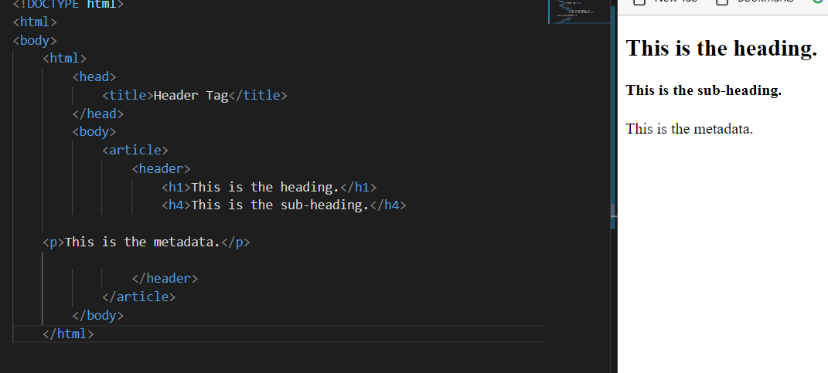**

1. [**Figure**](https://www.geeksforgeeks.org/html5-figure-tag/)**and [figcaption](https://www.geeksforgeeks.org/html5-figcaption-tag/):**

     HTML5 allows to use a <figure> element to mark up a photo in a document, and a <figcaption> element to define a caption for the photo. The <figcaption> tag defines a caption for a <figure> element. This tag provides a container for content that is equivalent to a figure. It can be used to group a caption with one or more images, a block of code, or other content. 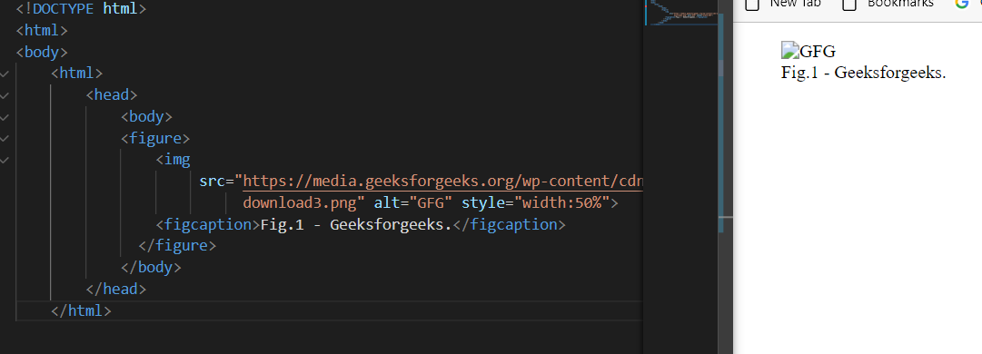

**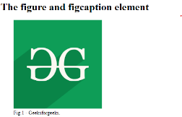**

**5.** [**Nav tag:**](https://www.geeksforgeeks.org/html-nav-tag/)

     The <nav> tag defines a set of navigation links. It is used for the part of an internet site that links to different pages on the website. The hyperlinks can be organized through several approaches. Common examples of the nav elements are menus, tables, contents, and indexes. This element makes it much easier to create a navigation menu, creates a neat horizontal menu of text links, and helps screen reading software correctly identify primary navigation areas in the document.

**Example:** **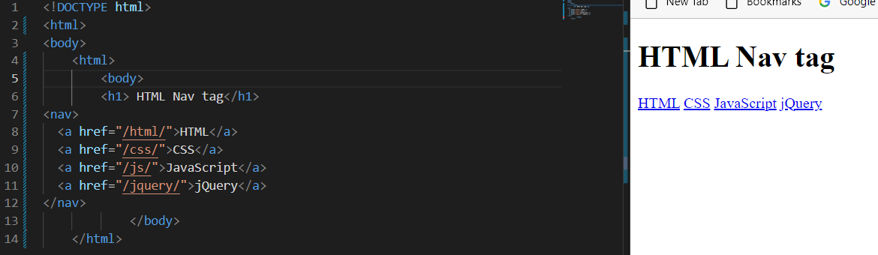**

6. [**Progress tag:**](https://www.geeksforgeeks.org/html-5-progress-tag/)

     The progress tag is used to check the progress of a task during execution. Progress tags can be used with the conjunction of JavaScript.

#### Example:

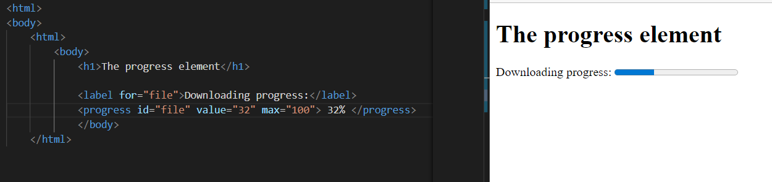

**7.** [**Placeholder Attribute:**](https://www.geeksforgeeks.org/html-placeholder-attribute/)  
The placeholder attribute specifies a short hint that describes the expected value of an input field/text area. The short hint is displayed in the field before the user enters a value.

**Example:**

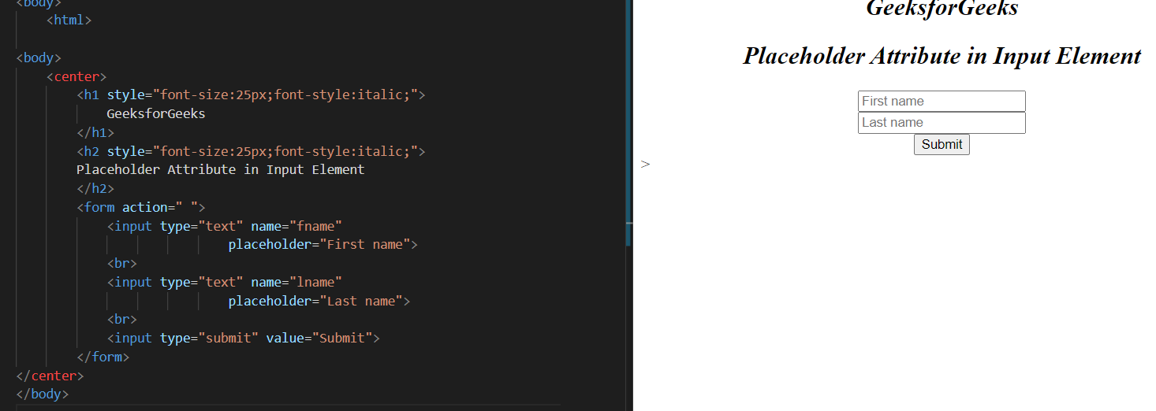

8. **Email attribute:**  
When the input type in the form is set as email, then the browser gets the instruction from the code to write a valid format email. The input email id is automatically validated to check the format of the email id is correct or not.  
**Example:**

**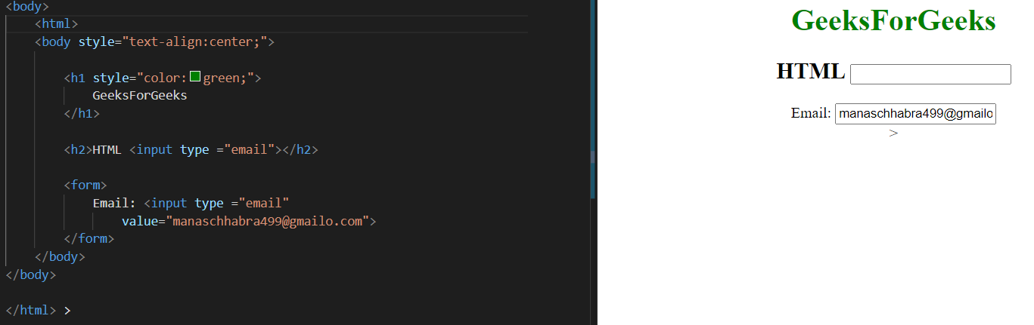**

**9. Storage:**

    In the case of HTML, we can use the browser as the temporary storage whereas, in the case of HTML5, application cache, web SQL database, and web storage is used.

**10. Ease of use:**

     While HTML5 does have risks like constant updates, it is generally easy to keep up with the changes & updates because of simpler syntax as compared to other versions of HTML.

There are a lot more tags and functionalities added in HTML5. Some common tags are nav, aside, section, summary, article, meter, and many more.

**2.Semantic& Structural Elements: -**

**Structural Elements: - These elements just define the structure of an HTML page. They don’t provide the browsers and search engines (Like Google and Bing), with what kind of data is being rendered by the HTML Page.**

**Ex: - <div>, <Span> etc.**

**Semantic Elements: - These elements define the structure as well as give meaning to the content of the HTML page. They help the browsers and search engines (Like Google and Bing), to understand the kind of data being rendered like which part is for navigation, which part is the main content, which part is the footer, etc.**

**Ex: - <header>, <nav> <main> etc.**

**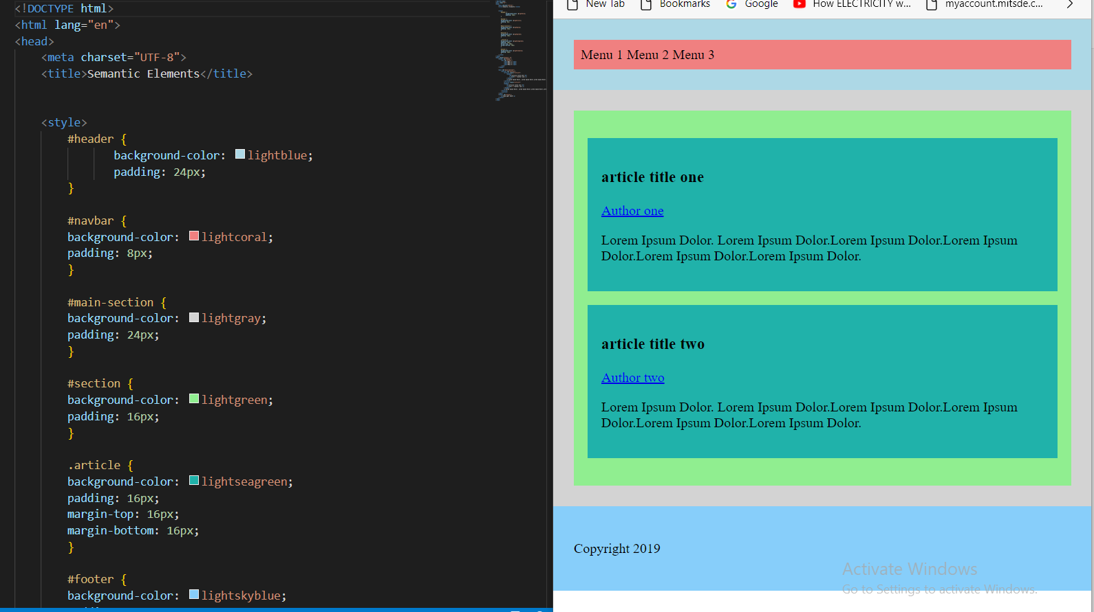**

**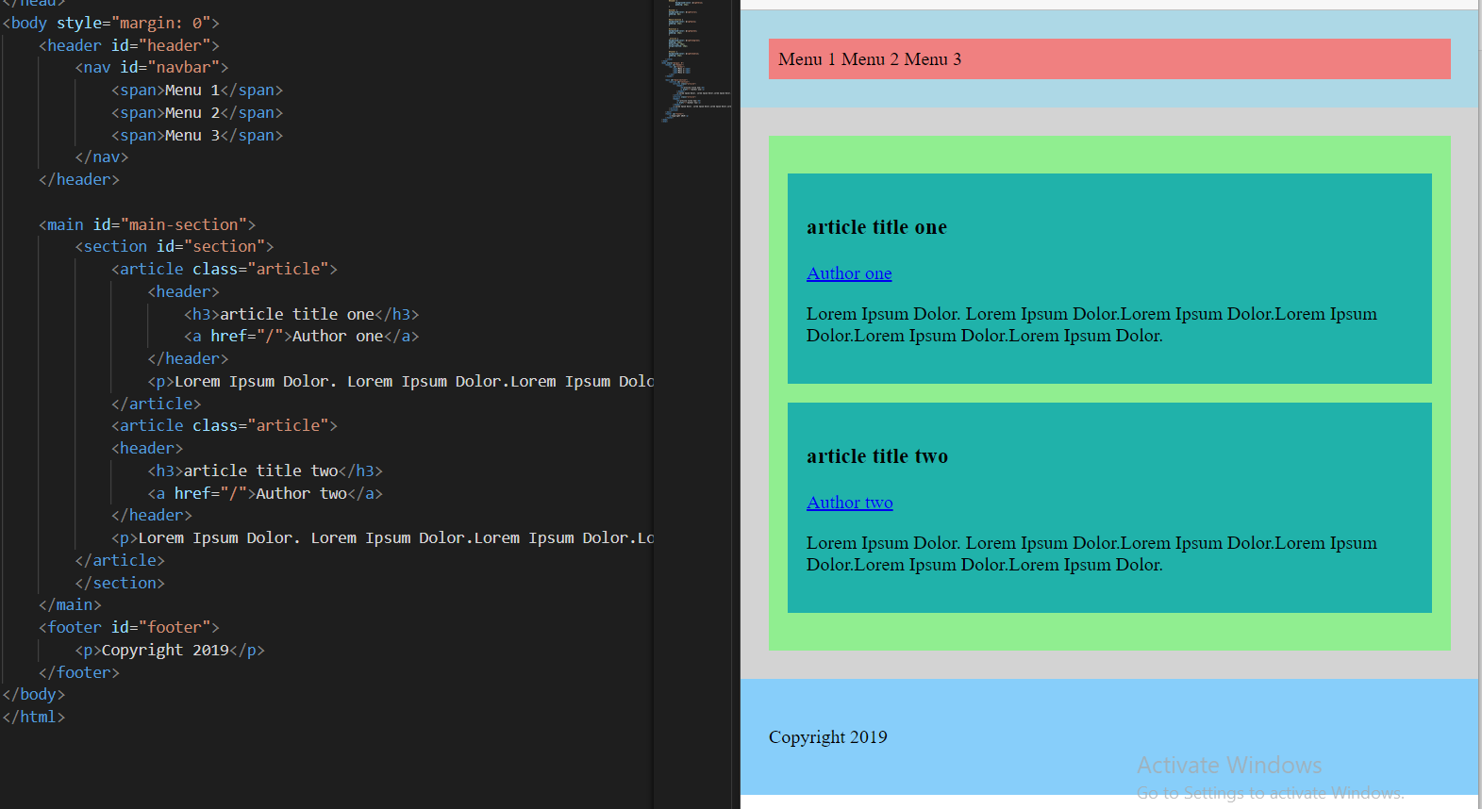**

**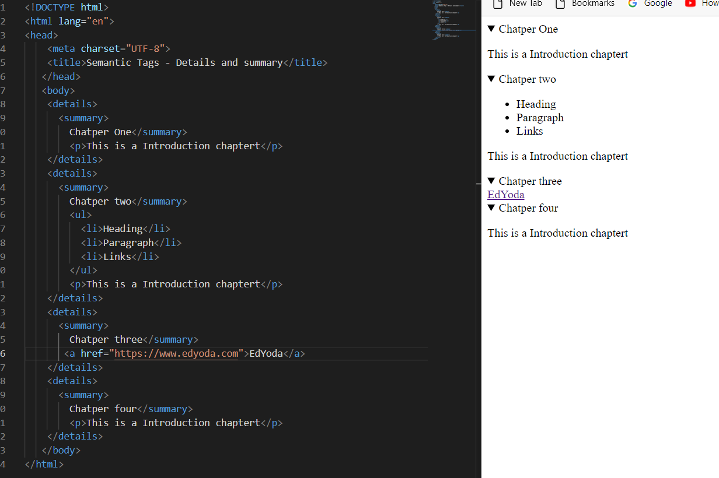**

**2. Why were semantic elements introduced?**

## **Ans: - So what are semantic elements good for?**

As their name implies, semantic tags are only good for semantic purposes. They’re all block-level elements that will render as expected, regardless of their HTML tag. They have other important benefits that we’ll list below, but if you read about HTML5 semantic elements on the web, you’ll often find this advice: Don’t spend too much time setting semantic elements at the detriment of more important tasks. Which is fair. After all, semantic elements don’t affect your site's performance in search engines, and your clients and website visitors probably won’t notice them. But once you read about how HTML5 affects accessibility (below), you might rethink your site structures and consider semantic elements an important — if not mandatory — aspect of your web design process.

### **Semantic elements’ benefits for designers and developers**

HTML5’s semantic elements help structure the code we create, making it more readable and easier to maintain. They help us think about the structure of our dynamic data, and to choose titles’ hierarchy properly. They help us differentiate the semantic elements of our markup from the ones we use solely for layout. And finally, HTML5 semantic elements push us to learn the meanings of HTML elements and better understand our audiences, particularly those who live with disabilities.

### **Semantic elements’ benefits for accessibility**

For sighted users, it’s easy enough to identify the various parts of a website. Headers and footers, menus, and form elements are all immediately, and visually apparent. But for a machine like Google’s spiders or a screen reader, these visual semantics aren’t so obvious. By defining block-level elements as semantic elements, we tell the machines what they are, so the machines can render elements appropriately. For example, we no longer declare italic elements with a <i> for “italics,” (which is a purely visual change, without intrinsic meaning) but with an <em>, for “emphasize.” On a screen, the browser will display text wrapped in an <em> in italics. But on an audio device for the visually impaired, the text will be pronounced with a corresponding emphasis, just like a friend would say it.

## **Accessibility and the web**

Web accessibility means that people with disabilities can use the Web. More specifically, Web accessibility means that people with disabilities can perceive, understand, navigate, and interact with the Web and that they can contribute to the Web. Web accessibility also benefits others, including older people with changing abilities due to aging.

Operating systems include many accessibility options by default, including text size control, text-to-speech, color and contrast controls, etc. Some people browse the web with assistive devices, machines that translate text and media to audio or braille, for example.

Naming the semantic elements of your sites using HTML5 tags is one of the most effective ways to make your site more accessible to people using these assistive technologies.

For example, if you’ve properly tagged your site navigation with <nav> and sidebars with <aside>, an assistive device will understand that these elements don’t belong to the main flow of the HTML document, enabling the device’s user to skip straight to the <article>.

Now, making your site more accessible is often up to you. Small and medium clients probably won’t bring up the topic at all, unless they specifically target disabled audiences. But larger projects and those involving civil or governmental organizations will probably require a high standard of accessibility.

Why? Because large sites want maximum visibility and usability, and public sites are often required by law to be compliant with accessibility standards. It’s the same law that says a public place must be accessible to people using wheelchairs and a public site must be accessible to anyone, on any device.

Of course, making your site accessible doesn’t stop at using HTML5 tags. The topic is vast, but here are a few essentials: **Use headings to properly structure your content Include descriptive alt text for images**Webflow makes it easy to add alt text to images in the Designer and the Editor, so be sure to take the time for this. No text-to-speech system can describe an image better than you can. **Give your links unique and descriptive text —**i.e., don’t use “learn more” or “read more” or “here.” Ever. **Use color with care**8% of the population suffers from red-green color deficiency. That’s a lot of people. And red-green color deficiency is just one of the various forms of color blindness. Never rely on color alone to communicate meaning to users. **Design your forms for accessibility**Forms fields need to be labeled appropriately for screen readers to handle them. **Use tables for tabular data, not layout Ensure that all content can be accessed with the keyboard alone Keep your clickable areas obvious and large 3.HTML5 NEW SEMANTIC/STRUCTURAL ELEMENTS: - New HTML 5 Semantic/Structural Elements** HTML5 offers new elements for better document structure:

|  |  |
| --- | --- |
| **Tag** | **Description** |
| <article> | Defines an article in a document |
| <aside> | Defines content aside from the page content |
| <bdi> | Isolates a part of the text that might be formatted in a different direction from other text outside it |
| <details> | Defines additional details that the user can view or hide |
| <dialog> | Defines a dialog box or window |
| <figcaption> | Defines a caption for a <figure> element |
| <figure> | Defines self-contained content |
| <footer> | Defines a footer for a document or section |
| <header> | Defines a header for a document or section |
| <main> | Defines the main content of a document |
| <mark> | Defines marked/highlighted text |
| <menuitem> | Defines a command/menu item that the user can invoke from a popup menu |
| <meter> | Defines a scalar measurement within a known range (a gauge) |
| <nav> | Defines navigation links |
| <progress> | Represents the progress of a task |
| <rp> | Defines what to show in browsers that do not support ruby annotations |
| <rt> | Defines an explanation/pronunciation of characters (for East Asian typography) |
| <ruby> | Defines a ruby annotation (for East Asian typography) |
| <section> | Defines a section in a document |
| <summary> | Defines a visible heading for a <details> element |
| <time> | Defines a date/time |
| <wbr> | Defines a possible line-break |

Many web sites contain HTML code like: <div id=”nav”> <div class=” header”> <div id=” footer”> to indicate navigation, header, and footer.

**Day: - 5**

**Topics: - 1. Introduction to Forms: -**

# <form>: The Form element

**The <form>**[**HTML**](https://developer.mozilla.org/en-US/docs/Web/HTML)**element represents a document section containing interactive controls for submitting information. It is possible to use the valid and**[**: invalid**](https://developer.mozilla.org/en-US/docs/Web/CSS/:invalid)**CSS**[**pseudo-classes**](https://developer.mozilla.org/en-US/docs/Web/CSS/Pseudo-classes)**to style an <form> element based on whether or not the**[**elements**](https://developer.mozilla.org/en-US/docs/Web/API/HTMLFormElement/elements)**inside the form are valid.**

## [**Attributes**](https://developer.mozilla.org/en-US/docs/Web/HTML/Element/form#attributes)

[**Accept**](https://developer.mozilla.org/en-US/docs/Web/HTML/Element/form#attr-accept)**: - Comma-separated**[**content types**](https://developer.mozilla.org/en-US/docs/Web/SVG/Content_type)**the server accepts.**

[**accept-charset**](https://developer.mozilla.org/en-US/docs/Web/HTML/Element/form#attr-accept-charset)**: - Space-separated**[**character encodings**](https://developer.mozilla.org/en-US/docs/Glossary/character_encoding)**the server accepts. The browser uses them in the order in which they are listed. The default value means**[**the same encoding as the page**](https://developer.mozilla.org/en-US/docs/Web/HTTP/Headers/Content-Encoding)**. (In previous versions of HTML, character encodings could also be delimited by commas.)**

[**Autocapitalize**](https://developer.mozilla.org/en-US/docs/Web/HTML/Element/form#attr-autocapitalize)**: - A nonstandard attribute used by iOS Safari that controls how textual form elements should be automatically capitalized. Auto-capitalize attributes on form elements override it on <form>. Possible values:**

* **none: No automatic capitalization.**
* **sentences (default): Capitalize the first letter of each sentence.**
* **words: Capitalize the first letter of each word.**
* **characters: Capitalize all characters — that is, uppercase.**

[**Autocomplete**](https://developer.mozilla.org/en-US/docs/Web/HTML/Element/form#attr-autocomplete)**: - Indicates whether input elements can by default have their values automatically completed by the browser. autocomplete attributes on form elements override it on <form>. Possible values:**

* **off: The browser may not automatically complete entries. (Browsers tend to ignore this for suspected login forms; see**[**The autocomplete attribute and login fields**](https://developer.mozilla.org/en-US/docs/Web/Security/Securing_your_site/Turning_off_form_autocompletion#the_autocomplete_attribute_and_login_fields)**.)**
* **on: The browser may automatically complete entries.**

[**Name**](https://developer.mozilla.org/en-US/docs/Web/HTML/Element/form#attr-name)**: - The name of the form. The value must not be the empty string and must be unique among the form elements in the forms collection that it is in if any.**

[**Rel**](https://developer.mozilla.org/en-US/docs/Web/HTML/Element/form#attr-rel)**: - Creates a hyperlink or annotation depending on the value, see the [rel](https://developer.mozilla.org/en-US/docs/Web/HTML/Attributes/rel) attribute for details.**

### [**Attributes for form submission**](https://developer.mozilla.org/en-US/docs/Web/HTML/Element/form#attributes_for_form_submission)

[**Action**](https://developer.mozilla.org/en-US/docs/Web/HTML/Element/form#attr-action)**: - The URL that processes the form submission. This value can be overridden by a [formaction](https://developer.mozilla.org/en-US/docs/Web/HTML/Element/button" \l "attr-formaction) attribute on a**[**<button>**](https://developer.mozilla.org/en-US/docs/Web/HTML/Element/button)**,**[**<input type="submit">**](https://developer.mozilla.org/en-US/docs/Web/HTML/Element/input/submit)**, or**[**<input type="image">**](https://developer.mozilla.org/en-US/docs/Web/HTML/Element/input/image)**element. This attribute is ignored when method="dialog" is set.**

[**Type**](https://developer.mozilla.org/en-US/docs/Web/HTML/Element/form#attr-enctype)**: - If the value of the method attribute is posted, enctype is the**[**MIME type**](https://en.wikipedia.org/wiki/Mime_type)**of the form submission. Possible values:**

* **application/x-www-form-urlencoded: The default value.**
* **multipart/form-data: Use this if the form contains**[**<input>**](https://developer.mozilla.org/en-US/docs/Web/HTML/Element/input)**elements with type=file.**
* **text/plain: Useful for debugging purposes.**

**This value can be overridden by [formenctype](https://developer.mozilla.org/en-US/docs/Web/HTML/Element/button" \l "attr-formenctype) attributes on**[**<button>**](https://developer.mozilla.org/en-US/docs/Web/HTML/Element/button)**,**[**<input type="submit">**](https://developer.mozilla.org/en-US/docs/Web/HTML/Element/input/submit)**, or**[**<input type="image">**](https://developer.mozilla.org/en-US/docs/Web/HTML/Element/input/image)**elements.**

[**Method**](https://developer.mozilla.org/en-US/docs/Web/HTML/Element/form#attr-method)**: - The**[**HTTP**](https://developer.mozilla.org/en-US/docs/Web/HTTP)**method to submit the form with. The only allowed methods/values are (case insensitive):**

* **post: The**[**POST method**](https://www.w3.org/Protocols/rfc2616/rfc2616-sec9.html#sec9.5)**; form data sent as the**[**request body**](https://developer.mozilla.org/en-US/docs/Web/API/Request/body)**.**
* **get The**[**GET method**](https://www.w3.org/Protocols/rfc2616/rfc2616-sec9.html#sec9.3)**; form data appended to the action URL with a ? separator. Use this method when the form**[**side**](https://developer.mozilla.org/en-US/docs/Glossary/Idempotent) **effects.**
* **dialog: When the form is inside a**[**<dialog>**](https://developer.mozilla.org/en-US/docs/Web/HTML/Element/dialog)**, close the dialog and throw a submit event on submission without submitting data or clearing the form.**

**This value is overridden by [formmethod](https://developer.mozilla.org/en-US/docs/Web/HTML/Element/button" \l "attr-formmethod) attributes on**[**<button>**](https://developer.mozilla.org/en-US/docs/Web/HTML/Element/button)**,**[**<input type="submit">**](https://developer.mozilla.org/en-US/docs/Web/HTML/Element/input/submit)**, or**[**<input type="image">**](https://developer.mozilla.org/en-US/docs/Web/HTML/Element/input/image)**elements.**

[**Novalidate**](https://developer.mozilla.org/en-US/docs/Web/HTML/Element/form#attr-novalidate)**: - This Boolean attribute indicates that the form shouldn't be validated when submitted. If this attribute is not set (and therefore the form is validated), it can be overridden by a**[**form**](https://developer.mozilla.org/en-US/docs/Web/HTML/Element/button#attr-formnovalidate) **validate attribute on a**[**<button>**](https://developer.mozilla.org/en-US/docs/Web/HTML/Element/button)**,**[**<input type="submit">**](https://developer.mozilla.org/en-US/docs/Web/HTML/Element/input/submit)**, or**[**<input type="image">**](https://developer.mozilla.org/en-US/docs/Web/HTML/Element/input/image)**element belonging to the form.**

[**Target**](https://developer.mozilla.org/en-US/docs/Web/HTML/Element/form#attr-target)**:- Indicates where to display the response after submitting the form. It is a name/keyword for a *browsing context* (for example, tab, window, or iframe). The following keywords have special meanings:**

* **\_self (default): Load into the same browsing context as the current one.**
* **\_blank: Load into a new unnamed browsing context.**
* **\_parent: Load into the parent browsing context of the current one. If no parent behaves the same as \_self.**
* **\_top: Load into the top-level browsing context (i.e., the browsing context that is an ancestor of the current one and has no parent). If no parent behaves the same as \_self.**

**This value can be overridden by a [formtarget](https://developer.mozilla.org/en-US/docs/Web/HTML/Element/button" \l "attr-formtarget) attribute on a**[**<button>**](https://developer.mozilla.org/en-US/docs/Web/HTML/Element/button)**,**[**<input type="submit">**](https://developer.mozilla.org/en-US/docs/Web/HTML/Element/input/submit)**, or**[**<input type="image">**](https://developer.mozilla.org/en-US/docs/Web/HTML/Element/input/image)**element.**

**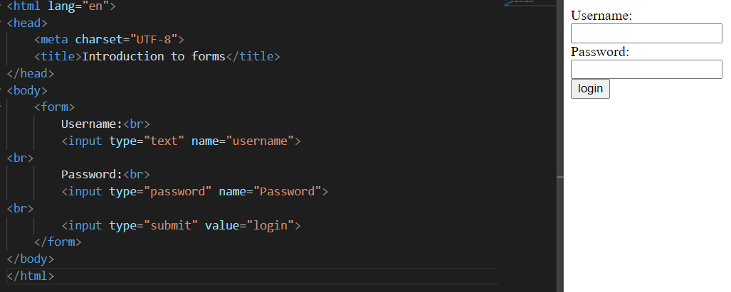**

**2.HTML5 FORMS ATTRIBUTES: -**

## HTML5 form attributes: - There are 14 new attributes that we’ll be looking at in this article.

[placeholder](http://html5doctor.com/html5-forms-introduction-and-new-attributes/#placeholder) [autofocus](http://html5doctor.com/html5-forms-introduction-and-new-attributes/#autofocus) [autocomplete](http://html5doctor.com/html5-forms-introduction-and-new-attributes/#autocomplete) [required](http://html5doctor.com/html5-forms-introduction-and-new-attributes/#required) [pattern](http://html5doctor.com/html5-forms-introduction-and-new-attributes/#pattern) [list](http://html5doctor.com/html5-forms-introduction-and-new-attributes/#list-datalist) [multiple](http://html5doctor.com/html5-forms-introduction-and-new-attributes/#multiple) [validate](http://html5doctor.com/html5-forms-introduction-and-new-attributes/#novalidate) [form](http://html5doctor.com/html5-forms-introduction-and-new-attributes/#novalidate) formation [form method](http://html5doctor.com/html5-forms-introduction-and-new-attributes/#formmethod) from the target

### **Placeholder: -**

**First up is the placeholder attribute, which allows us to set placeholder text as we would currently do in HTML4 with the value attribute. It should only be used for short descriptions. For anything longer, use the title attribute. The difference from HTML4 is that the text is only displayed when the field is empty and hasn’t received focus. Once the field receives focus (e.g., you click or tab to the field), and you begin to type, the text simply disappears. It’s very similar to the search box you see in Safari (see Figure 1).**

<input type="text" name="user-name" id="user-name" placeholder="at least 3 characters">

### **Autofocus: -**

**autofocus does exactly what it says on the tin. Adding it to an input automatically focuses that field when the page is rendered. As with placeholder, autofocus is something that we used JavaScript for in the past.**

**Traditional JavaScript methods do, though, have some serious usability problems. For example, if a user begins completing the form before the script loads, they will (jarringly) be returned to the first form field when the script is loaded. The autofocus attribute in HTML5 gets around this issue by focusing as soon as the document loads, without having to wait for the JavaScript to be loaded. However, we only recommend using it for pages whose sole purpose is the form (like Google) to prevent usability issues.**

**It is a Boolean attribute (except if you are writing XHTML5; see the note) and is implemented as follows:**

<input type="text" name="first-name" id="first-name" autofocus>

### **Autocomplete: -**

**The autocomplete attribute helps users complete forms based on earlier input. The attribute has been around since IE5.5 but has finally been standardized as part of HTML5. The default state is set to on. This means that generally, we won’t have to use it. However, if you want to insist that a form field be entered each time a form is completed (as opposed to the browser auto-filling the field), you would implement it like so:**

<input type="text" name="tracking-code" id="tracking-code" autocomplete="off">

### **Required: -**

**The required attribute doesn’t need much introduction; like autofocus, it does exactly what you’d expect. By adding it to a form field, the browser requires the user to enter data into that field before submitting the form. This replaces the basic form validation currently implemented with JavaScript, making things a little more usable and saving us a little more development time. required is a Boolean attribute, like autofocus. Let’s see it in action.**

<input type="text" id="given-name" name="given-name" required>

### **Pattern: -**

**The pattern attribute is likely to get a lot of developers very excited (well, as excited as you can get about form attributes). It specifies a JavaScript regular expression for the field’s value to be checked against. pattern makes it easy for us to implement specific validation for product codes, invoice numbers, and so on. The possibilities for the patterns are wide-ranging, and this is just one simple example of using a product number.**

<label>Product Number:  
<input pattern="[0-9][A-Z]{3}" name="product" type="text" title="Single digit followed by three uppercase letters."/>  
</label>

### **List and the Datalist element: -**

**The list attribute enables the user to associate a list of options with a particular field. The value of the list attribute must be the same as the ID of a datalist element that resides in the same document. The datalist element is new in HTML5 and represents a predefined list of options for form controls. It works in a similar way to the in-browser search boxes that autocomplete as you type (see Figure 4).**

<label>Your favorite fruit:  
<datalist id="fruits">  
  <option value="Blackberry">Blackberry</option>  
  <option value="Blackcurrant">Blackcurrant</option>  
  <option value="Blueberry">Blueberry</option>  
  <!-- … -->  
</datalist>  
If other, please specify:  
  <input type="text" name="fruit" list="fruits">  
</label>

### **Multiple: -**

**We can take our lists and data lists one step further by applying the Boolean attribute multiple to allow more than one value to be entered from the data list. Here is an example.**

<label>Your favorite fruit:  
<datalist id="fruits">  
  <select name="fruits">  
    <option value="Blackberry">Blackberry</option>  
    <option value="Blackcurrant">Blackcurrant</option>  
    <option value="Blueberry">Blueberry</option>  
    <!-- … -->  
  </select>  
If other, please specify:  
</datalist>  
  <input type="text" name="fruit" list="fruits" multiple>  
</label>

**multiple isn’t exclusively for use with data lists, though. A further example for multiple might be for email addresses when sending items to a friend or the attachment of files, as shown here:**

<label>Upload files:  
<input type="file" multiple name="upload"></label>

### **Novalidate and form validate: -**

**The novalidate and form validate attributes indicate that the form shouldn’t be validated when submitted. They are both Boolean attributes. Form validation can be applied to submit or image input types. The novalidate attribute can be set only on the form element.**

**An example use case for the form validates tribute could be on a “save draft” button, where the form has fields that are required for submitting the draft but aren’t required for saving the draft. novvalidateuld be used in cases where you don’t want to validate the form but do want to take advantage of the more useful user interface enhancements that the new input types offer.**

**The following example shows how to use form validate:**

<form action="process.php">  
  <label for="email">Email:</label>  
  <input type="text" name="email" value="gordo@example.com">  
  <input type="submit" formnovalidate value="Submit">  
</form>

And this example shows how to use validated:

<form action="process.php" novalidate>  
  <label for="email">Email:</label>  
  <input type="text" name="email" value="gordo@example.com">  
  <input type="submit" value="Submit">  
</form>

### **Formaction, formentype, formmethod, and formtarget : -**

**The foinformationfformer type form method and form target attributes each have a corresponding attribute on the form element, which you’ll be familiar with from HTML4, so let’s run through each of them briefly. These new attributes have been introduced primarily because you may require alternative actions for different submit buttons, as opposed to having several forms in a document.**

#### **Formation**

**formation specifies the file or application that will submit the form. It has the same effect as the action attribute on the form element and can only be used with a submit or image button (type="submit" or type="image"). When the form is submitted, the browser first checks for a formaction attribute; if that isn’t present, it proceeds to look for an action attribute on the form.**

<input type="submit" value="Submit" formaction="process.php">

#### **Former type**

**former type details how the form data is encoded with the POST method type. It has the same effect as the type attribute on the form element and can only be used with a submit or image button (type="submit" or type="image"). The default value if not included is application/x-www-formurlencoded.**

<input type="submit" value="Submit" formenctype="application/x-www-form-urlencoded">

#### **Form method**

**form detoxifies which HTTP method (GET, POST, PUT, DELETE) will be used to submit the form data. It has the same effect as the method attribute on the form element and can only be used with a submit or image button** (type="submit" or type="image").

<input type="submit" value="Submit" formmethod="POST">

#### **For target**

**Form target specifies the target window for the form results. It has the same effect as the target attribute on the form element and can only be used with a submit or image button (type="submit" or type="image").**

<input type="submit" value="Submit" formtarget="\_self">

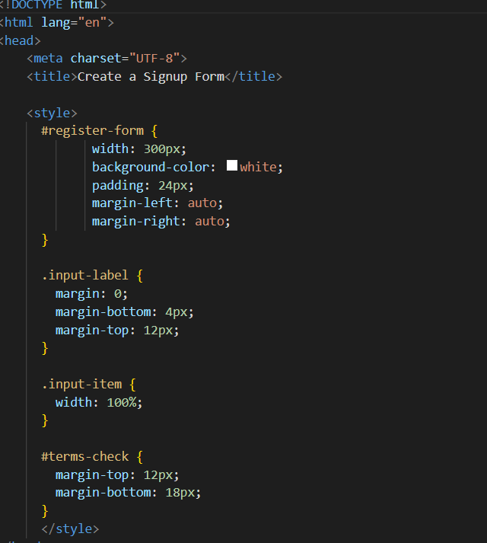

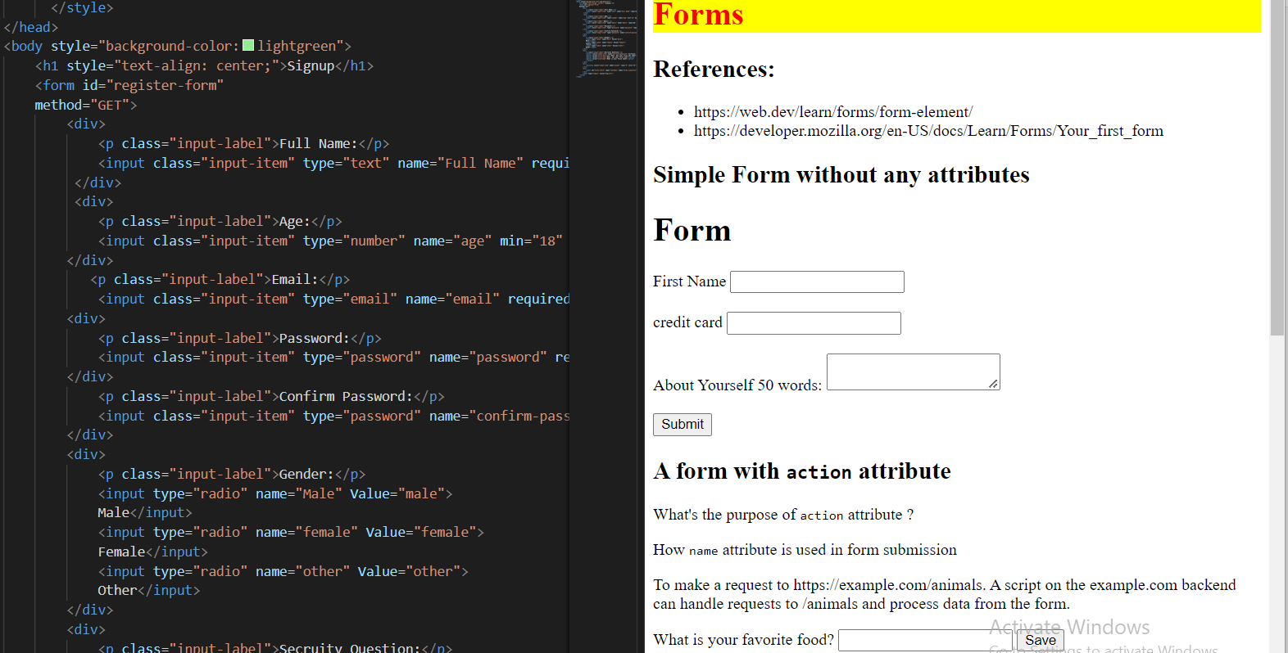

### 

**2. HTML5 Forms Elements: -**

## **The HTML <form> Elements**

The HTML <form> element can contain one or more of the following form elements:

* **<input> <label> <select> <textarea> <button> <fieldset> <legend> <datalist> <output> <optionelements> <optgroup>**

## **The <input> Element: -**One of the most used form elements is the <input> element. The <input> element can be displayed in several ways, depending on the type attribute.

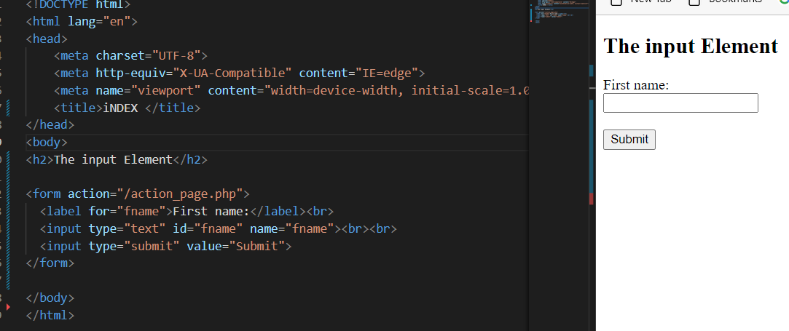

* 1. **The <label> Element: -** The <label> element defines a label for several form elements. The <label> element is useful for focuses-reader users because the screen-reader will read out loud the label when the user focuses on the input element. The <label> element also help users who have difficulty clicking on very small regions (such as radio buttons or checkboxes) - because when u clothe cks the text within the <label> element, it toggles the radio button/checkbox x. The attribute of the <label> tag should be equal to the id attribute of the <input> element to bind them together.

## **The <select> Element: -**The <select> element defines a drop-down list: The <option> elements defines an option that can be selected. By default, the first item in the drop-down list is selected. To define a pre-selected option, add the selected attribute to the option:

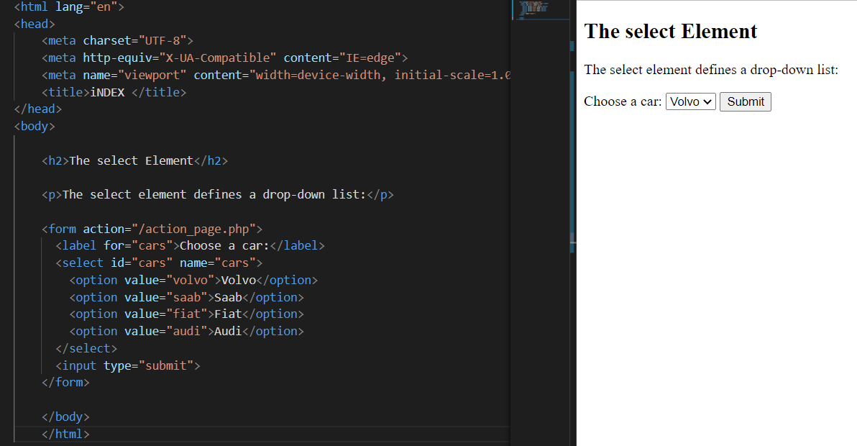

* 1. **Visible Values: -** Use the size attribute to specify the number of visiattributess:

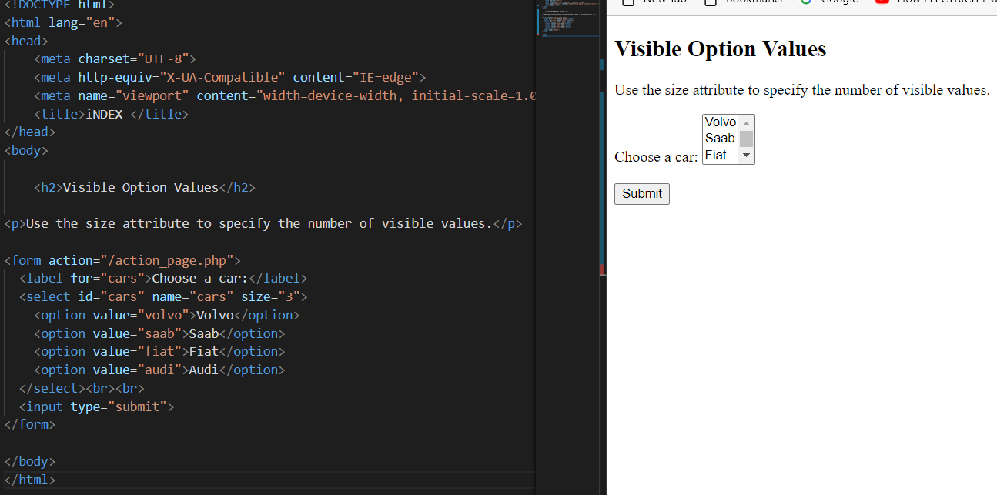

### **Allow Multiple Selections: -** Use the multiple attributes to allow the user to select more than one value:

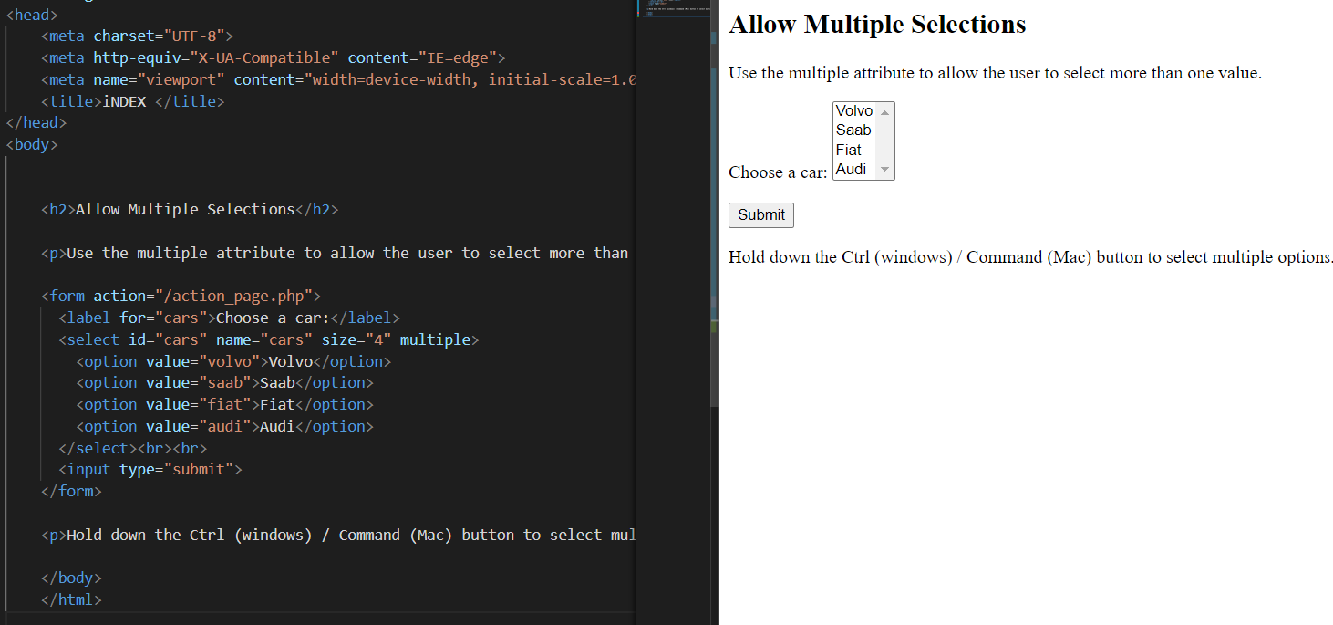

## **The <textarea> Element: -** The <textarea> element defines a multi-line input field (a text area): The rows attribute specifies the visible number of lines in a text area. The cols attribute specifies the visible width of a text area. This is how the HTML code above will be displayed in a browser:

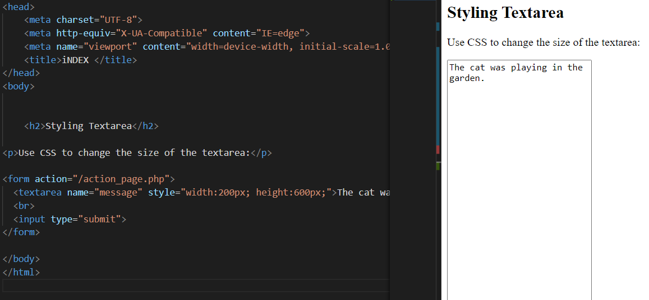

## **The <button> Element: -** The <button> element defines a clickable button: This is how the HTML code above will be displayed in a browser:

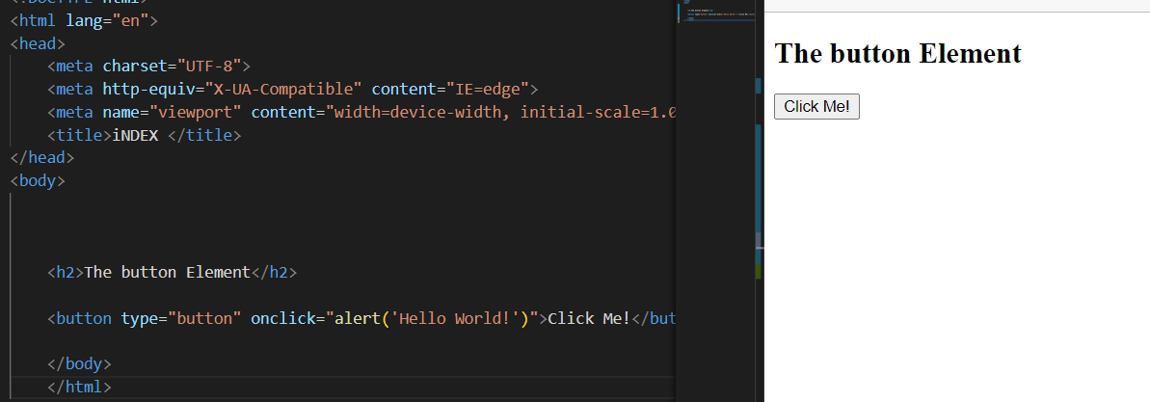

## **The <fieldset> and <legend> Elements: -** The <fieldset> element is used to group related data in a form. The <legend> element defines a caption for the <fieldset> element.

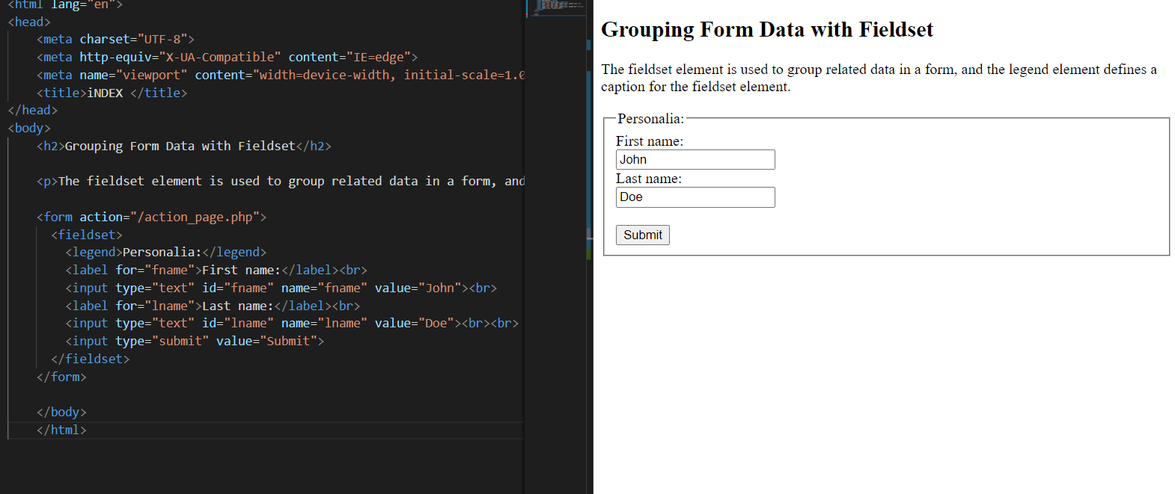

## **The <datalist> Element: -** The <datalist> element specifies a list of pre-defined options for an <input> element. Users will see a drop-down list of pre-defined options as they input data. The list attribute of the <input> element must refer to the id attribute of the <datalist> element.

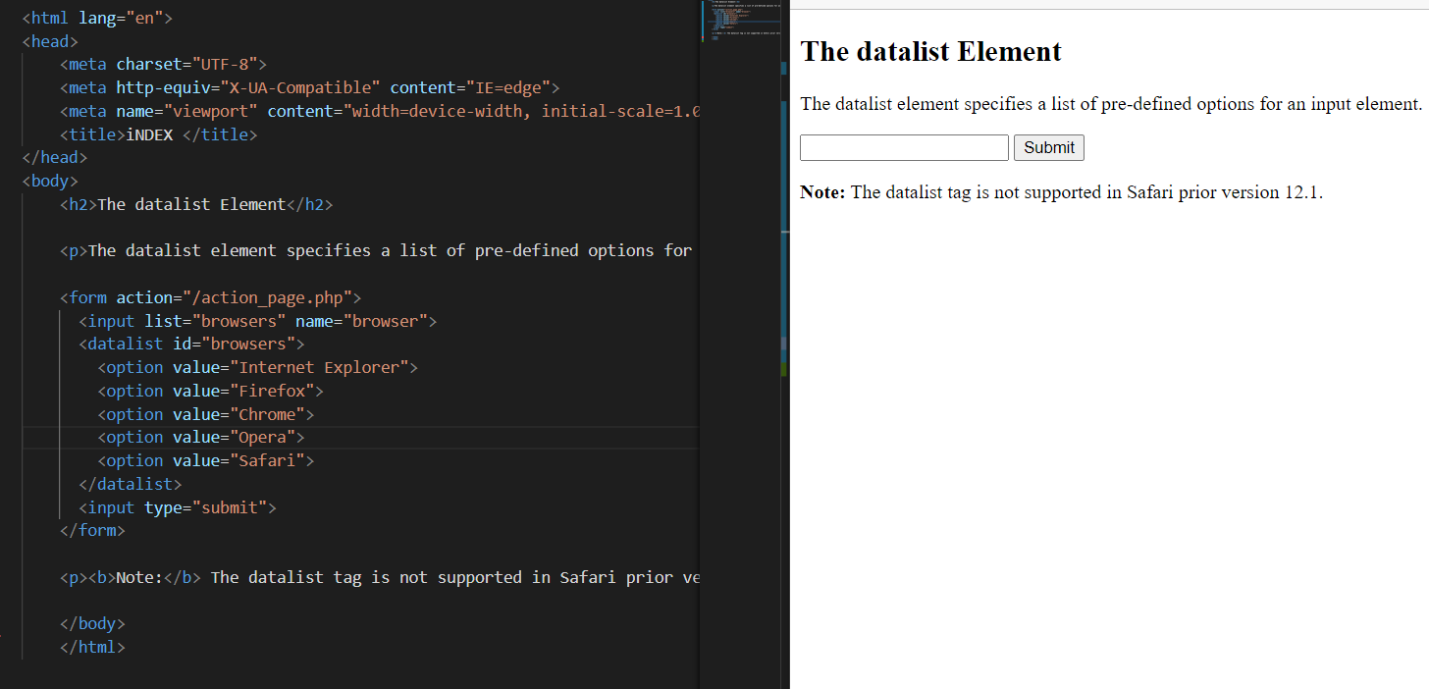

## **The <output> Element: -** The <output> element represents the result of a calculation (like one performed by a script).

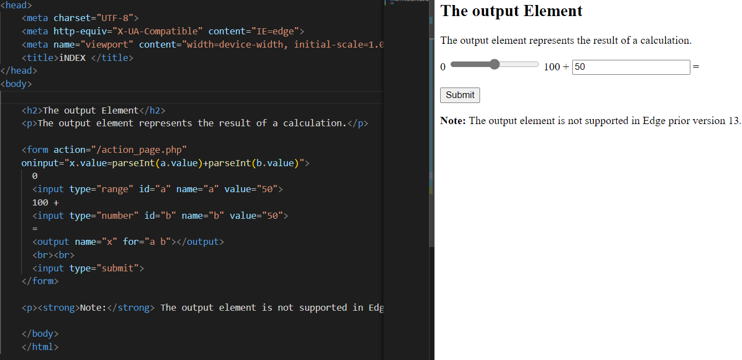

**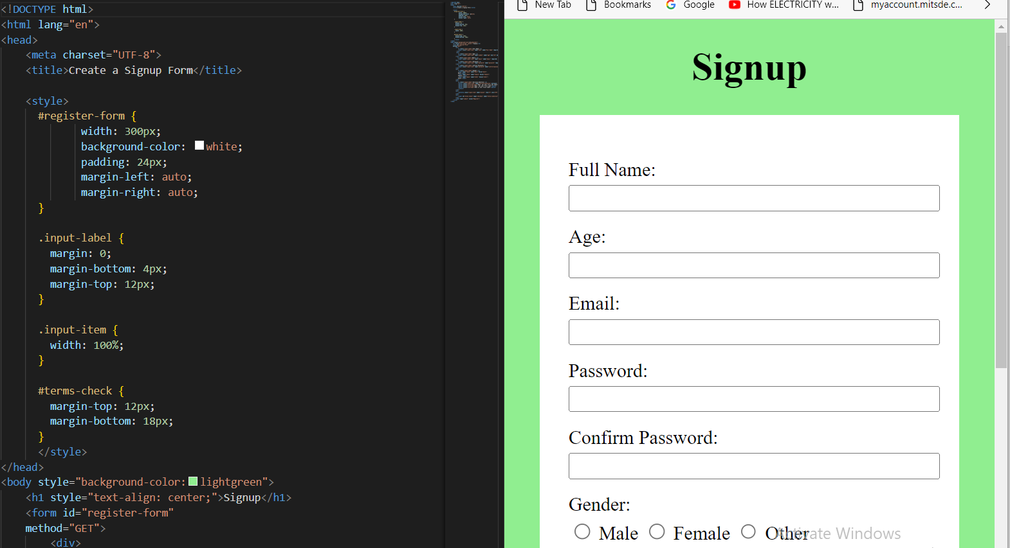**

**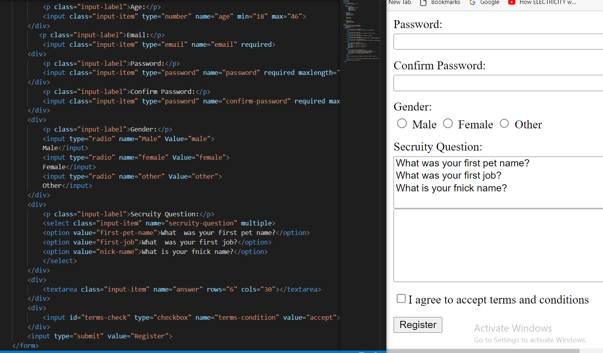**

**Day: - 7**

**Topics: - 1. New Forms Elements: -**

**HTML5 Form Elements: -** The HTML <form> element can contain one or more of the following form elements:

* **<input> <label> <select> <textarea> <button> <fieldset> <legend> <datalist> <output> <option elements> <optgroup>**

**HTMLFormElement.elements: -** **The [HTMLFormElement](https://developer.mozilla.org/en-US/docs/Web/API/HTMLFormElement) property elements returns an [HTMLFormControlsCollection](https://developer.mozilla.org/en-US/docs/Web/API/HTMLFormControlsCollection) listing all the form controls contained in the**[**<form>**](https://developer.mozilla.org/en-US/docs/Web/HTML/Element/form)**element. Independently, you can obtain just the number of form controls using the**[**length**](https://developer.mozilla.org/en-US/docs/Web/API/HTMLFormElement/length)**property. You can access a particular form control in the returned collection by using either an index or the element's name or id attributes. Prior to HTML 5, the returned object was an [HTMLCollection](https://developer.mozilla.org/en-US/docs/Web/API/HTMLCollection), on which HTMLFormControlsCollection is based.**

**Note: Similarly, you can get a list of all of the forms contained within a given document using the document's**[**forms**](https://developer.mozilla.org/en-US/docs/Web/API/Document/forms)**properly.**

## [**Value**](https://developer.mozilla.org/en-US/docs/Web/API/HTMLFormElement/elements#value)**: -**

**An [HTMLFormControlsCollection](https://developer.mozilla.org/en-US/docs/Web/API/HTMLFormControlsCollection) containing all non-image controls in the form. This is a live collection; if form controls are added to or removed from the form, this collection will update to reflect the change.**

**The form controls in the returned collection are in the same order in which they appear in the form by following a preorder, depth-first traversal of the tree. This is called tree order.**

**Only the following elements are returned:**

* [**<button>**](https://developer.mozilla.org/en-US/docs/Web/HTML/Element/button)
* [**<fieldset>**](https://developer.mozilla.org/en-US/docs/Web/HTML/Element/fieldset)
* [**<input>**](https://developer.mozilla.org/en-US/docs/Web/HTML/Element/input)**(with the exception that any whose**[**type**](https://developer.mozilla.org/en-US/docs/Web/HTML/Element/input#attr-type)**is "image" are omitted for historical reasons)**
* [**<object>**](https://developer.mozilla.org/en-US/docs/Web/HTML/Element/object)
* [**<output>**](https://developer.mozilla.org/en-US/docs/Web/HTML/Element/output)
* [**<select>**](https://developer.mozilla.org/en-US/docs/Web/HTML/Element/select)
* [**<textarea>**](https://developer.mozilla.org/en-US/docs/Web/HTML/Element/textarea)

**<form id="my-form">**

**<input type="text" name="username">**

**<input type="text" name="full-name">**

**<input type="password" name="password">**

**</form>**

**const inputs = document.getElementById("my-form").elements;**

**const input index = inputs[0];**

**const inputByName = inputs["username"];**

### [**Accessing form controls**](https://developer.mozilla.org/en-US/docs/Web/API/HTMLFormElement/elements#accessing_form_controls)

**This example gets the form's element list, then iterates over the list, looking for**[**<input>**](https://developer.mozilla.org/en-US/docs/Web/HTML/Element/input)**elements of type**[**"text"**](https://developer.mozilla.org/en-US/docs/Web/HTML/Element/input/text)**so that some form of processing can be performed on them.**

**const inputs = document. getElementById("my-form").elements;**

**// Iterate over the form controls**

**for (i = 0; i < inputs. Length; i++) {**

**if (inputs[i].nodeName === "INPUT" && inputs[i]. type === "text") {**

**// Update text input**

**inputs[i].value.toLocaleUpperCase();**

**}**

**}**

[**Disabling form controls**](https://developer.mozilla.org/en-US/docs/Web/API/HTMLFormElement/elements#disabling_form_controls)**: -**

**const inputs = document.getElementById("my-form").elements;**

**// Iterate over the form controls**

**for (i = 0; i < inputs.length; i++) {**

**// Disable all form controls**

**inputs[i].setAttribute("disabled", "");**

**}**

HTMLFormElement : -

The **HTMLFormElement** interface represents an [<form>](https://developer.mozilla.org/en-US/docs/Web/HTML/Element/form) element in the DOM. It allows access to—and, in some cases, modification of—aspects of the form, as well as access to its component elements.



## [**Properties**](https://developer.mozilla.org/en-US/docs/Web/API/HTMLFormElement#properties)**: -**

**This interface also inherits properties from its parent, [HTMLElement](https://developer.mozilla.org/en-US/docs/Web/API/HTMLElement).**

[**HTMLFormElement.elements**](https://developer.mozilla.org/en-US/docs/Web/API/HTMLFormElement/elements)**Read only**

**An [HTMLFormControlsCollection](https://developer.mozilla.org/en-US/docs/Web/API/HTMLFormControlsCollection) holding all form controls belonging to this form element.**

[**HTMLFormElement.length**](https://developer.mozilla.org/en-US/docs/Web/API/HTMLFormElement/length)**Read only**

**A long reflecting the number of controls in the form.**

[**HTMLFormElement.name**](https://developer.mozilla.org/en-US/docs/Web/API/HTMLFormElement/name)

**A string reflecting the value of the form's**[**name**](https://developer.mozilla.org/en-US/docs/Web/HTML/Element/form#attr-name)**HTML attribute, containing the name of the form.**

[**HTMLFormElement.method**](https://developer.mozilla.org/en-US/docs/Web/API/HTMLFormElement/method)

**A string reflecting the value of the form's**[**method**](https://developer.mozilla.org/en-US/docs/Web/HTML/Element/form#attr-method)**HTML attribute, indicating the HTTP method used to submit the form. Only specified values can be set.**

[**HTMLFormElement.target**](https://developer.mozilla.org/en-US/docs/Web/API/HTMLFormElement/target)

**A string reflecting the value of the form's**[**target**](https://developer.mozilla.org/en-US/docs/Web/HTML/Element/form#attr-target)**HTML attribute, indicating where to display the results received from submitting the form.**

[**HTMLFormElement.action**](https://developer.mozilla.org/en-US/docs/Web/API/HTMLFormElement/action)

**A string reflecting the value of the form's**[**action**](https://developer.mozilla.org/en-US/docs/Web/HTML/Element/form#attr-action)**HTML attribute, containing the URI of a program that processes the information submitted by the form.**

[**HTMLFormElement.encoding**](https://developer.mozilla.org/en-US/docs/Web/API/HTMLFormElement/encoding)**or [HTMLFormElement.enctype](https://developer.mozilla.org/en-US/docs/Web/API/HTMLFormElement/enctype)**

**A string reflecting the value of the form's [enctype](https://developer.mozilla.org/en-US/docs/Web/HTML/Element/form" \l "attr-enctype) HTML attribute indicates the type of content that is used to transmit the form to the server. Only specified values can be set. The two properties are synonyms.**

[**HTMLFormElement.acceptCharset**](https://developer.mozilla.org/en-US/docs/Web/API/HTMLFormElement/acceptCharset)

**A string reflecting the value of the form's**[**accept-charset**](https://developer.mozilla.org/en-US/docs/Web/HTML/Element/form#attr-accept-charset)**HTML attribute, representing the character encoding that the server accepts.**

**HTMLFormElement.autocomplete**

**A string reflecting the value of the form’s autocompleted HTML attribute indicates whether the controls in this form can have their values automatically populated by the browser.**

**HTMLFormElement.noValidate**

**A Boolean value reflects the value of the form**[**validate**](https://developer.mozilla.org/en-US/docs/Web/HTML/Element/form#attr-novalidate)**HTML attribute, indicating whether the form should not be validated.**

**Named inputs are added to their owner form instance as properties, and can overwrite native properties if they share the same name (e.g. a form with an input named action will have its action property return that input instead of the form's**[**action**](https://developer.mozilla.org/en-US/docs/Web/HTML/Element/form#attr-action)**HTML attribute).**

## [Methods](https://developer.mozilla.org/en-US/docs/Web/API/HTMLFormElement#methods)

**This interface also inherits methods from its parent, [HTMLElement](https://developer.mozilla.org/en-US/docs/Web/API/HTMLElement).**

**Check validity()**

**Returns true if the element's child controls are subject to**[**constraint validation**](https://developer.mozilla.org/en-US/docs/Web/Guide/HTML/Constraint_validation)**and satisfy those constraints; returns false if some controls do not satisfy their constraints. Fires an event named**[**invalid**](https://developer.mozilla.org/en-US/docs/Web/API/HTMLInputElement/invalid_event)**at any control that does not satisfy its constraints; such controls are considered invalid if the event is not canceled. It is up to the programmer to decide how to respond to false.**

[**reportValidity()**](https://developer.mozilla.org/en-US/docs/Web/API/HTMLFormElement/reportValidity)

**Returns true if the element's child controls satisfy their**[**validation constraints**](https://developer.mozilla.org/en-US/docs/Web/Guide/HTML/Constraint_validation)**. When false is returned, cancelable**[**invalid**](https://developer.mozilla.org/en-US/docs/Web/API/HTMLInputElement/invalid_event)**events are fired for each invalid child and validation problems are reported to the user.**

[**requestSubmit()**](https://developer.mozilla.org/en-US/docs/Web/API/HTMLFormElement/requestSubmit)

**Requests that the form is submitted using the specified submit button and its corresponding configuration.**

[**reset()**](https://developer.mozilla.org/en-US/docs/Web/API/HTMLFormElement/reset)

**Resets the form to its initial state.**

[**submit()**](https://developer.mozilla.org/en-US/docs/Web/API/HTMLFormElement/submit)

**Submits the form to the server.**

### [**Deprecated methods**](https://developer.mozilla.org/en-US/docs/Web/API/HTMLFormElement#deprecated_methods)

HTMLFormElement.requestAutocomplete() Deprecated

Triggers a native browser interface to assist the user in completing the fields which have an [autofill field name](https://html.spec.whatwg.org/#autofill-field-name) value that is not off or on. The form will receive an event once the user has finished with the interface, the event will either be autocompleted when the fields have been filled or autocomplete error when there was a problem.

## [**Events**](https://developer.mozilla.org/en-US/docs/Web/API/HTMLFormElement#events)

Listen to these events using addEventListener(), or by assigning an event listener to the event name property of this interface.

[formdata](https://developer.mozilla.org/en-US/docs/Web/API/HTMLFormElement/formdata_event)

The formdata event fires after the entry list representing the form's data are constructed.

[reset](https://developer.mozilla.org/en-US/docs/Web/API/HTMLFormElement/reset_event)

The reset event fires when a form is reset.

[submit](https://developer.mozilla.org/en-US/docs/Web/API/HTMLFormElement/submit_event)

The submit event fires when a form is submitted.

## [**Usage notes**](https://developer.mozilla.org/en-US/docs/Web/API/HTMLFormElement#usage_notes)

### [**Obtaining a form element object**](https://developer.mozilla.org/en-US/docs/Web/API/HTMLFormElement#obtaining_a_form_element_object)

To obtain an HTMLFormElement object, you can use a [CSS selector](https://developer.mozilla.org/en-US/docs/Web/CSS/CSS_Selectors) with [querySelector()](https://developer.mozilla.org/en-US/docs/Web/API/Document/querySelector" \o "querySelector()), or you can get a list of all of the forms in the document using its [forms](https://developer.mozilla.org/en-US/docs/Web/API/Document/forms) property.

[**Document. forms**](https://developer.mozilla.org/en-US/docs/Web/API/Document/forms) return an array of HTMLFormElement objects listing each of the forms on the page. You can then use any of the following syntaxes to get an individual form:

**document.forms**[index]

Returns the form at the specified index into the array of forms.

**document.forms[**id]

Returns the form whose ID is id.

**document.forms**[name]

Returns the form whose name attribute's value names.

### [**Accessing the form's elements**](https://developer.mozilla.org/en-US/docs/Web/API/HTMLFormElement#accessing_the_forms_elements)

**You can access the list of the form's data-containing elements by examining the form'selements’ properties. This returns an [HTMLFormControlsCollection](https://developer.mozilla.org/en-US/docs/Web/API/HTMLFormControlsCollection) listing all of the form's user data entry elements, both those which are descendants of the <form> and those which are made members of the form using their form attributes.**

**You can also get the form's element by using its name attribute as a key of the form, but using elements is a better approach—it contains only the form's elements, and it cannot be mixed with other attributes of the form.**

### [**Issues with Naming Elements**](https://developer.mozilla.org/en-US/docs/Web/API/HTMLFormElement#issues_with_naming_elements)

**Some names will interfere with JavaScript access to the form's properties and elements.**

**For example:**

* **<input name="id"> will take precedence over <form id="…">. This means that form. will not refer to the form's id, but to the element whose name is "id". This will be the case with any other form properties, such as <input name="action"> or <input name="post">.**
* **<input name="elements"> will render the form's elements collection inaccessible. The reference form. elements will now refer to the individual element.**

**To avoid such problems with element names:**

* **Always use the elements collection to avoid ambiguity between an element name and a form property.**
* **Never use "elements" as an element name.**

**If you are not using JavaScript, this will not cause a problem.**

### [**Elements that are considered form controls**](https://developer.mozilla.org/en-US/docs/Web/API/HTMLFormElement#elements_that_are_considered_form_controls)

**The elements included by HTMLFormElement.elements and HTMLFormElement.length are the following:**

* [**<button>**](https://developer.mozilla.org/en-US/docs/Web/HTML/Element/button)
* [**<fieldset>**](https://developer.mozilla.org/en-US/docs/Web/HTML/Element/fieldset)
* [**<input>**](https://developer.mozilla.org/en-US/docs/Web/HTML/Element/input)**(with the exception that any whose**[**type**](https://developer.mozilla.org/en-US/docs/Web/HTML/Element/input#attr-type)**is "image" are omitted for historical reasons)**
* [**<object>**](https://developer.mozilla.org/en-US/docs/Web/HTML/Element/object)
* [**<output>**](https://developer.mozilla.org/en-US/docs/Web/HTML/Element/output)
* [**<select>**](https://developer.mozilla.org/en-US/docs/Web/HTML/Element/select)
* [**<textarea>**](https://developer.mozilla.org/en-US/docs/Web/HTML/Element/textarea)

**No other elements are included in the list returned by elements, which makes it an excellent way to get at the elements most important when processing forms.**

**2. New Input Types: -**

# <input>: The Input (Form Input) element

The <input> [HTML](https://developer.mozilla.org/en-US/docs/Web/HTML) element is used to create interactive controls for web-based forms to accept data from the user; a wide variety of types of input data and control widgets are available, depending on the device and [user agent](https://developer.mozilla.org/en-US/docs/Glossary/User_agent). The <input> element is one of the most powerful and complex in all of HTML due to the sheer number of combinations of input types and attributes.

## [**<input> types**](https://developer.mozilla.org/en-US/docs/Web/HTML/Element/input#input_types)

**How a <input> works vary considerably depending on the value of its**[**type**](https://developer.mozilla.org/en-US/docs/Web/HTML/Element/input#type)**attribute, hence the different types are covered in their separate reference pages. If this attribute is not specified, the default type adopted is text.**

**The available types are as follows:**

**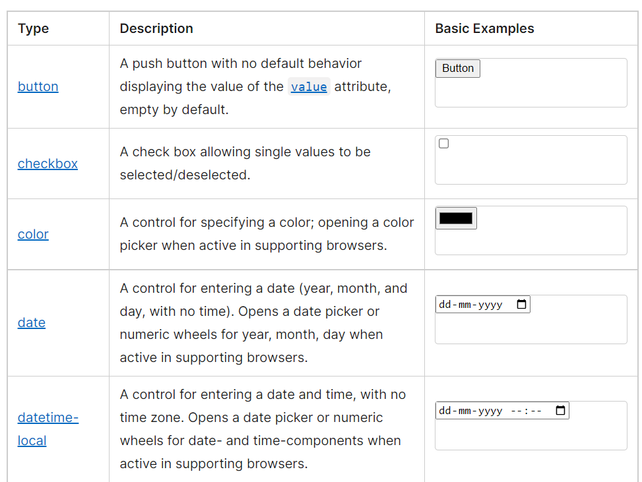**

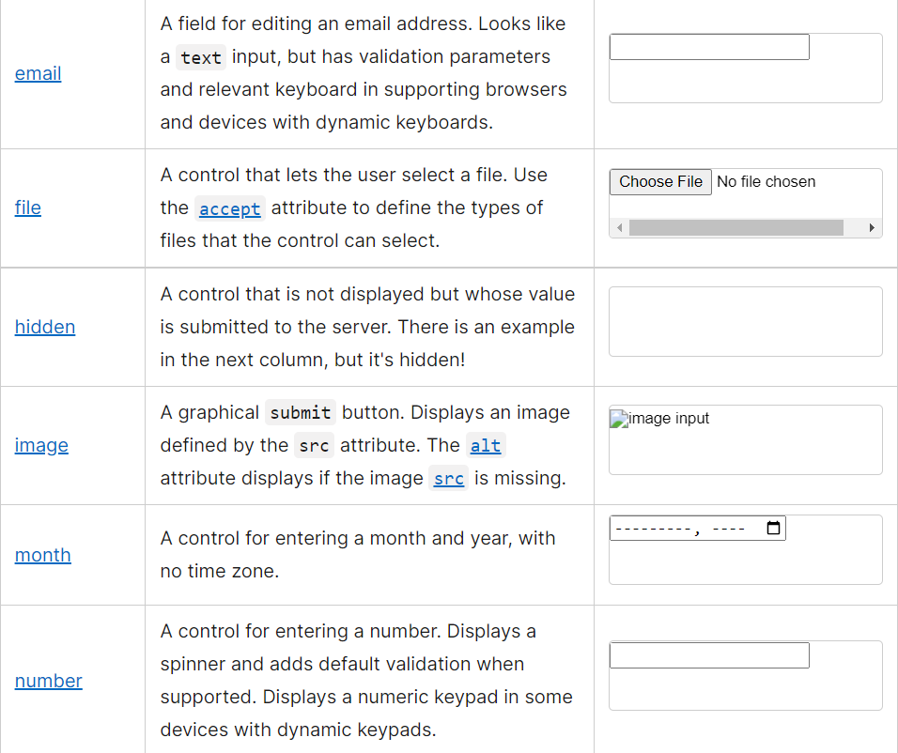

**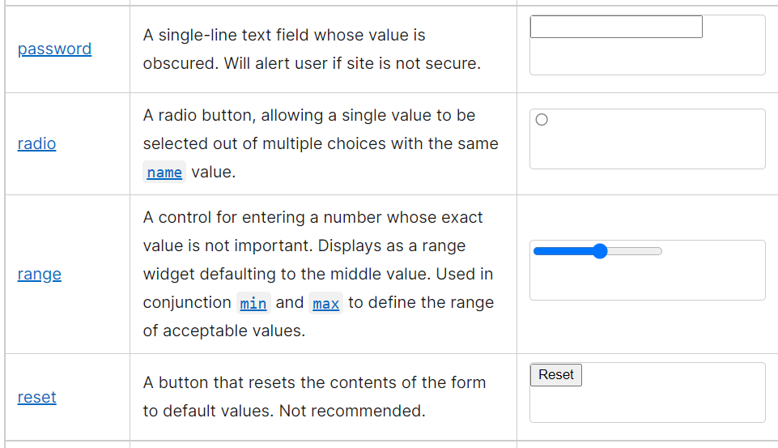**

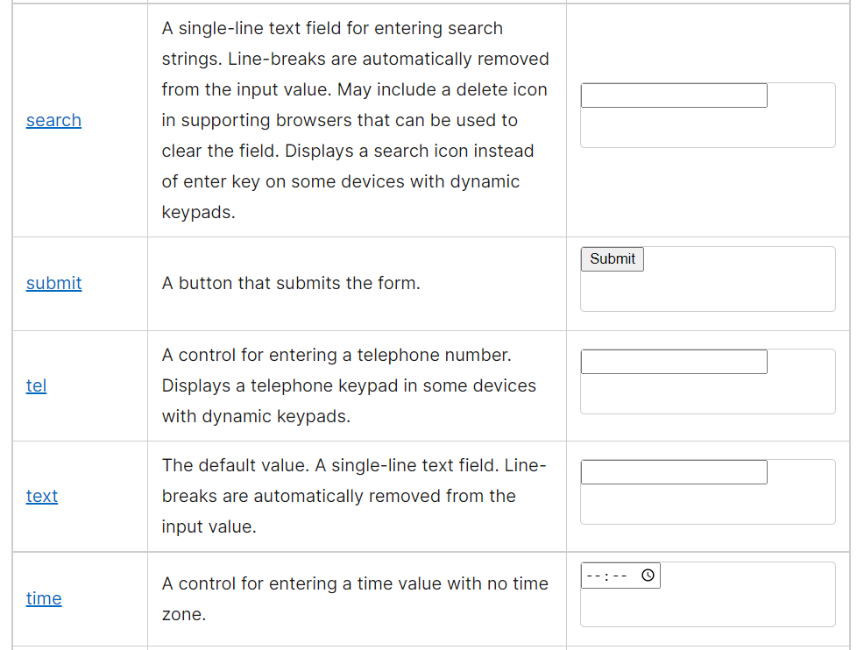

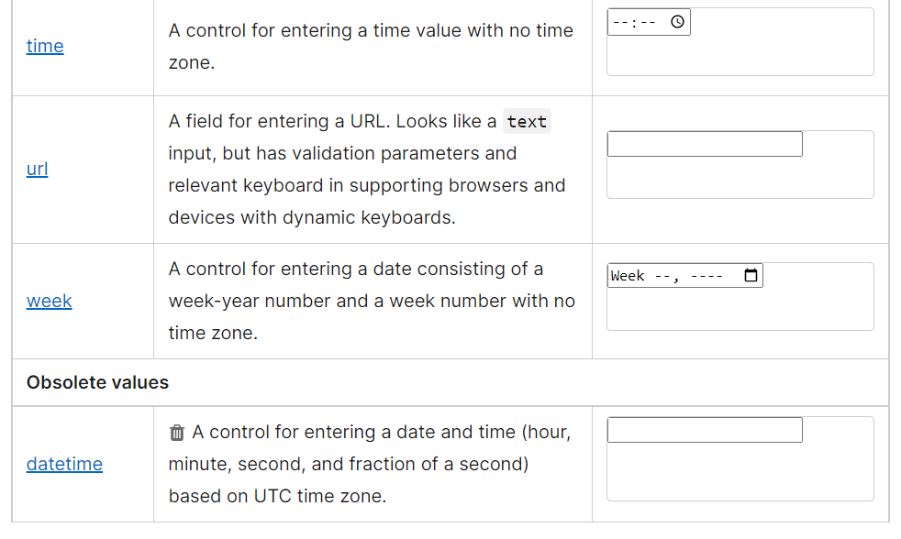

**3. New Attributes: -**

**The <input> element is so powerful because of its attributes; the**[**type**](https://developer.mozilla.org/en-US/docs/Web/HTML/Element/input#type)**attribute, described with examples above, is the most important. Since every <input> element, regardless of type, is based on the [HTMLInputElement](https://developer.mozilla.org/en-US/docs/Web/API/HTMLInputElement) interface, they technically share the same set of attributes. However, in reality, most attributes affect only a specific subset of input types. In addition, the way some attributes impact an input depends on the input type, impacting different input types in different ways.**

**This section provides a table listing all the attributes with a brief description. This table is followed by a list describing each attribute in greater detail, along with which input types they are associated with. Those that are common to most or all input types are defined in greater detail below. Attributes that are unique to particular input types—or attributes that are common to all input types but have special behaviors when used on a given input type—are instead documented on those types' pages.**

**Attributes for the <input> element include the**[**global HTML attributes**](https://developer.mozilla.org/en-US/docs/Web/HTML/Global_attributes)**and additionally:**

**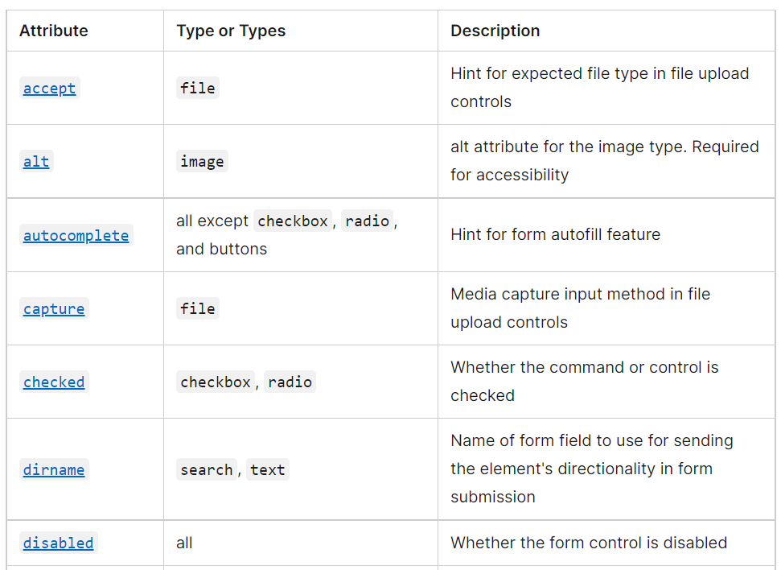**

**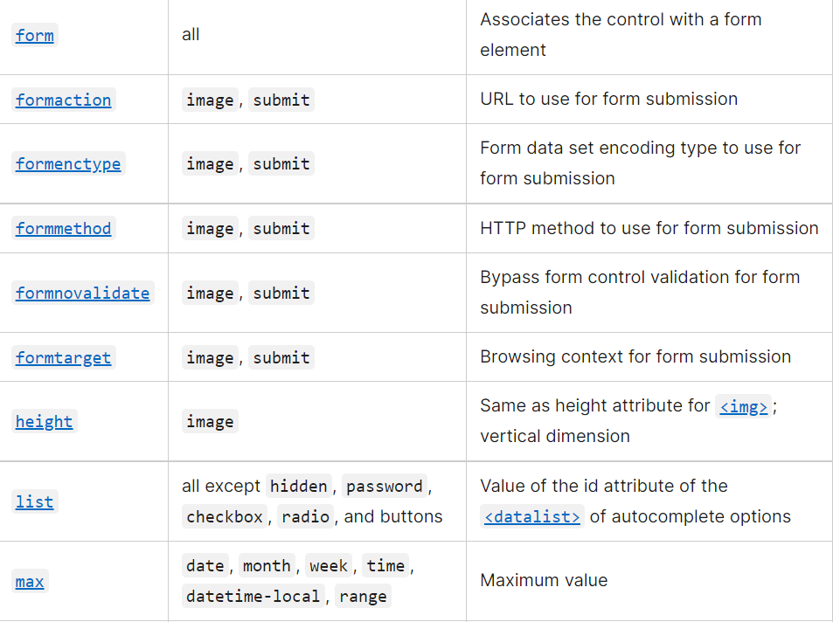**

**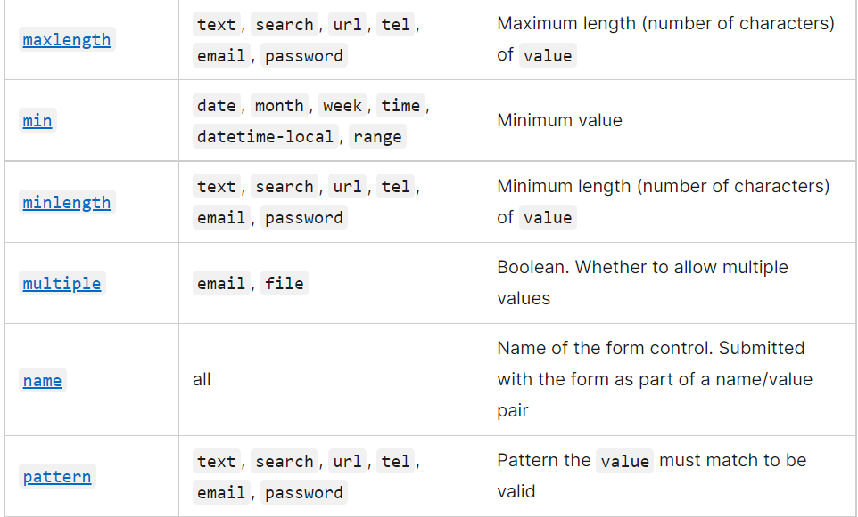**

**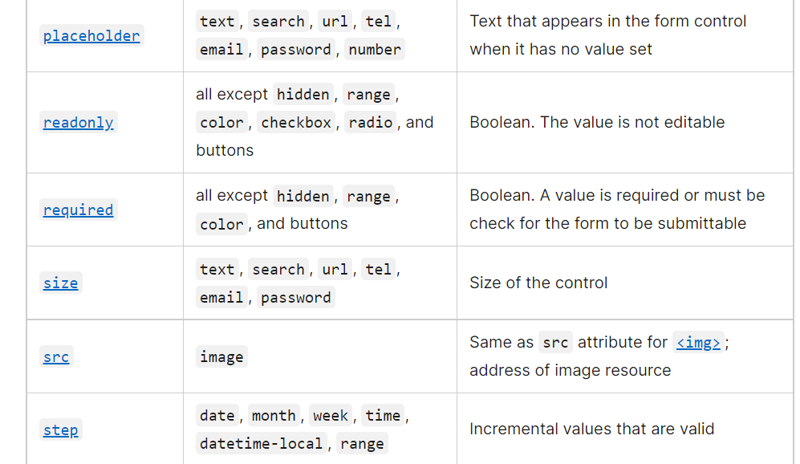**

**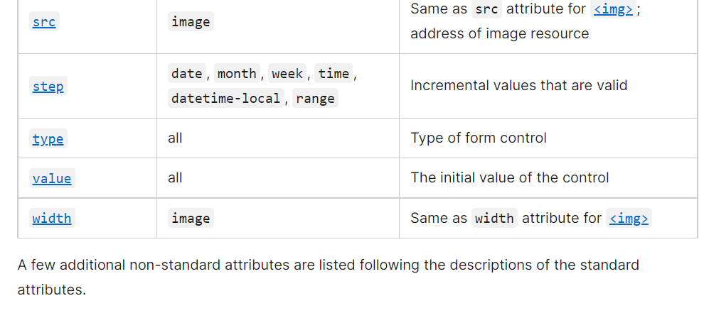**

### [**Individual attributes**](https://developer.mozilla.org/en-US/docs/Web/HTML/Element/input#individual_attributes)

**accept**

Valid for the file input type only, the accept attribute defines which file types are selectable in a file upload control. See the [file](https://developer.mozilla.org/en-US/docs/Web/HTML/Element/input/file) input type.

**alt**

Valid for the image button only, the alt attribute provides alternative text for the image, displaying the value of the attribute if the image [src](https://developer.mozilla.org/en-US/docs/Web/HTML/Element/input#src) is missing or otherwise fails to load. See the [image](https://developer.mozilla.org/en-US/docs/Web/HTML/Element/input/image) input type.

[**autocomplete**](https://developer.mozilla.org/en-US/docs/Web/HTML/Attributes/autocomplete)

(**Not** a Boolean attribute!) The [autocomplete](https://developer.mozilla.org/en-US/docs/Web/HTML/Attributes/autocomplete) attribute takes as its value a space-separated string that describes what, if any, type of autocomplete functionality the input should provide. A typical implementation of autocomplete recalls previous values entered in the same input field, but more complex forms of autocomplete can exist. For instance, a browser could integrate with a device's contacts list to autocomplete email addresses in an email input field. See [Values](https://developer.mozilla.org/en-US/docs/Web/HTML/Attributes/autocomplete#values) in [HTML attribute: autocomplete](https://developer.mozilla.org/en-US/docs/Web/HTML/Attributes/autocomplete) for permitted values.

The autocomplete attribute is valid on hidden, text, search, URL, tel, email, date, month, week, time, DateTime-local, number, range, color, and password. This attribute does not affect input types that do not return numeric or text data, being valid for all input types except checkbox, radio, file, or any of the button types.

See [The HTML autocomplete attribute](https://developer.mozilla.org/en-US/docs/Web/HTML/Attributes/autocomplete) for additional information, including information on password security and how to autocomplete is slightly different for hidden than for other input types.

**autofocus**

A Boolean attribute which, if present, indicates that the input should automatically have focus when the page has finished loading (or when the [<dialog>](https://developer.mozilla.org/en-US/docs/Web/HTML/Element/dialog) containing the element has been displayed).

**Note:** An element with the autofocus attribute may gain focus before the [DOMContentLoaded](https://developer.mozilla.org/en-US/docs/Web/API/Window/DOMContentLoaded_event" \o "DOMContentLoaded) event is fired.

No more than one element in the document may have the autofocus attribute. If put on more than one element, the first one with the attribute receives focus.

The autofocus attribute cannot be used on inputs of type hidden, since hidden inputs cannot be focused.

**Warning:** Automatically focusing a form control can confuse visually-impaired people using screen-reading technology and people with cognitive impairments. When autofocus is assigned, screen-readers "teleport" their user to the form control without warning them.

Use careful consideration for accessibility when applying the autofocus attribute. Automatically focusing on control can cause the page to scroll on load. The focus can also cause dynamic keyboards to display on some touch devices. While a screen reader will announce the label of the form control receiving focus, the screen reader will not announce anything before the label, and the sighted user on a small device will equally miss the context created by the preceding content.

**capture**

Introduced in the HTML Media Capture specification and valid for the file input type only, the capture attribute defines which media—microphone, video, or camera—should be used to capture a new file for upload with file upload control in supporting scenarios. See the [file](https://developer.mozilla.org/en-US/docs/Web/HTML/Element/input/file) input type.

**checked**

Valid for both radio and checkbox types, checked is a Boolean attribute. If present on a radio type, it indicates that the radio button is the currently selected one in the group of same-named radio buttons. If present on a checkbox type, it indicates that the checkbox is checked by default (when the page loads). It does not indicate whether this checkbox is currently checked: if the checkbox's state is changed, this content attribute does not reflect the change. (Only the [HTMLInputElement's checked IDL attribute](https://developer.mozilla.org/en-US/docs/Web/API/HTMLInputElement) is updated.)

**Note:** Unlike other input controls, checkboxes and radio buttons value are only included in the submitted data if they are currently checked. If they are, the name and the value(s) of the checked controls are submitted.

For example, if a checkbox whose name is fruit has a value of cherry, and the checkbox is checked, the form data submitted will include fruit=cherry. If the checkbox isn't active, it isn't listed in the form data at all. The default value for checkboxes and radio buttons is on.

**dirname**

Valid for text and search input types only, the dirname attribute enables the submission of the directionality of the element. When included, the form control will submit with two name/value pairs: the first being the [name](https://developer.mozilla.org/en-US/docs/Web/HTML/Element/input#name) and [value](https://developer.mozilla.org/en-US/docs/Web/HTML/Element/input#value), the second being the value of the surname as the name with the value of ltr or rtl being set by the browser.

<form action="page.html" method="post">

<label>Fruit: <input type="text" name="fruit" dirname="fruit.dir" value="cherry"></label>

<input type="submit"/>

</form>

<!-- page.HTML?fruit=cherry&fruit.dir=ltr -->

Copy to Clipboard

When the form above is submitted, the input cause both the name/value pair of fruit=cherry and the surname/direction pair of fruit.dir=ltr to be sent.

**disabled**

A Boolean attribute, if present, indicates that the user should not be able to interact with the input. Disabled inputs are typically rendered with a dimmer color or using some other form of indication that the field is not available for use.

Specifically, disabled inputs do not receive the [click](https://developer.mozilla.org/en-US/docs/Web/API/Element/click_event) event, and disabled inputs are not submitted with the form.

**Note:** Although not required by the specification, Firefox will by default [persist the dynamic disabled state](https://stackoverflow.com/questions/5985839/bug-with-firefox-disabled-attribute-of-input-not-resetting-when-refreshing) of an <input> across page loads. Use the [autocomplete](https://developer.mozilla.org/en-US/docs/Web/HTML/Element/input#autocomplete) attribute to control this feature.

**4. Form Validation: -**

### HTML Form Validation

There are mainly two ways by which HTML form validation can be performed, Using HTML5 built-in functionality and Using JavaScript

#### **1. Using HTML5 built-in functionality**

[**HTML5 provides**](https://www.educba.com/what-is-html5/)**this feature of form validation without using JavaScript. Form elements will have validation attributes added, which will enable the form validation for us automatically. Validation attributes allow us to specify various kinds of rules on our form elements. They allow us to set the length of the data, set a restriction on the values of the data, etc.**

**Let’s see one simple example of HTML form validation using built-in form validating elements and will then proceed further for HTML form validation using JavaScript.**

**Example**

**Form Validation using HTML5 validation attribute – In this example, we will use the form validation tag required, which will cause data in that field to be mandatory to be entered; otherwise, the form will not be submitted. Below is the code snippet for the same, along with some styling of a web form.**

**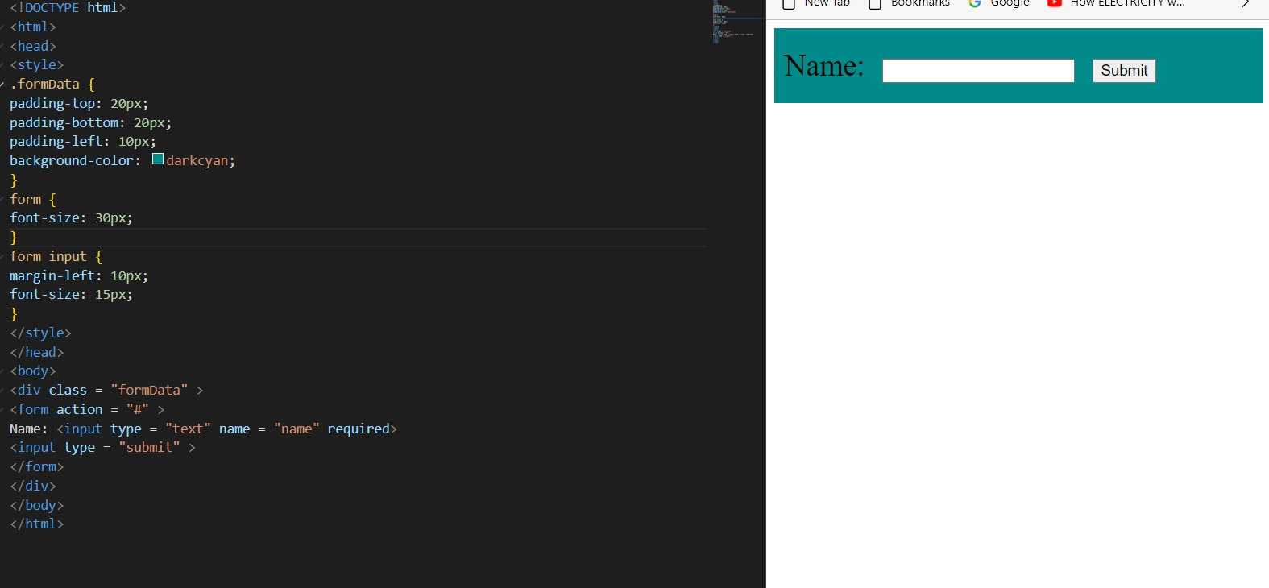**

**Form**

**A string specifying the**[**<form>**](https://developer.mozilla.org/en-US/docs/Web/HTML/Element/form)**element with which the input is associated (that is, its form owner). This string's value, if present, must match the**[**id**](https://developer.mozilla.org/en-US/docs/Web/HTML/Element/input#id)**of anthe a <form> element in the same document. If this attribute isn't specified, the <input> element is associated with the nearest containing form, if any.**

**The form attribute lets you place an input anywhere in the document but have it included with a form elsewhere in the document.**

**Formation**

**Valid for the image and submit input types only. See the**[**submit**](https://developer.mozilla.org/en-US/docs/Web/HTML/Element/input/submit)**input type for more information.**

**Former type**

**Valid for the image and submit input types only. See the**[**submit**](https://developer.mozilla.org/en-US/docs/Web/HTML/Element/input/submit)**input type for more information.**

**Form method**

**Valid for the image and submit input types only. See the**[**submit**](https://developer.mozilla.org/en-US/docs/Web/HTML/Element/input/submit)**input type for more information.**

**Formnovalidate**

**Valid for the image and submit input types only. See the**[**submit**](https://developer.mozilla.org/en-US/docs/Web/HTML/Element/input/submit)**input type for more information.**

**From target**

**Valid for the image and submit input types only. See the**[**submit**](https://developer.mozilla.org/en-US/docs/Web/HTML/Element/input/submit)**input type for more information.**

**Height**

**Valid for the image input button only, the height is the height of the image file to display to represent the graphical submit button. See the**[**image**](https://developer.mozilla.org/en-US/docs/Web/HTML/Element/input/image)**input type.**

**id**

**Global attribute valid for all elements, including all the input types, it defines a unique identifier (ID) which must be unique in the whole document. Its purpose is to identify the element when linking. The value is used as the value of the**[**<label>**](https://developer.mozilla.org/en-US/docs/Web/HTML/Element/label)**'s for attribute to link the label with the form control. See**[**<label>**](https://developer.mozilla.org/en-US/docs/Web/HTML/Element/label)**.Input model**

**Global value is valid for all elements, it provides a hint to browsers as to the type of virtual keyboard configuration to use when editing this element or its contents. Values include none, text, tour URL, email, numeric, decimal, and search.**

**list**

**The value given to the list attribute should be thid ofof ana**[**<datalist>**](https://developer.mozilla.org/en-US/docs/Web/HTML/Element/datalist)**element located in the same document. The <datalist> provides a list of predefined values to suggest to the user for this input. Any values in the list that are not compatible with the**[**type**](https://developer.mozilla.org/en-US/docs/Web/HTML/Element/input#type)**are not included in the suggested options. The values provided are suggestions, not requirements: users can select from this predefined list or provide a different value.**

**It is valid on text, searcURLurl, tel, email, date, month, week, timDateTimeime-local, number, range, and color.**

**Per the specifications, the list attribute is not supported by the hidden, password, checkbox, radio, file, or any of the button types.**

**Depending on the browser, the user may see a custom color palette suggested, tic marks along a range, or even input that opens like a**[**<select>**](https://developer.mozilla.org/en-US/docs/Web/HTML/Element/select)**but allows for non-listed values. Check out the**[**browser compatibility table**](https://developer.mozilla.org/en-US/docs/Web/HTML/Element/datalist#browser_compatibility)**for the other input types.**

**See the**[**<datalist>**](https://developer.mozilla.org/en-US/docs/Web/HTML/Element/datalist)**element.**

**Max**

**Valid fa or date, month, week, timDateTimeime-local, number, and range, it defines the greatest value in the range of permitted values. If the**[**value**](https://developer.mozilla.org/en-US/docs/Web/HTML/Element/input#value)**entered into the element exceeds this, the element fails**[**constraint validation**](https://developer.mozilla.org/en-US/docs/Web/Guide/HTML/Constraint_validation)**. If the value of the max attribute isn't a number, then the element has no maximum value.**

**There is a special case: if the data type is periodic (such as for dates or times), the value of max may be lower than the value of min, which indicates that the range may wrap around; for example, this allows you to specify a time range from 10 PM to 4 AMMax length**

**Valid for text, searcURLurl, tel, email, and password, it defines the maximum number of characters (as UTF-16 code units) the user can enter into the field. This must be an integer value ue 0 or higher. If max length is specified, or an invalid value is specified, the field has no maximum length. This value must also be greater than or equal to the value in length.**

**The input will fail**[**constraint validation**](https://developer.mozilla.org/en-US/docs/Web/Guide/HTML/Constraint_validation)**if the length of the text entered into the field is greater than the length of UTF-16 code units long. By default, browsers prevent users from entering more characters than allowed by the maxlength attribute. See**[**Client-side validation**](https://developer.mozilla.org/en-US/docs/Web/HTML/Element/input#client-side_validation)**for more information.**

**Min**

**Valid fa or date, month, week, timDateTimeime-local, number, and range, it defines the most negative value in the range of permitted values. If the**[**value**](https://developer.mozilla.org/en-US/docs/Web/HTML/Element/input#value)**entered into the element is less than this, the element fails**[**constraint validation**](https://developer.mozilla.org/en-US/docs/Web/Guide/HTML/Constraint_validation)**. If the value of the min attribute isn't a number, then the element has no minimum value.**

**This value must be less than or equal to the value of the max attribute. If the min attribute is present but is not specified or is invalid, no min value is applied. If the min attribute is valid and a non-empty value is less than the minimum allowed by the min attribute, constraint validation will prevent form submission. See**[**Client-side validation**](https://developer.mozilla.org/en-US/docs/Web/HTML/Element/input#client-side_validation)**for more information.**

**There is a special case: if the data type is periodic (such as for dates or times), the value of max may be lower than the value of min, which indicates that the range may wrap around; for example, this allows you to specify a time range from 10 PM to 4 AMMin length**

**Valid for text, searcURLurl, tel, email, and password, it defines the minimum number of characters (as UTF-16 code units) the user can enter into the entry field. This must be a non-negative integer value smaller than or equal to the value specified max length. If no minlength is specified, or an invalid value is specified, the input has no minimum length.**

**The input will fail**[**constraint validation**](https://developer.mozilla.org/en-US/docs/Web/Guide/HTML/Constraint_validation)**if the length of the text entered into the field is fewer than the length of UTF-16 code units long, preventing form submission. See**[**Client-side validation**](https://developer.mozilla.org/en-US/docs/Web/HTML/Element/input#client-side_validation)**for more information.**

**Multiple**

**The Boolean multipattributesute, if set, means the user can entcomma-separated the email addresses in the email widget or can choose more than one file with the file input. See the**[**email**](https://developer.mozilla.org/en-US/docs/Web/HTML/Element/input/email)**and**[**file**](https://developer.mozilla.org/en-US/docs/Web/HTML/Element/input/file)**input type.**

**Name**

**A string specifying a name for the input control. This name is submitted along with the control's value when the form data is submitted.**

**Consider the name a required attribute (even though it's not). If an input has no name specified, the name is empty, and the input's value is not submitted with the form! (Disabled controls, unchecked radio buttons, unchecked checkboxes, and reset buttons are also not sent.)**

**There are two special cases:**

1. **\_charst\_: If used as the name of an <input> element of type**[**hidden**](https://developer.mozilla.org/en-US/docs/Web/HTML/Element/input/hidden)**, the input's value is automatically set by the**[**user agent**](https://developer.mozilla.org/en-US/docs/Glossary/User_agent)**to the character encoding being used to submit the form.**
2. **Indexes exdex: For historical reasons, the index is not allowed.**

**The**[**name**](https://developer.mozilla.org/en-US/docs/Web/HTML/Element/input#name)**attribute creates a unique behavior for radio buttons.**

**Only one radio button then a same-named group of radio buttons can be checked at a time. Selecting any radio button in that group automatically deselects any currently-selected radio button in the same group. The value of that one checked radio button is sent along with the naof if the form is submitted,**

**When tabbing into a series of the same-named group of radio buttons, if one is checked, that one will receive focus. If they aren't grouped in source order if one of the groups up is checked, tabbing into the group starts when the first one in the group is encountered, skipping all those that aren't checked. In other words, if one is checked, tabbing skips the unchecked radio buttons in the group. If none are checked, the radio button group receives focus when the first button in the same name group is reached.**

**Once one of the radio buttons in a group hfocusedcus, using the arrow keys will navigate through all the radio buttons of the same name, even if the radio buttons are not grouper in the source order.**

**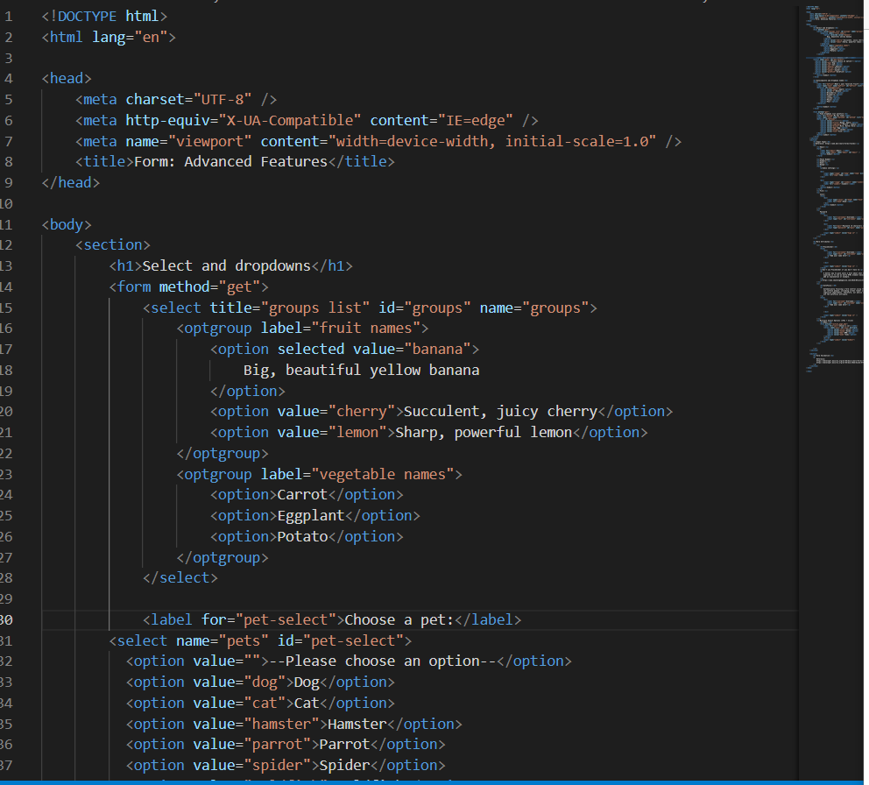**

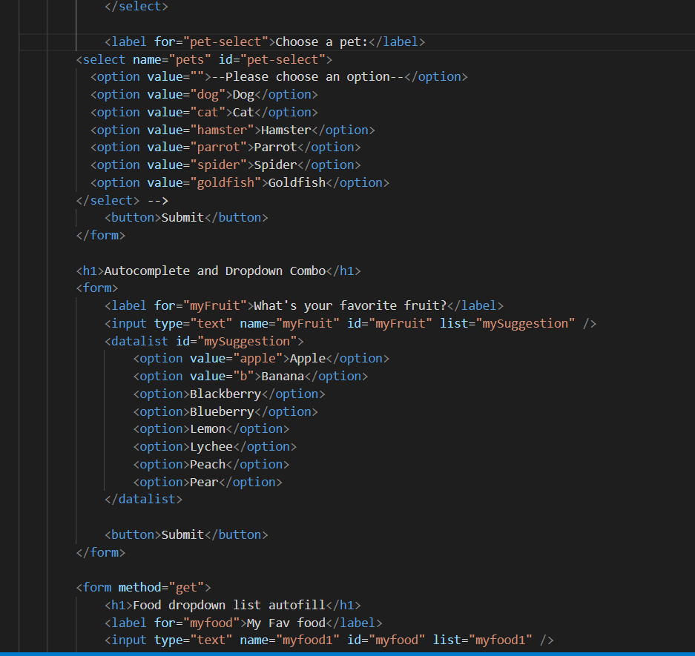

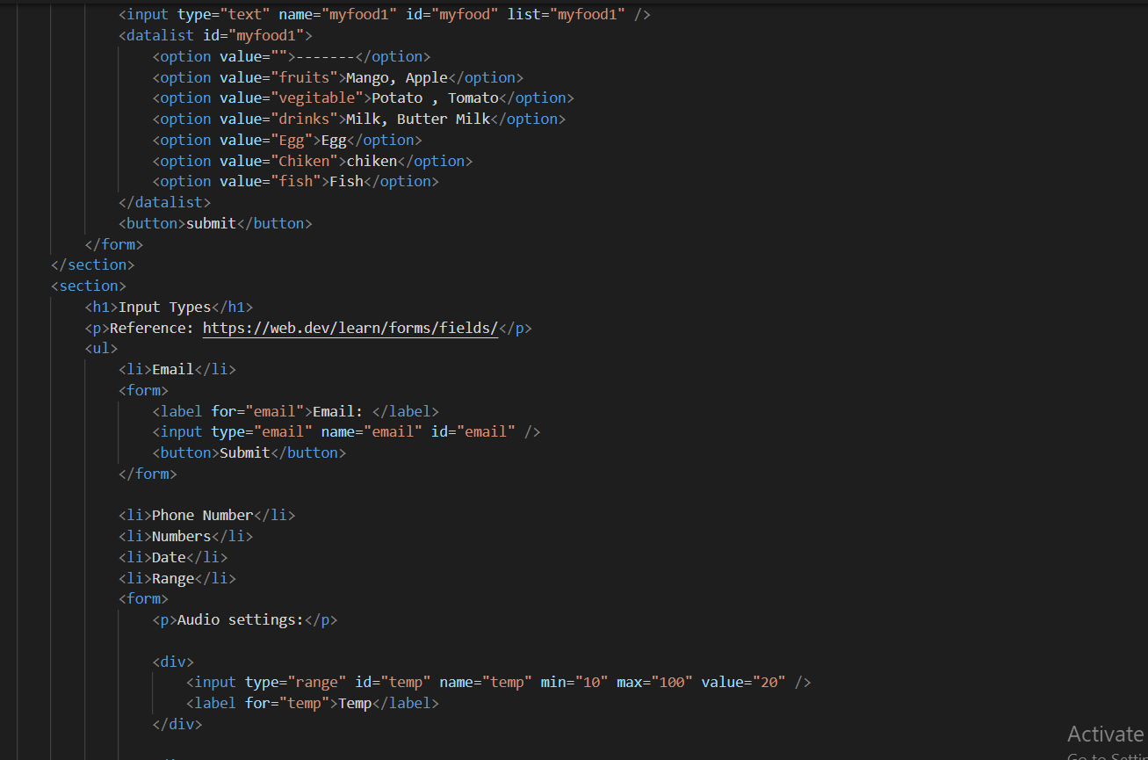

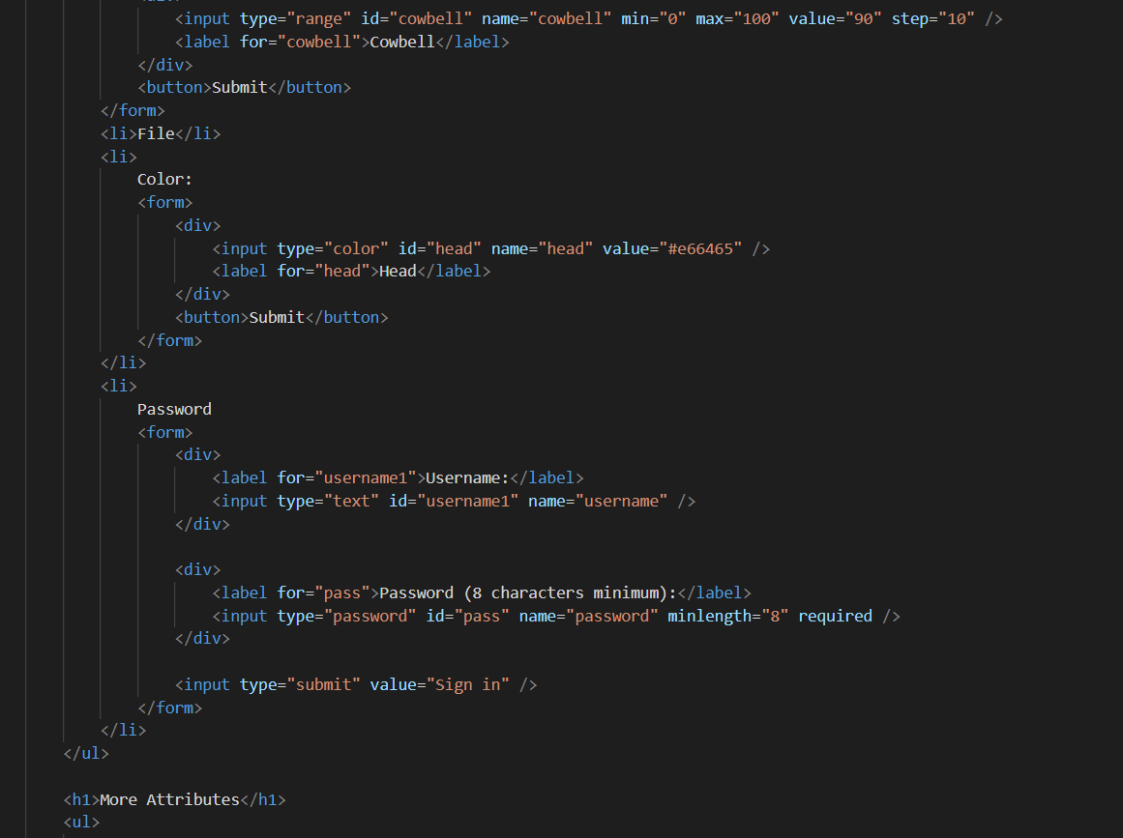

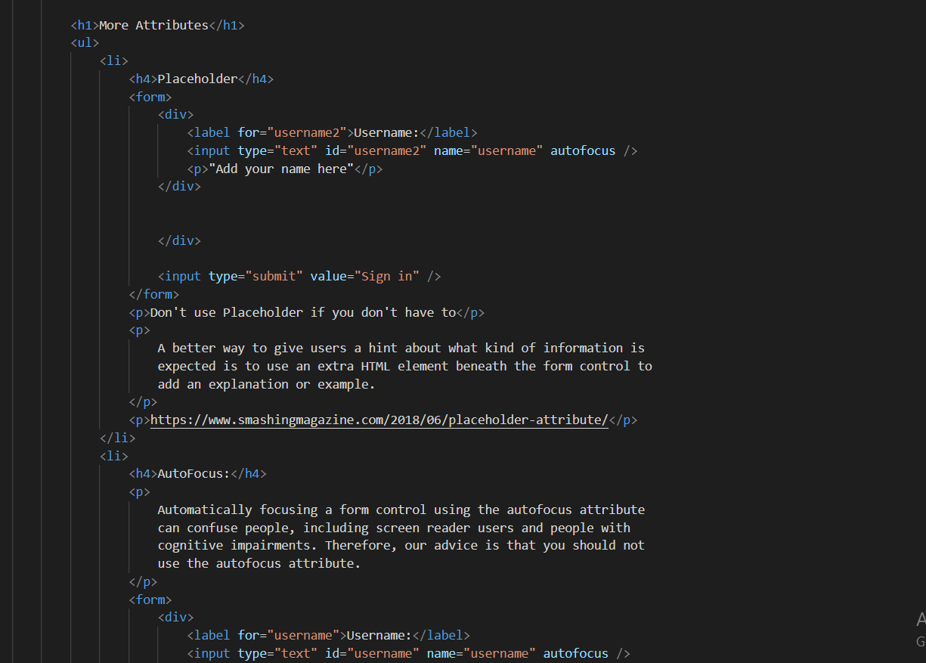

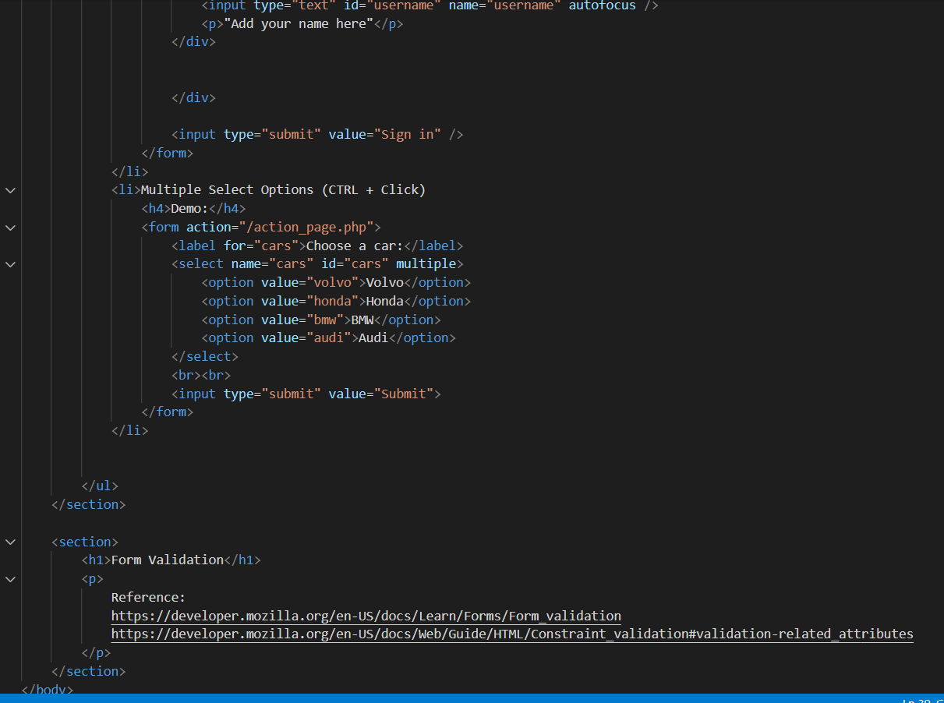

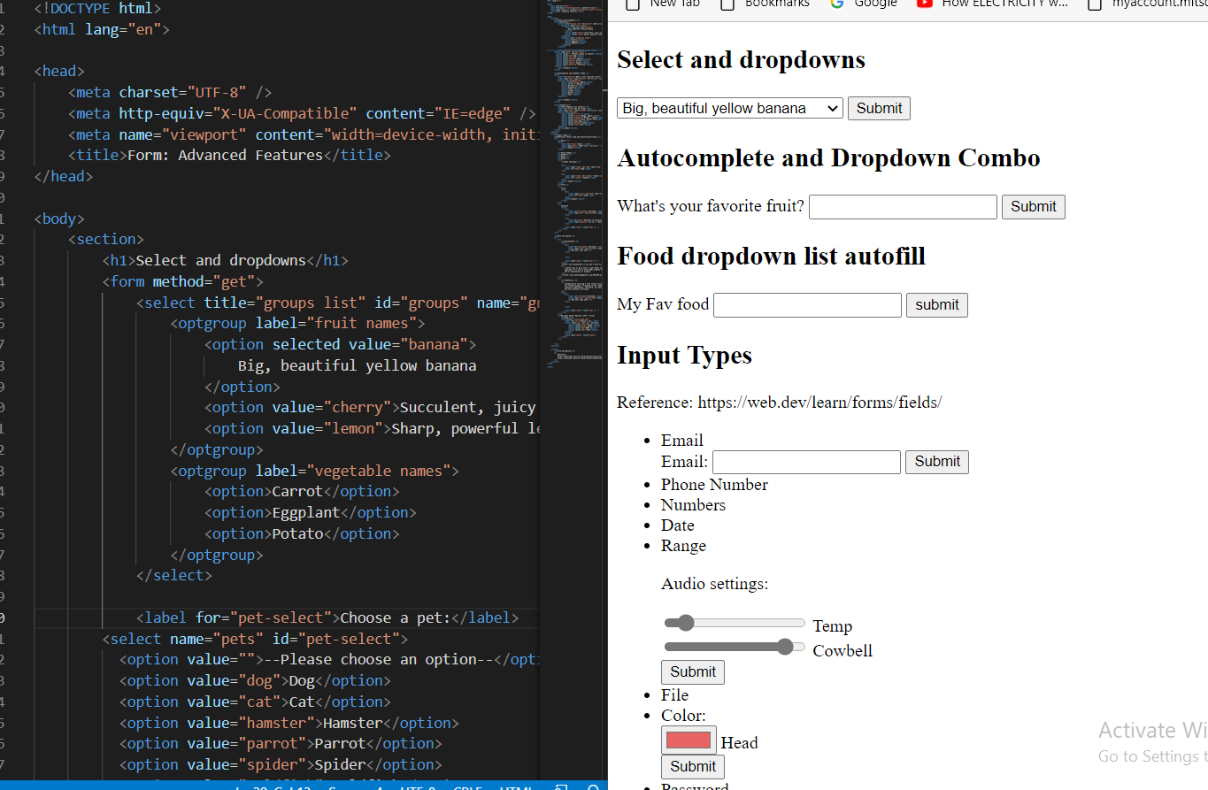

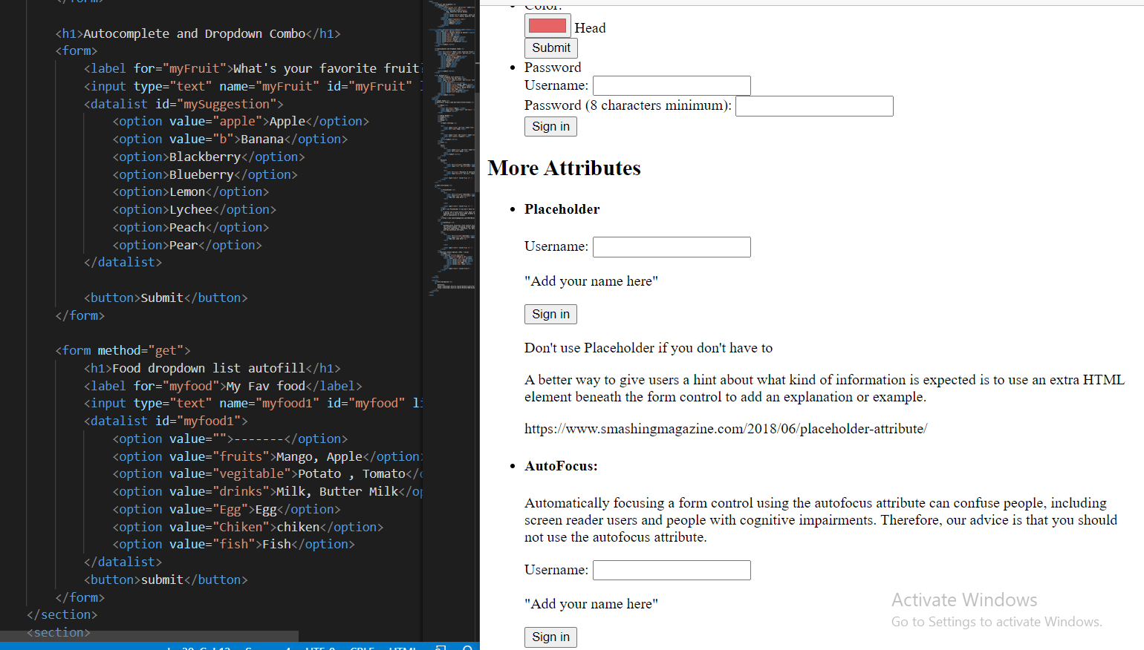

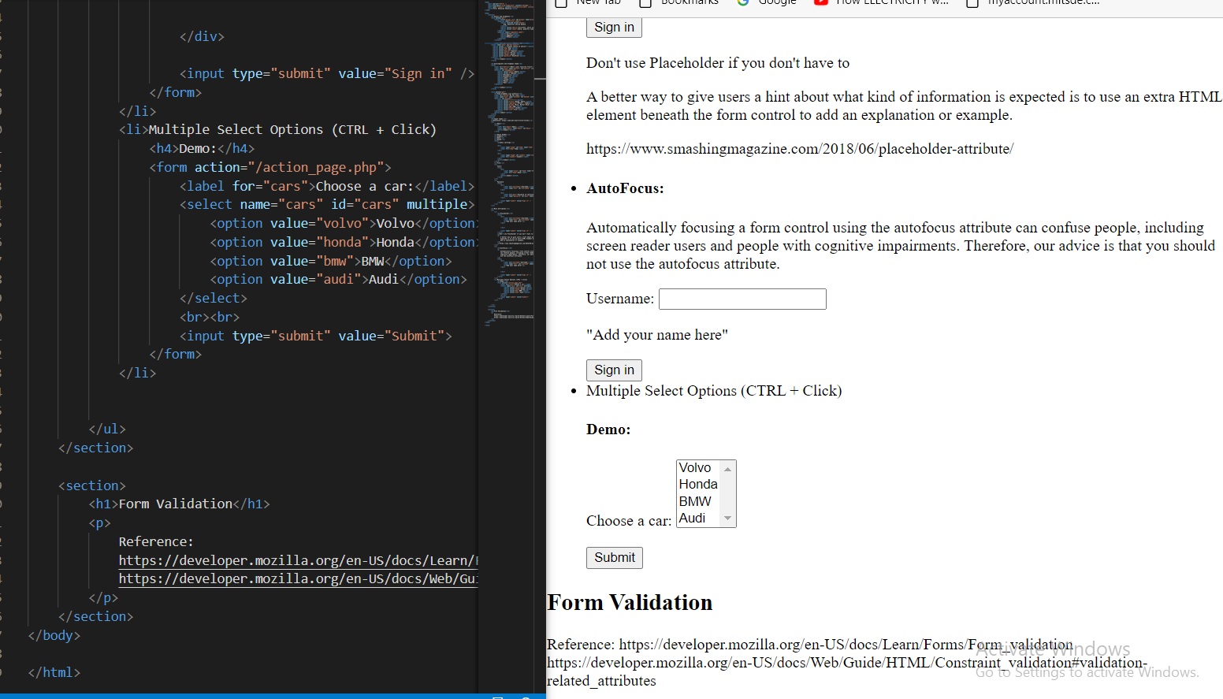

**Day: - 8**

**Topics: - 1. Embedding Audio: -**

# <audio>: The Embed Audio element

**The <audio>**[**HTML**](https://developer.mozilla.org/en-US/docs/Web/HTML)**element is used to embed sound content in documents. It may contain one or more audio sources, represented using the src attribute or the**[**<source>**](https://developer.mozilla.org/en-US/docs/Web/HTML/Element/source)**element: the browser will choose the most suitable one. It can also be the destination for streamed media, using**[**Media Stream**](https://developer.mozilla.org/en-US/docs/Web/API/MediaStream)**.**

**The above example shows simple usage of the <audio> element. In a similar manner to the**[**<img>**](https://developer.mozilla.org/en-US/docs/Web/HTML/Element/img)**element, we include a path to the media we want to embed inside the src attribute; we can include other attributes to specify information such as whether we want it to autoplay and loop, whether we want to show the browser's default audio controls, etc.**

**The content inside the opening and closing <audio></audio> tags are shown as a fallback in browsers that don't support the element.**

## [**Attributes**](https://developer.mozilla.org/en-US/docs/Web/HTML/Element/audio#attributes)

[**Autoplay**](https://developer.mozilla.org/en-US/docs/Web/HTML/Element/audio#attr-autoplay)**:- A Boolean attribute: if specified, the audio will automatically begin playback as soon as it can do so, without waiting for the entire audio file to finish downloading.**

[**Controls**](https://developer.mozilla.org/en-US/docs/Web/HTML/Element/audio#attr-controls)**: - If this attribute is present, the browser will offer controls to allow the user to control audio playback, including volume, seeking, and pause/resume playback.**

[**Cross-origin**](https://developer.mozilla.org/en-US/docs/Web/HTML/Element/audio#attr-crossorigin)**: - This enumerated attribute indicates whether to use CORS to fetch the related audio file.**[**CORS-enabled resources**](https://developer.mozilla.org/en-US/docs/Web/HTML/CORS_enabled_image)**can be reused in the**[**<canvas>**](https://developer.mozilla.org/en-US/docs/Web/HTML/Element/canvas)**element without being tainted. The allowed values are:**

**Anonymous: - Sends a cross-origin request without a credential. In other words, it sends the Origin: HTTP header without a cookie, X.509 certificate, or performing HTTP Basic authentication. If the server does not give credentials to the origin site (by not setting the Access-Control-Allow-Origin: HTTP header), the image will be tainted, and its usage restricted.**

**Use-credentials: - Sends a cross-origin request with a credential. In other words, it sends the Origin: HTTP header with a cookie, a certificate, or performing HTTP Basic authentication. If the server does not give credentials to the origin site (through Access-Control-Allow-Credentials: HTTP header), the image will be tainted and its usage restricted. When not present, the resource is fetched without a CORS request (i.e. without sending the Origin: HTTP header), preventing its non-taintedused in**[**<canvas>**](https://developer.mozilla.org/en-US/docs/Web/HTML/Element/canvas)**elements. If invalid, it is handled as if the enumerated painted usednymous was used. See**[**CORS settings attributes**](https://developer.mozilla.org/en-US/docs/Web/HTML/Attributes/crossorigin)**for additional information.**

[**Disableremoteplayback**](https://developer.mozilla.org/en-US/docs/Web/HTML/Element/audio#attr-disableremoteplayback)**Experimental: - A Boolean attribute used to disable the capability of remote playback in devices that are attached using wired (HDMI, DVI, etc.) and wireless technologies (Miracast, Chromecast, DLNA, AirPlay, etc.). See**[**this proposed specification**](https://www.w3.org/TR/remote-playback/#the-disableremoteplayback-attribute)**for more information.**

[**Loop**](https://developer.mozilla.org/en-US/docs/Web/HTML/Element/audio#attr-loop)**: - A Boolean attribute: if specified, the audio player will automatically seek back to the start upon reaching the end of the audio.**

[**Muted**](https://developer.mozilla.org/en-US/docs/Web/HTML/Element/audio#attr-muted)**: - A Boolean attribute that indicates whether the audio will be initially silenced. Its default value is false.**

[**Preload**](https://developer.mozilla.org/en-US/docs/Web/HTML/Element/audio#attr-preload)**: - This enumerated attribute is intended to provide a hint to the browser about what the author thinks will lead to the best user experience. It may have one of the following values:**

* **none: Indicates that the audio should not be preloaded.**
* **metadata: Indicates that only audio metadata (e.g. length) is fetched.**
* **auto: Indicates that the whole audio file can be downloaded, even if the user is not expected to use it.**
* ***empty string*: A synonym of the auto value.**

**The default value is different for each browser. The spec advises it to be set to metadata.**

[**src**](https://developer.mozilla.org/en-US/docs/Web/HTML/Element/audio#attr-src)**: - The URL of the audio to embed. This is subject to**[**HTTP access controls**](https://developer.mozilla.org/en-US/docs/Web/HTTP/CORS)**. This is optional; you may instead use the**[**<source>**](https://developer.mozilla.org/en-US/docs/Web/HTML/Element/source)**element within the audio block to specify the audio to embed.**

1. **Iframes: -**

# <iframe>: The Inline Frame element

**The <iframe>**[**HTML**](https://developer.mozilla.org/en-US/docs/Web/HTML)**element represents a nested**[**browsing context**](https://developer.mozilla.org/en-US/docs/Glossary/Browsing_context)**, embedding another HTML page into the current one.**

## [**Attributes**](https://developer.mozilla.org/en-US/docs/Web/HTML/Element/iframe#attributes)

[**Allow**](https://developer.mozilla.org/en-US/docs/Web/HTML/Element/iframe#attr-allow)**: - Specifies a**[**feature policy**](https://developer.mozilla.org/en-US/docs/Web/HTTP/Feature_Policy)**for the <iframe>. The policy defines what features are available to the <iframe> based on the origin of the request (e.g. access to the microphone, camera, battery, web-share API, etc.). For more information and examples see:**[**Using Feature Policy**](https://developer.mozilla.org/en-US/docs/Web/HTTP/Feature_Policy/Using_Feature_Policy)**> [Tallowsrame allow attribute](https://developer.mozilla.org/en-US/docs/Web/HTTP/Feature_Policy/Using_Feature_Policy" \l "the_iframe_allow_attribute).**

[**Allowfullscreen**](https://developer.mozilla.org/en-US/docs/Web/HTML/Element/iframe#attr-allowfullscreen)**: - Set to true if the <iframe> can activate fullscreen mode by calling the [requestFullscreen()](https://developer.mozilla.org/en-US/docs/Web/API/Element/requestFullscreen" \o "requestFullscreen()) method.**

[**Allowpaymentrequest**](https://developer.mozilla.org/en-US/docs/Web/HTML/Element/iframe#attr-allowpaymentrequest)**: - Set to true if a cross-origin <iframe> should be allowed to invoke the**[**Payment Request API**](https://developer.mozilla.org/en-US/docs/Web/API/Payment_Request_API)**.** [**CSP**](https://developer.mozilla.org/en-US/docs/Web/HTML/Element/iframe#attr-csp)**Experimental A**[**Content Security Policy**](https://developer.mozilla.org/en-US/docs/Web/HTTP/CSP)**enforced for the embedded resource. See [HTMLIFrameElement.csp](https://developer.mozilla.org/en-US/docs/Web/API/HTMLIFrameElement/csp) for details.**

[**Fetchpriority**](https://developer.mozilla.org/en-US/docs/Web/HTML/Element/iframe#attr-fetchpriority)**: - Provides a hint of the relative priority to use when fetching the iframe document. Allowed values: 1. high 2. Signals a high-priority fetch relative to other iframe documents. 3. Low 4. Signals a low-priority fetch relative to other iframe documents. 5. Auto 6. Default: Signals automatic determination of fetch priority relative to other iframe documents 7.** [**height**](https://developer.mozilla.org/en-US/docs/Web/HTML/Element/iframe#attr-height) **8. The height of the frame in CSS pixels. Default is 150.**

[**Loading**](https://developer.mozilla.org/en-US/docs/Web/HTML/Element/iframe#attr-loading)**Experimental : - Indicates how the browser should load the iframe: 1. eager: Load the iframe immediately, regardless if it is outside the visible viewport (this is the default value). 2. lazy: Defer loading of the iframe until it reaches a calculated distance from the viewport, as defined by the browser.**

[**Name**](https://developer.mozilla.org/en-US/docs/Web/HTML/Element/iframe#attr-name)**: - A targetable name for the embedded browsing context. This can be used in the target attribute of the**[**<a>**](https://developer.mozilla.org/en-US/docs/Web/HTML/Element/a)**,**[**<form>**](https://developer.mozilla.org/en-US/docs/Web/HTML/Element/form)**, or**[**<base>**](https://developer.mozilla.org/en-US/docs/Web/HTML/Element/base)**elements; the form target attribute of the**[**<input>**](https://developer.mozilla.org/en-US/docs/Web/HTML/Element/input)**or**[**<button>**](https://developer.mozilla.org/en-US/docs/Web/HTML/Element/button)**elements; or the window Name parameter in the**[**window. Open()**](https://developer.mozilla.org/en-US/docs/Web/API/Window/open)**method.**

[**referrer policy**](https://developer.mozilla.org/en-US/docs/Web/HTML/Element/iframe#attr-referrerpolicy) **Indicates which**[**referrer**](https://developer.mozilla.org/en-US/docs/Web/API/Document/referrer)**to send when fetching the frame's resource: 1. No-referrer: The [Referer](https://developer.mozilla.org/en-US/docs/Web/HTTP/Headers/Referer) header will not be sent. 2. no-referrer-when-downgrade: The [Referer](https://developer.mozilla.org/en-US/docs/Web/HTTP/Headers/Referer) header will not be sent to**[**origin**](https://developer.mozilla.org/en-US/docs/Glossary/Origin)**s without**[**TLS**](https://developer.mozilla.org/en-US/docs/Glossary/TLS)**(**[**HTTPS**](https://developer.mozilla.org/en-US/docs/Glossary/https)**). 3. origin: The sent referrer will be limited to the origin of the referring page: its**[**scheme**](https://developer.mozilla.org/en-US/docs/Learn/Common_questions/What_is_a_URL)**,**[**host**](https://developer.mozilla.org/en-US/docs/Glossary/Host)**, and**[**port**](https://developer.mozilla.org/en-US/docs/Glossary/Port)**. 4. origin-when-cross-origin: The referrer sent to other origins will be limited to the scheme, the host, and the port. Navigations on the same origin will still include the path.**

**5. same-origin: A referrer will be sent for**[**same origin**](https://developer.mozilla.org/en-US/docs/Glossary/Same-origin_policy)**, but cross-origin requests will contain no referrer informa. 6. strict-origin: Only send the origin of the document as the referrer when the protocol security level stays the same (HTTPS→HTTPS), but don't send it to a less secure destination (HTTPS→HTTP). 7. strict-origin-when-cross-origin (default): Send a full URL when performing a same-origin request, only send the origin when the protocol security level stays the same (HTTPS→HTTPS), and send no header to a less secure destination (HTTPS→HTTP). 8. unsafe-URL: The referrer will include the origin and the path (but not the**[**fragment**](https://developer.mozilla.org/en-US/docs/Web/API/HTMLAnchorElement/hash)**,**[**password**](https://developer.mozilla.org/en-US/docs/Web/API/HTMLAnchorElement/password)**, or**[**username**](https://developer.mozilla.org/en-US/docs/Web/API/HTMLAnchorElement/username)**). This value is unsafe, because it leaks origins and paths from TLS-protected resources to insecure origins.**

[**Sandbox**](https://developer.mozilla.org/en-US/docs/Web/HTML/Element/iframe#attr-sandbox)**: - Applies extra restrictions to the content in the frame. The value of the attribute can either be empty to apply all restrictions, or space-separated tokens to lift particular restrictions:**

1. **Allow-downloads-without-user-activation Experimental: Allows for downloads to occur without a gesture from the user. allow-downloads: Allows for downloads to occur with a gesture from the user.**
2. **allow-forms: Allows the resource to submit forms. If this keyword is not used, form submission is blocked.**
3. **allow-modals: Let the resource**[**open modal windows**](https://html.spec.whatwg.org/multipage/origin.html#sandboxed-modals-flag)**.**
4. **allow-orientation-lock: Lets the resource**[**lock the screen orientation**](https://developer.mozilla.org/en-US/docs/Web/API/Screen/lockOrientation)**.**
5. **allow-pointer-lock: Lets the resource use the**[**Pointer Lock API**](https://developer.mozilla.org/en-US/docs/Web/API/Pointer_Lock_API)**.**
6. **allow-popups: Allows popups (such as window.open(), target="\_blank", or showModalDialog()). If this keyword is not used, the popup will silently fail to open.**
7. **allow-popups-to-escape-sandbox: Lets the sandboxed document open new windows without those windows inheriting the sandboxing. For example, this can safely sandbox an advertisement without forcing the same restrictions upon the page the ad links to.**
8. **allow-presentation: Let the resource start a**[**presentation session**](https://developer.mozilla.org/en-US/docs/Web/API/PresentationRequest)**.**
9. **allow-same-origin: If this token is not used, the resource is treated as being from a special origin that always fails the**[**same-origin policy**](https://developer.mozilla.org/en-US/docs/Glossary/Same-origin_policy)**(potentially preventing access to**[**data storage/cookies**](https://developer.mozilla.org/en-US/docs/Web/Security/Same-origin_policy#cross-origin_data_storage_access)**and some JavaScript APIs).**
10. **allow-scripts: Lets the resource run scripts (but not create popup windows).**
11. **allow-storage-access-by-user-activation Experimental: Lets the resource request access to the parent's storage capabilities with the**[**Storage Access API**](https://developer.mozilla.org/en-US/docs/Web/API/Storage_Access_API)**.**
12. **allow-top-navigation: Lets the resource navigate the top-level browsing context (the one named \_top).**
13. **allow-top-navigation-by-user-activation: Lets the resource navigate the top-level browsing context, but only if initiated by a user gesture.**

[**src**](https://developer.mozilla.org/en-US/docs/Web/HTML/Element/iframe#attr-src)**:- The URL of the page to embed. Use a value of about: blank to embed an empty page that conforms to the**[**same-origin policy**](https://developer.mozilla.org/en-US/docs/Web/Security/Same-origin_policy#inherited_origins)**. Also note that programmatically removing an <iframe>'s src attribute (e.g. via [Element.removeAttribute()](https://developer.mozilla.org/en-US/docs/Web/API/Element/removeAttribute)) causes about:blank to be loaded in the frame in Firefox (from version 65), Chromium-based browsers, and Safari/iOS.**

[**Srcdoc**](https://developer.mozilla.org/en-US/docs/Web/HTML/Element/iframe#attr-srcdoc)**: - Inline HTML to embed, overriding the src attribute. If a browser does not support the srcdoc attribute, it will fall back to the URL in the src attribute.**

[**Width**](https://developer.mozilla.org/en-US/docs/Web/HTML/Element/iframe#attr-width)**: - The width of the frame in CSS pixels. Default is 300.**

### [**Deprecated attributes**](https://developer.mozilla.org/en-US/docs/Web/HTML/Element/iframe#deprecated_attributes) **:- These attributes are deprecated and may no longer be supported by all user agents. You should not use them in new content, and try to remove them from existing content.**

[**Align**](https://developer.mozilla.org/en-US/docs/Web/HTML/Element/iframe#attr-align)**Deprecated : -**  **The alignment of this element with respect to the surrounding context.**

[**Frameborder**](https://developer.mozilla.org/en-US/docs/Web/HTML/Element/iframe#attr-frameborder)**Deprecated: - The value 1 (the default) draws a border around this frame. The value 0 removes the border around this frame, but you should instead use the CSS property**[**border**](https://developer.mozilla.org/en-US/docs/Web/CSS/border)**to control <iframe> borders.**

[**Longdesc**](https://developer.mozilla.org/en-US/docs/Web/HTML/Element/iframe#attr-longdesc)**Deprecated: - A URL of a long description of the frame's content. Due to widespread misuse, this is not helpful for non-visual browsers.**

[**Marginheight**](https://developer.mozilla.org/en-US/docs/Web/HTML/Element/iframe#attr-marginheight)**Deprecated: - The amount of space in pixels between the frame's content and its top and bottom borders.**

[**Marginwidth**](https://developer.mozilla.org/en-US/docs/Web/HTML/Element/iframe#attr-marginwidth)**Deprecated: - The amount of space in pixels between the frame's content and its left and right borders.**

[**Scrolling**](https://developer.mozilla.org/en-US/docs/Web/HTML/Element/iframe#attr-scrolling)**Deprecated: - Indicates when the browser should provide a scrollbar for the frame:**

* **auto: Only when the frame's content is larger than its dimensions.**
* **yes: Always show a scrollbar.**
* **no: Never show a scrollbar.**

## **Scripting: - Inline frames, like**[**<frame>**](https://developer.mozilla.org/en-US/docs/Web/HTML/Element/frame)**elements, are included in the [window.frames](https://developer.mozilla.org/en-US/docs/Web/API/Window/frames) pseudo-array.**

**With the DOM [HTMLIFrameElement](https://developer.mozilla.org/en-US/docs/Web/API/HTMLIFrameElement) object, scripts can access the**[**window**](https://developer.mozilla.org/en-US/docs/Web/API/Window)**object of the framed resource via the [contentWindow](https://developer.mozilla.org/en-US/docs/Web/API/HTMLIFrameElement/contentWindow" \o "contentWindow) property. The [contentDocument](https://developer.mozilla.org/en-US/docs/Web/API/HTMLIFrameElement/contentDocument" \o "contentDocument) property refers to the document inside the <iframe>, same as contentWindow. Document.**

**From the inside of a frame, a script can get a reference to its parent window with [window.parent](https://developer.mozilla.org/en-US/docs/Web/API/Window/parent).**

**Script access to a frame's content is subject to the**[**same-origin policy**](https://developer.mozilla.org/en-US/docs/Web/Security/Same-origin_policy)**. Scripts cannot access most properties in other window objects if the script was loaded from a different origin, including scripts inside a frame accessing the frame's parent. Cross-origin communication can be achieved using [Window.postMessage()](https://developer.mozilla.org/en-US/docs/Web/API/Window/postMessage).**

## [**Positioning and scaling**](https://developer.mozilla.org/en-US/docs/Web/HTML/Element/iframe#positioning_and_scaling)**: - As a**[**replaced element**](https://developer.mozilla.org/en-US/docs/Web/CSS/Replaced_element)**, the position, alignment, and scaling of the embedded document within the <iframe> element's box, can be adjusted with the**[**object-position**](https://developer.mozilla.org/en-US/docs/Web/CSS/object-position)**and**[**object-fit**](https://developer.mozilla.org/en-US/docs/Web/CSS/object-fit)**properties.**

## [**Examples**](https://developer.mozilla.org/en-US/docs/Web/HTML/Element/iframe#examples)

### [**A simple <iframe>**](https://developer.mozilla.org/en-US/docs/Web/HTML/Element/iframe#a_simple_iframe) **: - This example embeds the page at**[**https://example.org**](https://example.org/)**in an iframe.**

#### **HTML**

**<iframe src="https://example.org"**

**title="iframe Example 1" width="400" height="300">**

**</iframe>**

1. **Embedding Video: -**

# EMBED A RESPONSIVE YOUTUBE OR VIMEO VIDEO

## **How to embed a responsive YouTube or Vimeo video**

**YouTube and Vimeo videos have fixed widths and heights by default. Since messiah.edu is a responsive website, this can create problems with different screen sizes and resolutions.**

**Users can make small changes to the YouTube or Vimeo embed code to make the videos responsive. Follow the steps below.**

## **Step 1 - Locate the YouTube or Vimeo embed code. It should look like the one below.**

**<iframe width="560" height="315" src="//www.youtube.com/embed/evRpbhqbbzY" frameborder="0" allowfullscreen></iframe>**

## **Step 2 - Replace the width and height with 100%. Example below.**

**<iframe width=“100%” height=“100%” src="//www.youtube.com/embed/evRpbhqbbzY" frameborder="0" allowfullscreen></iframe>**

## **Step 3 - Wrap the updated embed code with a new class.**

**<div class=“youtube**

**<iframe width="100%" height="100%" src="//www.youtube.com/embed/evRpbhqbbzY" frameborder="0" allowfullscreen></iframe>**

**</div>**

## **Step 4 -**

**Navigate to your page (homepage or document page), in the content widget, or document content area, click the "Insert Code Snippet" icon on the far right, second row.  Copy and paste the step 3 code with your video link into the snippet.  Click Insert Snippet.  You will see a grey 'placeholder'.  This is correct.  Click continue or save and publish your page.**

# <video>: The Video Embed element

**The <video>**[**HTML**](https://developer.mozilla.org/en-US/docs/Web/HTML)**element embeds a media player which supports video playback into the document. You can use <video> for audio content as well, but the**[**<audio>**](https://developer.mozilla.org/en-US/docs/Web/HTML/Element/audio)**element may provide a more appropriate user experience.**

## [**Attributes**](https://developer.mozilla.org/en-US/docs/Web/HTML/Element/video#attributes)**: - Like all other HTML elements, this element supports the**[**global attributes**](https://developer.mozilla.org/en-US/docs/Web/HTML/Global_attributes)**.**

[**Autoplay**](https://developer.mozilla.org/en-US/docs/Web/HTML/Element/video#attr-autoplay)**. 1. A Boolean attribute; if specified, the video automatically begins to play back as soon as it can do so without stopping to finish loading the data. 2. To disable video autoplay, autoplay="false" will not work; the video will autoplay if the attribute is there in the <video> tag at all. To remove autoplay, the attribute needs to be removed altogether.3. In some browsers (e.g. Chrome 70.0) autoplay doesn't work if no muted attribute is present.**

[**Autopictureinpicture**](https://developer.mozilla.org/en-US/docs/Web/HTML/Element/video#attr-autopictureinpicture)**Experimental: - A Boolean attribute that if true indicates that the element should automatically toggle picture-in-picture mode when the user switches back and forth between this document and another document or application.**

[**Controls**](https://developer.mozilla.org/en-US/docs/Web/HTML/Element/video#attr-controls)**: - If this attribute is present, the browser will offer controls to allow the user to control video playback, including volume, seeking, and pause/resume playback.**

[**controlslist**](https://developer.mozilla.org/en-US/docs/Web/HTML/Element/video#attr-controlslist)**Experimental: - The [controlslist](https://wicg.github.io/controls-list/html-output/multipage/embedded-content.html" \l "attr-media-controlslist) attribute, when specified, helps the browser select what controls to show on the media element whenever the browser shows its own set of controls (e.g. when the controls attribute is specified). The allowed values are nodownload, nofullscreen and noremoteplayback. Use the [disablepictureinpicture](https://developer.mozilla.org/en-US/docs/Web/HTML/Element/video" \l "attr-disablepictureinpicture) attribute if you want to disable the Picture-In-Picture mode (and the control).**

[**Cross-origin**](https://developer.mozilla.org/en-US/docs/Web/HTML/Element/video#attr-crossorigin)**: - This enumerated attribute indicates whether to use CORS to fetch the related video.**[**CORS-enabled resources**](https://developer.mozilla.org/en-US/docs/Web/HTML/CORS_enabled_image)**can be reused in the**[**<canvas>**](https://developer.mozilla.org/en-US/docs/Web/HTML/Element/canvas)**element without being tainted. The allowed values are anonymous 1. Sends a cross-origin request without a credential. In other words, it sends the Origin: HTTP header without a cookie, X.509 certificate, or performing HTTP Basic authentication. If the server does not give credentials to the origin site (by not setting the Access-Control-Allow-Origin: HTTP header), the image will be tainted, and its usage restricted. 2. use-credentials Sends a cross-origin request with a credential. In other words, it sends the Origin: HTTP header with a cookie, a certificate, or performing HTTP Basic authentication. If the server does not give credentials to the origin site (through Access-Control-Allow-Credentials: HTTP header), the image will be tainted and its usage restricted. When not present, the resource is fetched without a CORS request (i.e. without sending the Origin: HTTP header), preventing its non-tainted use in**[**<canvas>**](https://developer.mozilla.org/en-US/docs/Web/HTML/Element/canvas)**elements. If invalid, it is handled as if the enumerated keyword anonymous was used. See**[**CORS settings attributes**](https://developer.mozilla.org/en-US/docs/Web/HTML/Attributes/crossorigin)**for additional information.** [**disablepictureinpicture**](https://developer.mozilla.org/en-US/docs/Web/HTML/Element/video#attr-disablepictureinpicture)**Experimental Prevents the browser from suggesting a Picture-in-Picture context menu or requesting Picture-in-Picture automatically in some cases.**

[**Disableremoteplayback**](https://developer.mozilla.org/en-US/docs/Web/HTML/Element/video#attr-disableremoteplayback)**Experimental:- A Boolean attribute used to disable the capability of remote playback in devices that are attached using wired (HDMI, DVI, etc.) and wireless technologies (Miracast, Chromecast, DLNA, AirPlay, etc.). In Safari, you can use**[**x-Webkit-airplay="deny"**](https://developer.apple.com/library/archive/documentation/AudioVideo/Conceptual/AirPlayGuide/OptingInorOutofAirPlay/OptingInorOutofAirPlay.html)**as a fallback.**

[**Height**](https://developer.mozilla.org/en-US/docs/Web/HTML/Element/video#attr-height)**: - The height of the video's display area, in**[**CSS pixels**](https://drafts.csswg.org/css-values/#px)**(absolute values only;**[**no percentages**](https://html.spec.whatwg.org/multipage/embedded-content.html#dimension-attributes)**).**

[**loop**](https://developer.mozilla.org/en-US/docs/Web/HTML/Element/video#attr-loop)**: - A Boolean attribute; if specified, the browser will automatically seek back to the start upon reaching the end of the video.**

[**Muted**](https://developer.mozilla.org/en-US/docs/Web/HTML/Element/video#attr-muted)**: - A Boolean attribute that indicates the default setting of the audio contained in the video. If set, the audio will be initially silenced. Its default value is false, meaning that the audio will be played when the video is played.**

[**Playsinline**](https://developer.mozilla.org/en-US/docs/Web/HTML/Element/video#attr-playsinline)**: - A Boolean attribute indicating that the video is to be played "inline", that is within the element's playback area. Note that the absence of this attribute does not imply that the video will always be played on fullscreen.**

[**Poster**](https://developer.mozilla.org/en-US/docs/Web/HTML/Element/video#attr-poster)**: - A URL for an image to be shown while the video is downloading. If this attribute isn't specified, nothing is displayed until the first frame is available, then the first frame is shown as the poster frame.**

[**Preload**](https://developer.mozilla.org/en-US/docs/Web/HTML/Element/video#attr-preload)**: - This enumerated attribute is intended to provide a hint to the browser about what the author thinks will lead to the best user experience with regards to what content is loaded before the video is played. It may have one of the following values: 1. none: Indicates that the video should not be preloaded. 2. metadata: Indicates that only video metadata (e.g. length) is fetched. 3. auto: Indicates that the whole video file can be downloaded, even if the user is not expected to use it. empty string: Synonym of the auto value. 4. The default value is different for each browser. The spec advises it to be set to metadata.**

[**src**](https://developer.mozilla.org/en-US/docs/Web/HTML/Element/video#attr-src)**: - The URL of the video to embed. This is optional; you may instead use the**[**<source>**](https://developer.mozilla.org/en-US/docs/Web/HTML/Element/source)**element within the video block to specify the video to embed.**

[**width**](https://developer.mozilla.org/en-US/docs/Web/HTML/Element/video#attr-width)**: - The width of the video's display area, in**[**CSS pixels**](https://drafts.csswg.org/css-values/#px)**(absolute values only;**[**no percentages**](https://html.spec.whatwg.org/multipage/embedded-content.html#dimension-attributes)**).**

**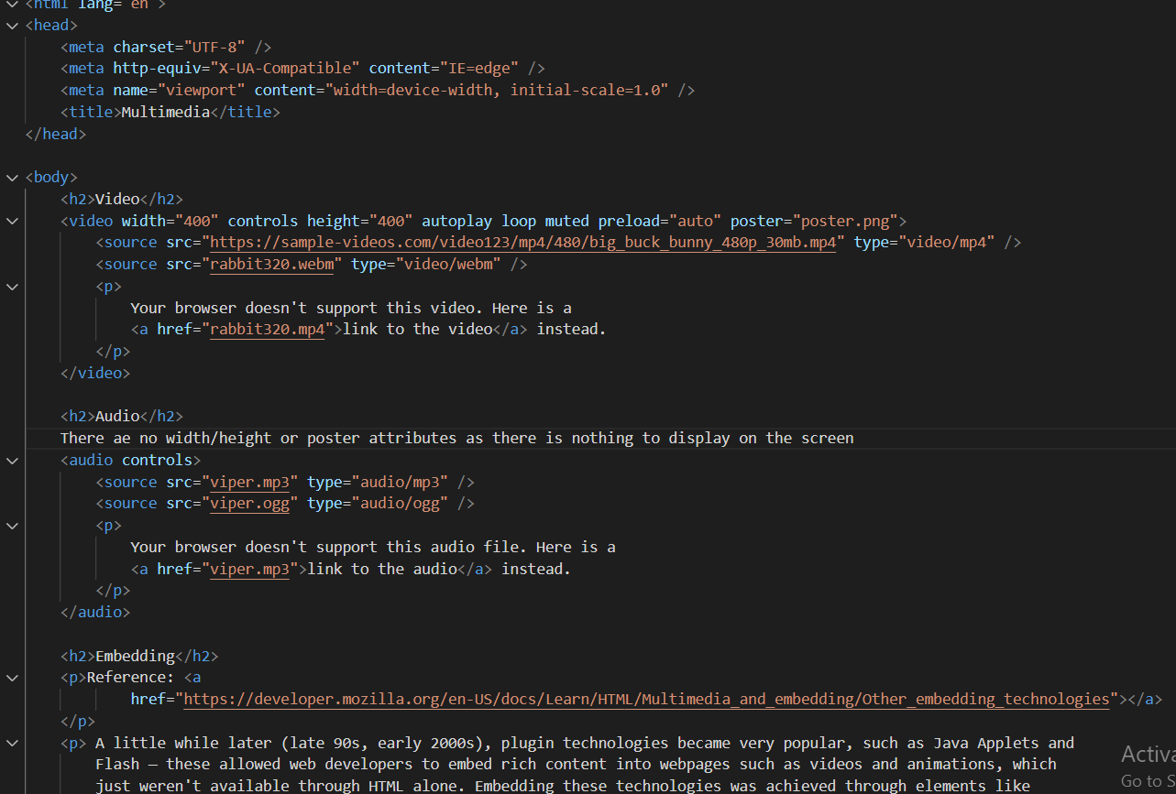**

**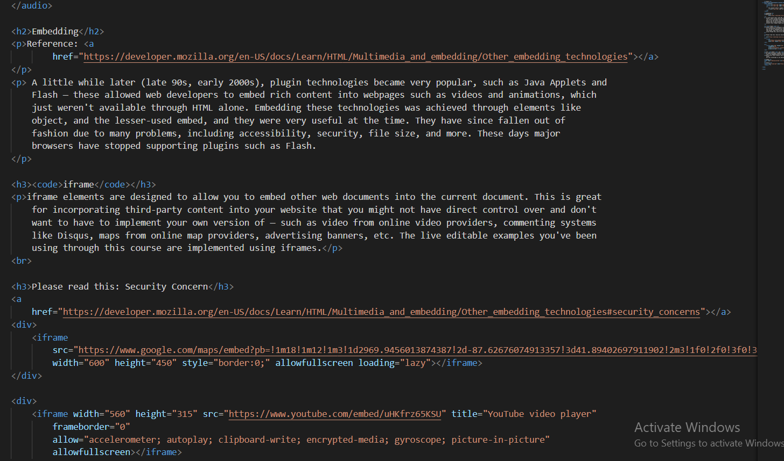**

**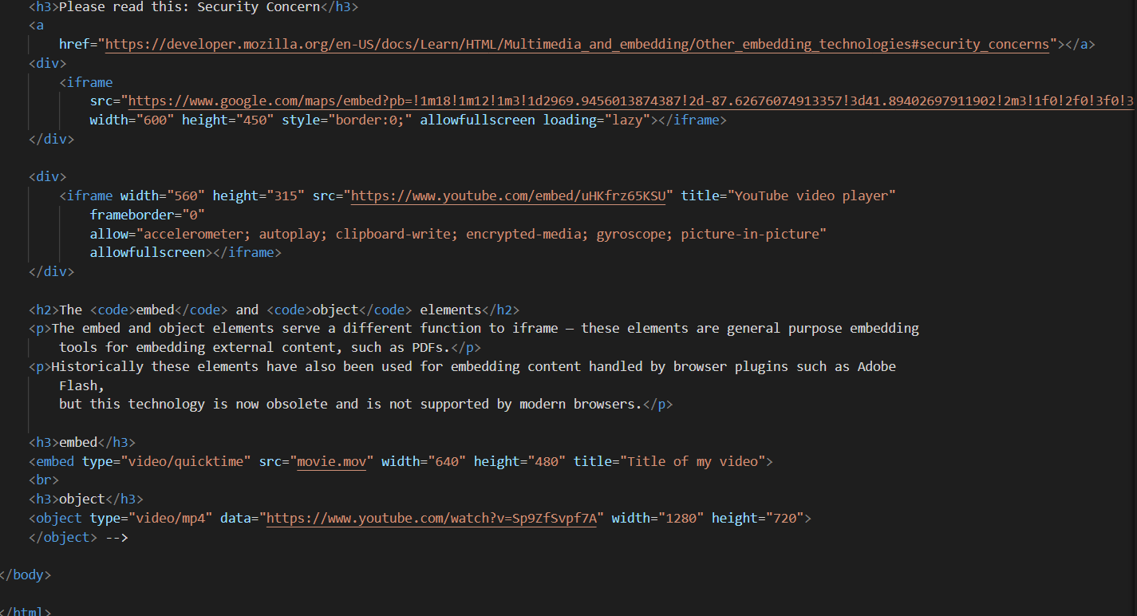**

**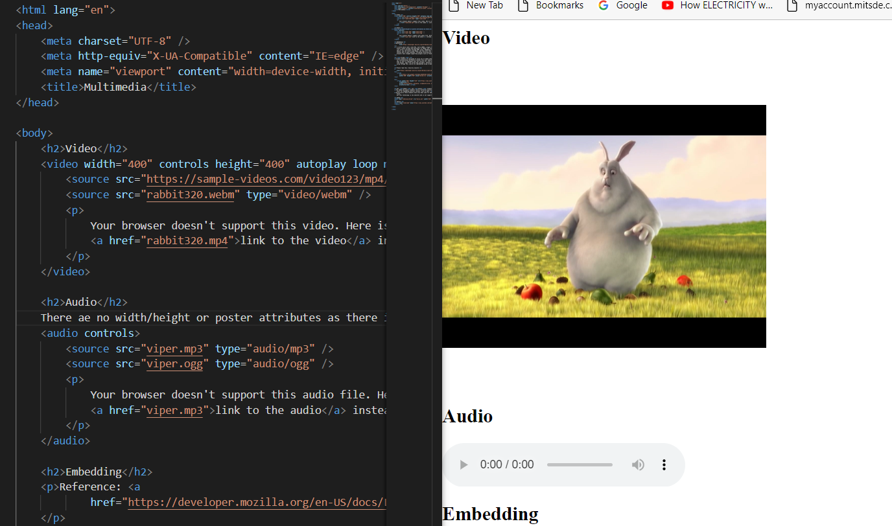**

**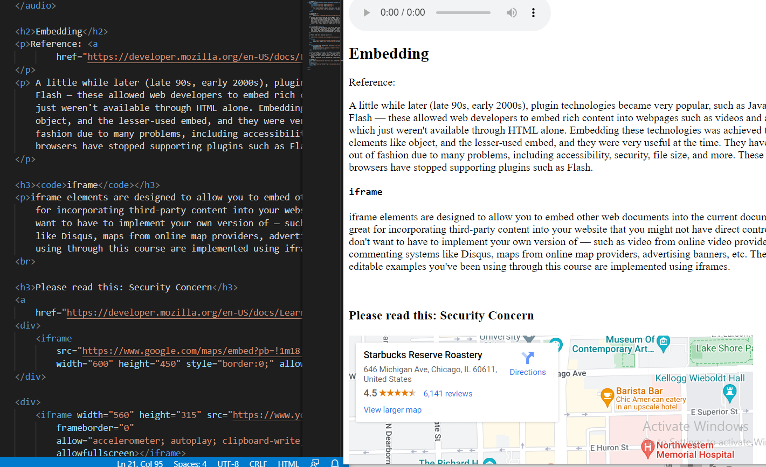**

**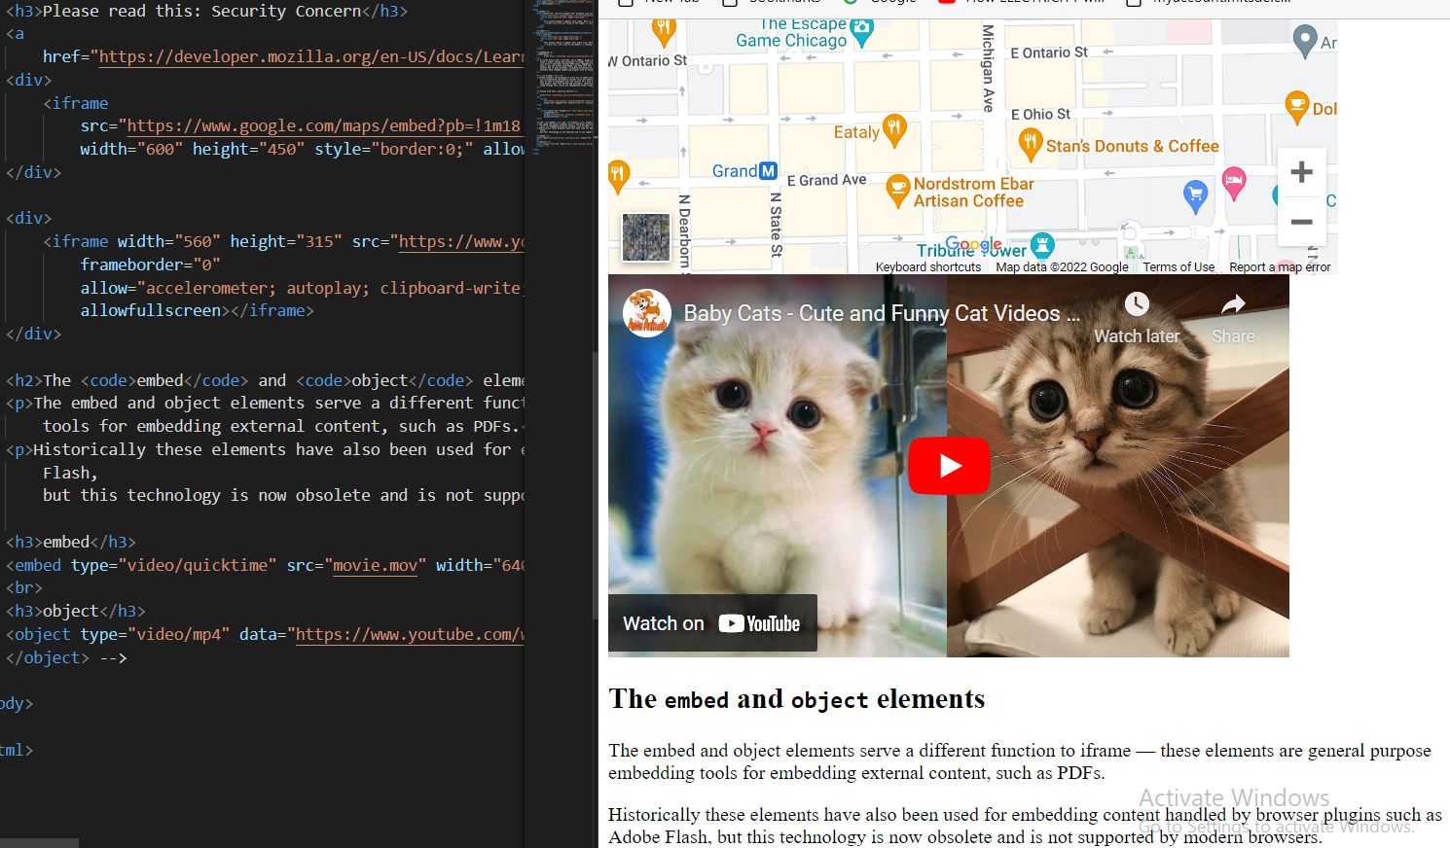**

Quiz Problems 1: -

* 1. HTML web pages can be read and rendered by ------------------------
     + 1. Interpreter B. Web Browser C. Compiler D. Server.
  2. How many types of heading tags do we have in HTML?
     + 1. 5 B. 6 C. 7 D. 8
  3. HTML is a --------------- language.
     + 1. Scripting Language B. Markup language C. Programming Language D. Network Protocol.
  4. How many types of list we have in HTML?
     + 1. 2 B. 5 C. 4 D. 1
  5. How do you change the list label to uppercase alphabets?
     + 1. List-style-type: alphabets B. List-style-type: upper-alphabets C. List-style-type: upper-alpha D. None of the above.
  6. How do you change the text color to blue?
     + 1. Font-color: blue B. text-color: blue C. color: blue D. None of the above.
  7. How do you bring text from one line to the next line?
     + 1. <nextline /> B. <changeline /> <break /> D. <br />
  8. How do you add multiple styles to an HTML element?
     + 1. font-size: 10px & color: blue B. font-size: 10px + color: blue C. font-size: 10px , color: blue D. font-size: 10px ; color: blue
  9. What happens when you just write the following code on the screen?

<ol></ol>

* + - 1. It will create an ordered list with one item B. It will create an unordered list with one item C. It will not show anything on the screen D. It will create an ordered list with one item

* 1. When you create an ordered list what is the list style by default?
     + 1. numbers B. lowercase alphabets C. uppercase alphabets D. uppercase roman numbers.
  2. Which is the correct option below to show two <span> elements with an empty line in between?

Convert this look (incorrect look):

**span line 1 span line 2**

into this (incorrect look):

**span line 1**

**span line 2**

* + - 1. <span> span line 1</span>

<span> span line 1</span>

* + - 1. <span> span line 1</span>

<br/>

<span> span line 1</span>

* + - 1. Correct option is not given here
      2. This is not possible because <span> is an inline element.

Quiz Problems 2: -

* 1. Where can you use “optgroup” tag in an HTML Form?
     + 1. To group options when using the <select>
       2. To group radio buttons C. To group checkboxes buttons D. To group input box.

* 1. What is the default value of method attribute in the form tag?
     + 1. GET B. POST C. None D. Both (GET and POST)
  2. Which HTML5 tag is used to provide native autocomplete dropdown feature in HTML forms?
     + 1. <ul> B. <select> C. <datalist> D. <dl>
  3. Which of the following statements are true for GET and POST Methods?
     + 1. GET will show values in URLs but POST will NOT show values in the URL.
       2. GET will NOT show values in URLs but POST will show values in the URL.
       3. GET will refresh the page on submit
       4. POST will not refresh the page on the submit
  4. Which is a valid way to load videos in a webpage?
     + 1. <video href=” video-url”></video>
       2. <video><source> type=mp4>video-url</source></video>
       3. <video><source> src=” video-url” type=” video/mp4”/></video>
       4. <video href=” video-url” type=”mp4”></video>
  5. Which of the following attribute adds video controls, like play, pause and volume?
     + 1. source B. controls C. control D. src
  6. If you don’t provide a value to the name attitude of an attribute of an input element, then on form submission, the data entered in that element will not be passed to the backend.
     + 1. True B. False
  7. Select the Correct line of code that will create a form input to enter a message that spans multiple lines.
     + 1. <input type=text name=” message”>
       2. <text name=” message”> C. <textarea name=” message”> D. <input type=” textarea name=” message”>
  8. Radio button can be Toggled as selected/Unselected by clicking on it.
     + 1. True B. False
  9. Which HTML element is used to create the input box with multiple lines?
     + 1. input B. Textarea C. select D. figure
  10. Using multiple <h1> elements inside a single HTML file is not considered as a best practice.
      + 1. True B. False
  11. All the hyperlinks with <a> tags in an HTML page should be wrapped inside the <nav><nav/> element to make the page semantically correct.
      + 1. True B. False
  12. Which of the following options promote the best practice for the code shown in the below image?

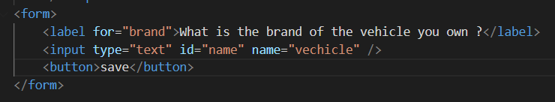

* + - 1. The value of attributes for and name should be the same.
      2. The value of attributes id and name should be the same.
      3. The value of attributes id and for should be the same.
      4. The value of attributes type and name should be the same.